

St. Mary’s Church of England VC Infant School

‘Sharing, Caring, Learning and Loving with God’

St Mary’s Way
Baldock
SG7 6HY

www.stmarysinfants.herts.sch.uk

Tel: 01462 892347

Spirituality Policy

Policy Review:

This Policy will be reviewed annually.

Reviewed | January 2026
Next Review | January 2027

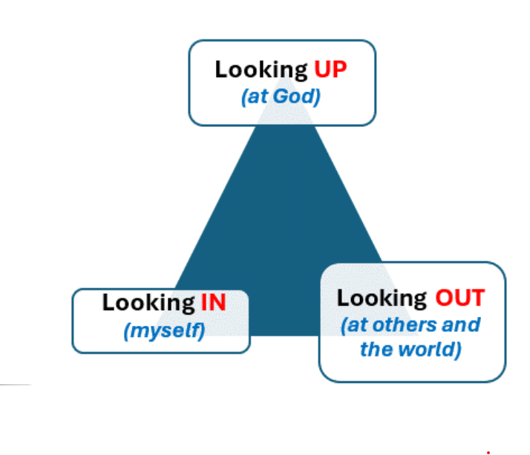
Spirituality is supported through Looking In, Looking Out and Looking Up, helping children to reflect, wonder and grow

Our Vision
We aspire to be a community living life in all its fullness. We share, care, learn and love with God, valuing the dignity and respect of all humanity and creation. Through the power of the Holy Spirit, Jesus’ Kingdom comes and everyone can flourish together.
Our Mission
‘Sharing, caring, learning and loving with God.’
Our Values
Friendship, Perseverance, Respect, Trust, Thankfulness, Humility, Generosity, Forgiveness, Courage, Peace, Compassion, Responsibility.
Our 6 Key ideals that underpin our vision
 | Uphold the Values of God
Nurture Creativity, Encourage Curiosity | Learning Together, Flourishing Together | Connecting Communities
 | Stimulating Surroundings
 | One Message
Understanding our vision
Our 6 key ideals were created through the input of all stakeholders as being important factors in what we want from our school every day.
‘We aspire to be a community living life in all its fullness’ (John 10:10) Church of England vision for Education
‘Sharing, Caring, Learning and Loving with God’ (School’s mission statement)
‘Valuing the dignity and respect of all humanity and all creation’ (Reference to Jonah and the Whale and the Church of England vision)
‘Through the power of the Holy Spirit’ (The importance of the Holy trinity and that we can’t do it alone. We must work together.)
‘Jesus’ kingdom comes.’ (Themed verse, Lord ’s Prayer and the goal of the school for us to create a peaceful and successful kingdom)
Flourish: Achievement
Together: Community
‘Sharing, caring, learning and loving with God.’

Our School Ethos
In this Church of England school, the ethos is founded on Christian values, beliefs and in particular, on the unique capacity and worth of each individual. St. Mary’s Infants School promotes a Christian ethos by example and direct teaching, following and promoting the teachings of Jesus, whilst recognising that not all members in its community will be practising Christians.

Our Shared Definition of Spirituality
“Spirituality is not material; it is not something we can see but rather something we can feel. It is about awe and wonder, asking questions, inspiration and being aware of something ‘bigger’ outside of ourselves.”

‘Our children understand and can say that ‘it is not something you can see, but something you can feel and wander about that is greater than ourselves.’

Spirituality at St. Mary’s
At St. Mary’s Infants School, we believe that spirituality is what defines us. It is the expression of our beliefs, the consistency of our actions and the reflection of our core values within the choices we make. Our vision statement articulates that we aspire to live life in all its fullness whilst valuing dignity and respecting all humanity and creation. Through Bible-based teachings, daily discussions as a school community and a holistic, child-led approach to education, we encourage all to develop their own sense of spirituality, a strong ethical foundation and a wider understanding and acceptance of all humankind, celebrating all backgrounds and faiths.
We recognise that the spiritual development of pupils plays an integral role in shaping the citizens and leaders of our future. We therefore aim to offer a holistic education that provides pupils with opportunities to explore and develop their own values, beliefs and spiritual awareness. Opportunities for spiritual development are presented or naturally arise. They are promoted in all aspects of the curriculum and school life as the children become actively engaged in an enquiry-based curriculum, which provides a wide range of experiential learning opportunities, enabling them to question, consider, reflect and respond. The curriculum will also support pupils to consider their own values, beliefs, feelings and those of others, with whom they are working alongside or with.
Spirituality is not taught but is inherently interwoven into all aspects of school life and is nurtured and promoted as a natural element of our curriculum. The following opportunities will be made available, as an integral part of the school’s practice to facilitate the development of spirituality:
- To explore values and beliefs, including religious beliefs, and the way in which they impact on peoples’ lives.
- To provide regular opportunities for staff and pupils to consult together, discuss, reflect and build upon how we would like to develop the spirituality of each individual pupil and our time for stillness as a community.
- Where children already have religious beliefs, to support and develop these beliefs in ways which are personal and relevant to them as an integral part of the school’s practice.
- To engage in enquiry and exploration as part of experiential, first-hand learning.
- To look attentively and observe carefully.
- To be creative and imaginative.
- To listen with discernment.
- To reflect and respond to issues in moments of quiet or inspired through music, art, text, film or artefacts.
- To explore and develop what animates themselves and others.
- To understand human feelings and emotions, the way they impact on people and how an understanding of them can be helpful.
- To value what is good and worthwhile and to make value judgements through discussion and exchange of views.
- To work collaboratively with peers, valuing the contribution made by others.
- To respect all, as modelled by staff in their relationships with others.
- To experience and develop an appreciation for silent, calm and tranquil moments which afford time for reflection.
- To work and live in harmony with others in our school and wider community.
- To have confidence to express ideas, views and opinions, even if others do not agree.
The integrity and spirituality of pupils from other faith backgrounds will be respected and explored. The diversity of spiritual traditions will be recognised, and pupils will be given access to alternative views. All adults will model and promote expected behaviour, treating all people as unique and valuable individuals, showing respect for pupils and their families.
The school community will be a calm, welcoming place where pupils can find acceptance for themselves as unique individuals, and where they will be encouraged to value themselves and others.

Spiritual Development:
This relates to the quest for individual identity and the search for meaning and purpose in our existence. It leads towards the understanding of self and others. It has to do with feelings, emotions, attitudes and beliefs. It is not linked solely to a particular doctrine or faith and spiritual development is therefore accessible to everyone.

Pupils’ spiritual development is shown by their:
- beliefs, religious or otherwise, which inform their perspective on life and their interest in and respect for different people’s feelings and values;
- respect for themselves and the ability to make and maintain positive relationships with others;
- sense of enjoyment and fascination in learning about themselves, others and the world around them, including the intangible;
- use of imagination and creativity in their learning;
- willingness to reflect on their experiences;
- capacity for quiet reflection and stillness;
- ability to listen and talk with one another;
- developing understanding and awareness of issues of equality which is reflected in our speech and actions;
- growing ability to debate, both agreeing and disagreeing with others in a reasoned way;
- sense of fairness while taking turns and sharing;
- independent work as well as that with others, developing the ability to cooperate, collaborate and get along;
- discussions about and sharing of personal experiences and feelings with others;
- expression and clarification of personal ideas and beliefs through discussion with others;
- exploring of difficult subjects including life events (e.g. playground conflict, death, illness etc.) and challenging questions (e.g. what happens when we die?);
- exploring of positive and negative relationships with friends, family and others;
- showing empathy and respect for others;
- developing self-esteem and a respect for themselves;
- developing respect for the environment and the world around us, which is reflected in their conscientious actions;
- developing a sense of belonging and confidence;
- spending time in quiet reflection, learning to manage our feelings, to be calm and still.
Spiritual Spaces within the School
All within St. Mary’s community have an opportunity to access their spirituality throughout the day across a variety of designated areas- all of which have been designed for the children and by the children. Within the classroom, each class has its own personalised spiritual area which is created with the class’ spirituality needs in mind and it is constantly evolving to meet the needs of all. We are very fortunate at St. Mary’s to be immersed in the beauty and wonder of nature itself with a wide sweeping field, glorious trees and lots of different birds to see- so we have honed in on this to create outdoor spirituality areas which the children can access in their own time during playtimes, lunchtimes and collective worship. This includes a spiritual garden, a spiritual reading and mindfulness hub and an area for spiritual reflection. These spaces are not fixed in appearance but rather everchanging with the children.
Spiritual Styles and Awareness
All at St. Mary’s embark upon a journey of spiritual self-discovery and self-awareness by undertaking an audit tool to provide insight into their spiritual styles. We are guided by the work of David Csinos who divides up the styles simply into word, emotion, symbol and action. This knowledge helps shape collective worship also as it enables the spiritual styles to be catered for.

Links with our wider community
Visitors are welcomed into school to support learning, to build relationships and help raise awareness of important issues such as safety, charity, environmental impact and equality. For example, we have previously arranged visits with local faith leaders, our local MP, health professionals, ‘people who help us’, environmentally aware authors and sports professionals.
Children make visits beyond the school to develop their awareness of the wider community and world, other cultures, faiths and environments. Links with the Church are fostered through connections with our local church – St. Mary’s Church in Baldock – and the Dioceses.
The development of a strong home-school link is actively pursued, enabling families and teachers to work in an effective partnership to support all pupils.

Monitoring and Evaluation
Provision for SMSC is monitored and reviewed on a regular basis.
This is achieved by:
- Whole school audits of SMSC provision using the SMSC grid and SMSC National Quality Mark self-review tool;
- Governor monitoring visits;
- Gathering of evidence from parent questionnaires, Christian Distinctiveness Working Party meetings and through the monitoring of teaching and learning.

