

St. Mary’s Church of England VC Infant School

‘Sharing, Caring, Learning and Loving with God’

Special Educational Needs and Disability Policy

Policy Review:

Reviewed | March 2026
Next Review | March 2027

Our Vision
We aspire to be a community living life in all its fullness. We share, care, learn and love with God, valuing the dignity and respect of all humanity and creation. Through the power of the Holy Spirit Jesus’ Kingdom comes and everyone can flourish together.
Our Mission
‘Sharing, caring, learning and loving with God.’
Our Values
Friendship, Perseverance, Respect, Trust, Thankfulness, Humility, Generosity, Forgiveness, Courage, Peace, Compassion, Responsibility
Our 6 Key ideals that underpin our vision

 | Uphold the Values of God
Nurture Creativity, Encourage Curiosity | Learning Together, Flourishing Together | Connecting Communities
 | Stimulating Surroundings
 | One Message
Understanding our vision
Our 6 key ideals were created through the input of all stakeholders as being important factors in what we want from our school every day.
‘We aspire to be a community living life in all its fullness’ (John 10:10) Church of England vision for Education
‘Sharing, Caring, Learning and Loving with God’ (School’s mission statement)
‘Valuing the dignity and respect of all humanity and all creation’ (Reference to Jonah and the Whale and the Church of England vision)
‘Through the power of the Holy Spirit’ (The importance of the Holy trinity and that we can’t do it alone. We must work together.)
‘Jesus’ kingdom comes.’ (Themed verse, Lord ’s Prayer and the goal of the school for us to create a peaceful and successful kingdom)
Flourish: Achievement
Together: Community

Purpose
The Special Educational Needs and Disability Code of Practice (2015) states that a child or young person ‘has SEN if they have a learning difficulty of disability which calls for special educational provision to be made for him or her… or if they have a significantly greater difficulty in learning than the majority of others of the same age.’ Or if the child or young person has a disability which prevents or hinders him or her from making use of the facilities of a kind generally provided for others of the same age in mainstream schools.’
We at St. Mary’s Infants Church of England School believe that each pupil has individual and unique needs. All children can expect a fully inclusive, well differentiated education at our school, some children may need additional support during their time with us and a few children will need more precise individualised support to achieve their potential. Some of these pupils may require help throughout their time in school, while others may need a little extra support for a short period, to help them overcome more temporary needs. St Mary’s Infants School aims to provide all pupils with strategies for dealing with their needs in a supportive, nurturing environment, and to give them meaningful access to learning and the National Curriculum.
We aim to:
- enable every pupil to experience success.
- promote self-confidence and a positive attitude.
- ensure that all pupils, whatever their Special Educational Need or Disability, receive appropriate educational provision through a broad and balanced curriculum that is relevant and differentiated, and that demonstrates coherence and progression in learning.
- provide high quality teaching developed through training, appraisal against teacher’s standards, peer support and feedback from observations.
- ensure that barriers to learning are reduced through careful planning.
- give pupils with SEND, equal opportunities to take part in all aspects of the school’s provision using reasonable adjustments.
- support the child and the child’s parents, to facilitate the development of the child and to help them achieve the best possible educational and other outcomes.
- identify, assess, record and regularly review pupils’ progress and needs through Pupil Progress Meetings and reviews and through the assess, plan, do review cycle.
- work collaboratively with parents, other professionals and support services.
- ensure that the responsibility held by all staff and governors for SEND is implemented and maintained.
- provide support, advice and training to all staff working with children with SEND.
- involve parents/carers in planning and supporting at all stages of their children’s development.
- involve pupils in their own journey and decision making.
Statutory Information and SEN Information Report
In line with the SEND Code of Practice 2014 the school has appointed a SENCo.
Our website http://www.stmarysinfants.herts.sch.uk/ has links to our SEN Information Report, key polices including managing medical conditions, transition arrangements (via SEN Information Report) and admission arrangements. Our SEN Information Report contains the information required in Regulation 51 of The Special Educational Needs and Disability Regulations 2014 and has been coproduced with Staff, Parents and Pupils at the school to answer all their questions about Special Educational Needs support at St Mary’s
Pupils with an EHC plan are admitted if the school is named on the plan by a Local Authority. Pupils with SEND are considered for admission to the school on the same basis as pupils without SEND.
What is a Special Educational Need?
The SEND Code of Practice 2014 describes the possible barriers to learning under four broad areas:
- Communication and interaction including speech and language difficulties and autistic spectrum disorders
- Cognition and learning including specific learning difficulties such as dyslexia and dyspraxia
- Emotional, social or mental health including ADHD and attachment disorders
- Sensory, medical or physical including, hearing, visual or physical impairments
Progress and attainment may also be affected by either one of more of the following but would not be considered as SEND:
- Attendance and Punctuality
- Health and Welfare
- English as an Additional Language
- Being in receipt of Pupil Premium Grant or Pupil Premium Plus Grant
- Being a Child Looked After
- Being the child of Service Personnel
Identifying Special Educational Needs
A pupil has SEN where their learning difficulty or disability calls for special educational provision, namely provision different from or additional to that normally available to pupils of the same age (SEN Code of Practice 2015, Paragraph 6.15)
Children with SEND at St Mary’s are identified through a variety of assessment routes, all of which are part of the overall approach to monitoring progress of all pupils.
The class teacher continually assesses the progress of children and on termly basis reports to the Senior Leadership Team and SENCo via a Pupil Progress Meeting. The impact of the quality first teaching, interventions and catch-up programmes, which target areas of support needed, are analysed and the progress of identified groups of children are monitored by the SENCo.
If a child, as recommended by the 2014 Code of Practice, is making less than expected progress, given their age and individual circumstances, the class teacher and SENCo will work with parents to find a cause. This can be characterised by progress which (SEN Code of Practice 2015 Paragraph 6.17):
· Is significantly slower than their peers starting from the same baseline
· Fails to match or better the child’s previous rate of progress
· Fails to close the attainment gap between the child and their peers
· Widens the attainment gap
Persistent disruptive or withdrawn behaviours do not necessarily mean that a child or young person has SEN (SEN Code of Practice 2015, Paragraph 6.21)
The class teacher will also liaise with the SENCo at any point in the term, when concerns are beginning to become apparent and will be in contact with the child’s parents to share their concerns and what provision the school has put in place to support the child.
Advice from external support services and Specialised assessments may be required to ascertain the barriers. Any concerns will be discussed with parents at the earliest opportunity and the child will also be consulted in an age-appropriate manner.
We recognise that some pupils will have a diagnosed Special Educational Need or a Disability which can be supported fully through reasonable adjustments and high-quality teaching. These children are recorded as having a Special Educational Need but are not receiving SEND Support. We regularly review the reasonable adjustments made for these children and monitor their progress to ensure their needs continue to be met.
St Mary’s Infant School also recognise that parents know their children best in the home context. Parents with concerns should speak to the child’s class teacher, in the first instance. If the concerns are evident in school and/or are having an impact on the child’s learning, then the class teacher will involve the SENCo. If the concerns do not impact on school life, then parents may be signposted by the class teacher or SENCo to seek external advice e.g. Doctor, Health Visitor.
A small number of pupils may require an Education, Health and Care (EHC) needs assessment for their local authority to decide whether it is necessary for it to make provision in accordance with an EHC Plan. This is required only where a pupil has failed to make progress despite intensive and sustained SEND provision from the school. All parents have the right to ask for a Special Educational Needs Assessment by the Local Authority in which they live, who will assess this application and decide as to whether a needs assessment needs to take place within 6 weeks of the application. The purpose of an EHC Plan is to:
“make special educational provision to meet the special educational needs of the child or young person, to secure the best possible outcomes for them across education, health and social care and, as they get older, prepare them for adulthood. SEN Code of Practice 2015, Paragraph 9.2
“If the school feel that a child would benefit from an EHC Plan they will discuss this option with the parents and the SENCo will support the parents through the process of applying for one. Where a pupil has an EHC Plan, the local authority must review that plan, at a minimum, once every twelve months. In Hertfordshire the local authority require schools to convene and hold annual review meetings on its behalf.” SEN Code of Practice 2015, Paragraph 9.2
Pupil Profile
Pupil Profiles are created detailing the reasonable adjustments which are made to everyday teaching for children with identified SEND needs. These allow details of these adjustments to be clear to all staff who teach a child including supply teachers. Pupil Profiles are the responsibility of the class teacher but many of the adjustments will be drawn from external expertise and will be monitored over a set time frame. The Pupil Profiles are regularly reviewed by the class teacher in conjunction with the child’s parents.

A Graduated Approach to SEN Support
The Code of Practice 2015 delivers SEN Support through the Graduated Response, which is underpinned by high quality teaching. It is comprised of four stages, which form a cycle:
- Assess – specifically identifying what a child needs support with
- Plan – the class teacher in consultation with the parents and SENCo, agree the outcomes they are seeking, the interventions and support to put in place and the expected impact on progress, development or behaviour with a clear date for review
- Do – the interventions and support are implemented by the class teacher or under the direction of the class teacher
- Review – the effectiveness of the support and its impact on the child’s progress is reviewed by the class teacher and evaluated by the SENCo.
A support plan (APDR – Assess, Plan, Do, Review) is created by the class teacher, following this process, for all children identified as requiring SEN Support. Provision across the school is monitored and evaluated by SENCo to ensure impact and value for money, strategies are reviewed, and training is provided as necessary to support staff.
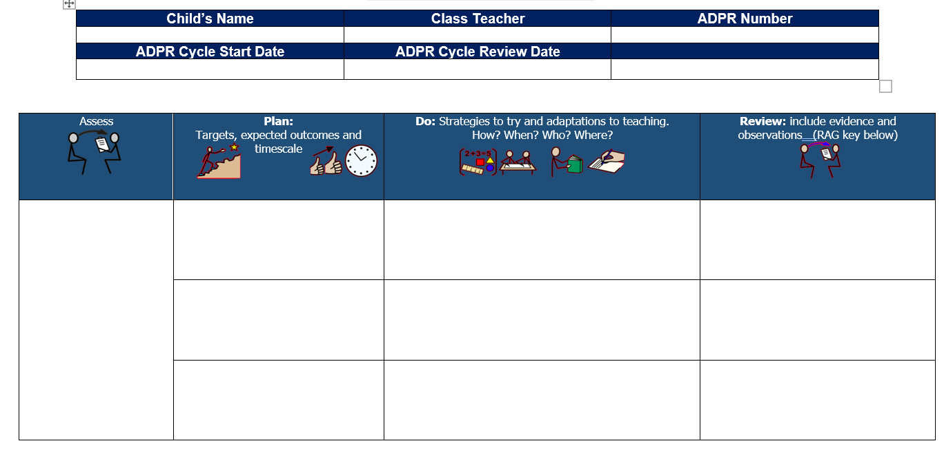

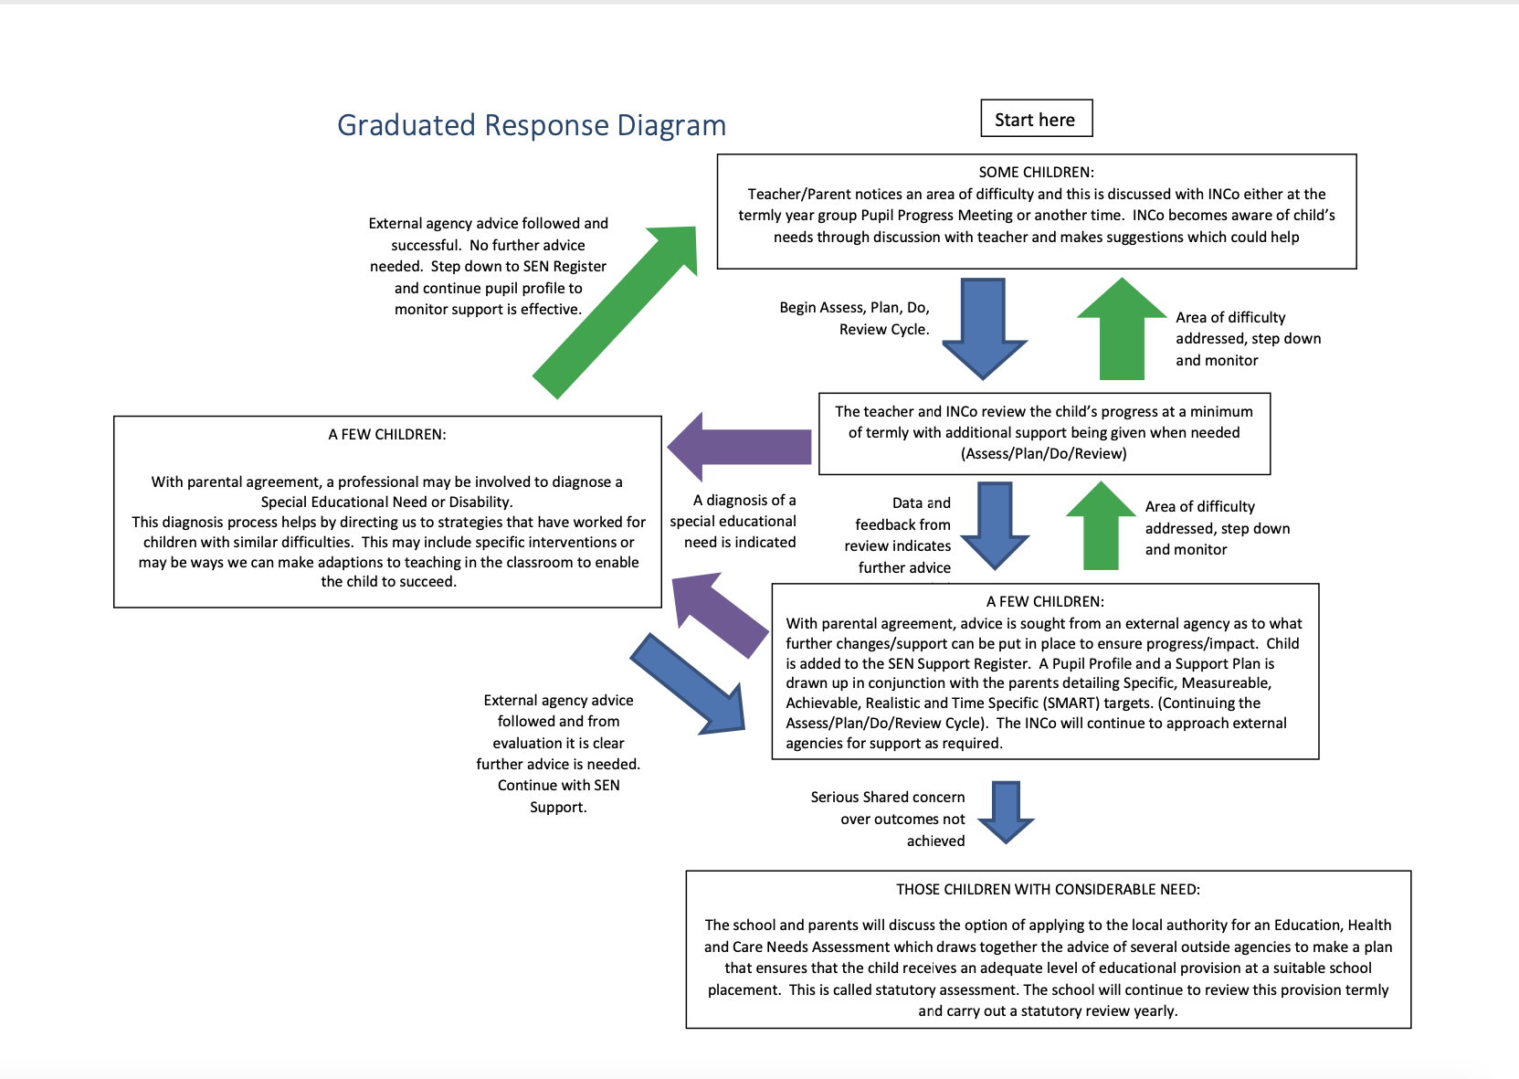
Responding to pupils needs through SEN Support
If a child has been identified as needing more specialist input instead of/or in addition excellent classroom teaching and targeted learning, referrals may be made to outside agencies to advise and support the school in enabling the child to make progress.
- Before referrals are made parents will be asked to come to a meeting to discuss their child’s progress and help plan possible ways forward.
- If it is agreed that the support of an outside agency or professional, is a way forward, parents will be asked to give permission for the school to refer the child to a specialist professional. This will help the school, and the parents understand the child’s particular needs better.
- The specialist professional will work with the child to understand their needs and make recommendations.
- Regular meetings will be held with external agencies and professionals and all reports received from them will be shared with the parents and class teachers. The type of specialist agencies and professionals are listed as an appendix to this document.
- If more than one external agency is involved, and to ensure effective collaboration when identifying needs and making provision for our most vulnerable pupils, Early Help Module (EHM) meetings which involve representation from all appropriate external agencies, may be arranged.
Training and Resources
St Mary’s Infants School recognises that all children have the right to first quality teaching and the need for a comprehensive programme of staff professional development to ensure that this is the case for all pupils.
All staff undertake an induction process on taking up a post at St Mary’s.
This induction process ensures that all members of teaching staff are confident with:
- their responsibilities under current SEND legislation relating to inclusion
- differentiation and planning for inclusion of all learners
- assessment of learners working below age related expectations
- reasonable adjustments that can be made to support learners with SEND
- the teaching of reading through Read Write Inc
- the teaching of mathematics through a mastery based approach using concrete manipulatives for all pupils.
- behaviour management using Therapeutic Approaches to Behaviour (TAB) and our Behaviour Policy
- effective deployment of teaching assistants within the classroom.
- how and when to use support to promote independent working
- how to support the self-esteem and resilience of pupils.
The induction process for all staff ensures that Teaching Assistants are confident with:
- their responsibilities under current SEND legislation relating to inclusion
- facilitating learning in lessons by repeating and reviewing key points, using open and closed questions, prompting, simplifying language, scribing key points and reminding pupils of class rules
- the principles and techniques of both forward and backward chaining when teaching sequential tasks
- how and when to use support to promote independent working
- how to support the self-esteem and resilience of pupils.
In addition to this the training needs of all staff are continually evaluated through the appraisal process and training targeted to support these needs.
Criteria for exiting the SEN Register
If a child has made good progress and closed the gap with their peers, in discussion with all parties, children may no longer require SEN Support. If the child requires reasonable adjustments to teaching in order to continue to progress that child will still be recorded as having a Special Educational Need but will no longer require the intensive SEN Support they had previously. If however, they are able to access the curriculum without a greater difficulty than the majority of their peers they will be removed from the SEN Register but will continue to be closely monitored to ensure their progress continues.
The role of external professionals
External professionals have a variety of expertise they can add to that already held in school. We recognise and value these skills and call upon them when necessary:
- Early Years Advisory Teacher for children of SEN (EYFS SEN Team)
- Specialist Teacher for children with Autism (SCLN team)
- Family Support Worker (FSW)
- North Herts Primary Behaviour Support Services (NHPSS)
- Specialist Teacher for children with Visual Impairments (VI Team)
- Speech and Language Therapist (SALT)
- Occupational Therapist (OT)
- Physiotherapist
- Educational Psychologist (EP)
- Outreach support from Woolgrove Special School
- Child and Adolescent Mental Health Services (CAMHS)
- Positive behaviour, Autism, Learning disability, and Mental health Service (PALMS)
- Child Development Centre Paediatricians (CDC)
- Thriving Families
- BeeZee Bodies
- School Nursing Team
- Health Visitor Team
- Specific branches of the NHS e.g. Epilepsy Nurses
- Hertfordshire Post Adoption Team
- Virtual Schools (Children in Care, Children previously in care, children with a social worker)
- Specialist Teacher for children with Physical and Neurological Impairments.
- NESSIE (Emotional Wellbeing Support Therapists)
In some cases, the school may employ private professionals to provide services for our children in the past this has included:
- Educational Psychologist
- Speech and Language Therapist
- Art Therapist
This will only take place where the school feels that the need identified cannot be met by the local authority children’s services team. We undertake professional checks on all specialists employed to ensure that they are well qualified and ensuring the safeguarding of our children at all times.
Expectations of external professionals
At St Mary’s Infants School we recognise that the Class Teacher is always responsible for the education of all pupils within the class whether or not they have Special Educational Needs. Therefore, we have a protocol for the external professionals that visit our school to ensure this remains the case:
We expect that external professionals that visit the school meet with the Class Teacher to discuss the child’s needs and progress to date. It is never the responsibility of a Teaching Assistant to share this information. If a child is receiving multiple visits per term for example to receive Speech Therapy or Occupational Therapy, then this face-to-face communication between the Class Teacher and Professional should take place on one occasion per term.
- All suggestions for provision should be shared with the Class Teacher and although it is often a Teaching Assistant who is trained to deliver an intervention between visits, it is important that the Class Teacher knows exactly what is involved.
- All visits should be communicated via email to the SENCo to comply with our safeguarding procedures and ensure that they are recorded on the school calendar and the class teacher is expecting the visit. This is the case even when a date has been agreed with a member of school staff verbally. It is the duty of the outside professional to inform the parents of this date, if the school is aware of the date, they may inform the parents out of courtesy.
- Written reports are welcome and are particularly helpful when received promptly after a visit. School protocol expects that all professionals refrain from using staff names in their reports as this breaches the staff member’s rights under the General Data Protection Regulations and we request that staff members are referred to by their job role instead.
- Communication via email can help all involved who work with a child but due to General Data Protection Regulations we ask that no identifiable information about a child is included in email correspondence. The school uses the encryption service Schoolsfx/Hertsfx [Transfering to Herts Secure in March 2026] to send and receive information containing this information to ensure it is secure. At all times professionals should adhere to the school’s format for sending emails.
Private Professionals
At St Mary’s Infants school we believe in quality first teaching and that all children should benefit from accessing their full timetable.
We recognise that there are occasions where parents would like an assessment carried out on their child by a private professional in order to speed up the assessment process, confirm a diagnosis not available through the local authority (for example dyslexia) or if they disagree with the advice given to us. In these instances, we would request that this is organised for a time outside of the school day. However, we do recognise that this is not always possible and if a parent requests to remove a child from school to undertake such a private assessment on a “one off” basis we would authorise this absence.
Regular absence from class for private treatment may have an adverse effect on the pupil’s access to first quality teaching and we would therefore strongly advise that this takes place outside of the school day.
We value the support all outside professionals whether private or from statutory services can give and will carefully consider advice given to the school in respect of children’s needs. However, implementation of strategies recommended by private professionals will be at the discretion of the class teacher, SENCo and Senior Leadership Team. Parents should be aware that no favourable treatment will be given to children who have seen a private professional over children who have not.
Due to safeguarding protocols and timetabling of rooms we are unable to accommodate private professionals within the school and parents should be mindful of this.
Interventions
St Mary’s Infants school recognises the importance of scaffolded first quality teaching in supporting children to make progress in their learning. However, we also recognise that there are some evidence based interventions that do help children to make more rapid progress and these may be used with children at the discretion of the class teacher. In all cases the following will be considered:
- The aims and expected impact of the intervention and how this will be measured
- The time commitment for the intervention
- The best time for the intervention to take place
- Time missed from learning in the classroom
- How the intervention links and feeds into work in the classroom
- The evidence base supporting the intervention.
- Whether the appropriate member of staff that will be required to deliver the training has received high quality training and is confident in its delivery
- Whether the school feels the benefit of such an intervention outweighs the missed learning opportunities in the classroom.
Intervention will only be carried out for a time limited period and parents will be informed if their child is taking part in such an activity. Interventions are reviewed during the Pupil Progress Meeting cycle
Teaching Assistant Support
We try to balance the support a child needs with their independence and inclusion with peers.
In Hertfordshire the funding mechanism for 1:1 support is called ‘Higher Needs Funding’ with and is only given to the very few children whose needs are considered exceptional across the county.
If funding is successfully applied for, parents will be informed of the teaching assistants who are working with their child. The class teacher will direct this resource, and this will involve scheduled time when the teaching assistant scaffolds the child to be independent and time when the teaching assistant prepares resources for the child as well as providing interventions and in class support.
Not all pupils with Education, Health and Care plans require 1:1 support and this is considered on a case-by-case basis. Pupils who receive High Needs Funding (HNF) through an Education, Health and Care (EHC) Plan that specifies one-to-one supported interventions should be aware that the school is only able to allocate the level of support in line with the funding provided by the Local Authority. While the school is committed to delivering the provision outlined in each pupil’s EHC Plan, the funding awarded often does not equate to full-time one-to-one support. Consequently, support may be delivered through a combination of individual, small group, and class-based strategies, as appropriate to the child’s needs and the available resources.
All teaching assistants at St Mary’s Infants are excellent practitioners with a high level of training and a thorough induction as outlined above. The Senior Leadership Team will consider the needs of the child requiring support and the skills and development priorities of staff when considering which teaching assistants will support children in this way and parents are not able to request a specific member of staff to work with their child.
The Class Teacher is responsible for delivering the outcomes in the EHCP plan. We therefore insist that parents communicate with the Class Teacher and not through a Teaching Assistant.
Supporting children and families
The school offers termly SEND coffee afternoons as informal social opportunities for parents and carers of children with SEND. These sessions are intended to provide peer support and a sense of community, rather than serve as meetings with the SENCo. Please note that if parental uptake is low, these events may be cancelled to ensure the effective use of the SENCo’s directed time and capacity.
Hertfordshire’s Local Offer – the purpose of the Local Offer is to enable parents and young people to see more clearly what services are available in their area and how to access them. It can be found at https://www.hertfordshire.gov.uk/microsites/local-offer/about-the-local-offer.aspx
Roles and Responsibilities of staff
Class teachers are central to the success of inclusive practice and are responsible for the following:
- Being accountable for the outcomes and progress of all pupils in their class, including those with SEND.
- Adapting the curriculum to ensure it meets the individual needs of every pupil.
- Monitoring pupil progress and identifying any additional support or intervention required. This may include targeted teaching, additional adult support, or the use of adapted resources, in collaboration with the SENCo where appropriate.
- Writing and regularly updating Pupil Profiles.
- Writing, implementing, and reviewing Assess–Plan–Do–Review (APDR) cycles for pupils receiving SEND support.
- Implementing and delivering the outcomes and provision set out in the child's Education, Health and Care Plan (EHCP), in collaboration with the SENCo and other relevant staff.
- Ensuring that all staff working with a child are aware of their individual needs or diagnoses, and understand the adjustments required to enable the child to be included and make expected progress.
- Supporting the professional development of staff by ensuring all colleagues working with children are appropriately trained in line with school expectations.
- Following the school’s SEND Policy and ensuring that reasonable adjustments are made to support inclusion and access to learning.
The Headteacher is responsible for:
- The day-to-day management of all aspects of the school, including the support for children with SEND. While the Headteacher will delegate responsibility to the SENCo and class/subject teachers, they remain accountable for ensuring that the needs of all pupils are met.
- Keeping the Governing Body informed about any issues relating to SEND within the school.
The Governing Body’s Responsibilities for SEND
The Governing Body, in co-operation with the Headteacher, has a legal responsibility for monitoring the policy and provision for pupils with SEND, in line with the SEND Code of Practice (2015). The Governing Body has appointed a representative Governor to liaise with the SENCo and report back to the Governing Body. This Governor does not hold individual responsibility for SEND, as this is a collective responsibility of the Governing Body.
The SEN Governor, as part of the Governing Body, will ensure that:
- SEND provision is an integral part of the school’s improvement and development plan, as outlined in the SEND Code of Practice.
- Appropriate provision is made for pupils with SEND, in line with statutory duties outlined in the SEND Code of Practice.
- Staff are aware of the need to identify and provide for pupils with SEND, in accordance with the principles of the SEND Code of Practice.
- Pupils with SEND are able to participate in school activities alongside their peers, as far as is reasonably practical and compatible with their needs and the efficient education of other pupils, in line with SEND CoP guidance.
- The school has regard to the requirements of the SEND Code of Practice (2015) and any subsequent statutory updates.
- The SEN Governor is kept informed about SEND issues to enable them to actively contribute to the school’s self-evaluation process in accordance with the SEND Code of Practice.
- The Governing Body monitors appropriate staffing and funding arrangements, and oversees the school’s work for pupils with SEND, ensuring compliance with the SEND Code of Practice.
- The quality of SEND provision is regularly monitored to ensure it meets the standards set out in the SEND Code of Practice.
- The Governing Body, along with the school as a whole, is involved in monitoring and reviewing this policy to ensure continuous improvement and adherence to SEND CoP guidelines.
Responsibilities of the SENCo
- Oversee the day-to-day operation of the school’s SEND policy and provision, ensuring it aligns with the SEND Code of Practice (2015).
- Ensure the identification of pupils with SEND and work with class teachers to assess, plan, and implement support strategies tailored to individual needs.
- Monitor and review progress for all pupils with SEND, ensuring that appropriate interventions are in place and that outcomes are achieved.
- Support teachers to coordinate the provision of support, including interventions, additional support staff, and resources, to meet the needs outlined in pupils' EHC Plans or SEND support plans.
- Liaise with and provide advice to class teachers to ensure effective differentiation and the implementation of strategies that support pupils with SEND within the classroom.
- Ensure the school’s compliance with statutory requirements under the SEND Code of Practice (2015), including arranging and reviewing EHC Plans and APDR cycles (Assess, Plan, Do, Review).
- Work with external agencies and professionals (e.g., Educational Psychologists, Speech and Language Therapists, etc.) to secure additional support for pupils with more complex needs.
- Ensure staff are trained and supported in understanding SEND needs and providing effective strategies to support inclusion within the classroom.
- With teachers, communicate regularly with parents and carers of pupils with SEND, keeping them informed about their child’s progress and the support in place.
- Monitor and evaluate SEND provision to ensure it is effective and contributes to improved outcomes for pupils with SEND.
- Ensure pupils with SEND have access to the full curriculum and participate in school activities alongside their peers, as far as is reasonable and practical.
- Contribute to the development of the school’s SEND policy and ensure that it is consistently implemented across the school.
- Provide leadership for the SEND team and support other staff in meeting the needs of pupils with SEND.
- Report to the Governing Body on the effectiveness of SEND provision and the implementation of the SEND policy, ensuring the Governing Body is kept informed of any issues or developments related to SEND.
- Ensure that transition arrangements for pupils with SEND are smooth and well-supported, both when moving between classes, key stages, and when leaving school.
Responsibilities of Learning Support Staff/Teaching Assistants
Learning support staff and teaching assistants should:
- Work in partnership with teaching staff to support the individual needs of pupils, ensuring tailored provision is in place.
- Actively encourage pupil interaction and engagement in both teacher-led and child-initiated activities, fostering an inclusive learning environment.
- Provide targeted support to individual pupils or small groups to help them achieve their specific learning goals and targets.
- Follow the school’s procedures for providing feedback to both pupils and teachers, contributing to the evaluation of strategies and tasks.
- Be fully familiar with and adhere to the school’s SEND policy, understanding the procedures for identifying, assessing, and providing for pupils with SEND.
- Serve as positive role models for the children they support, demonstrating appropriate behaviour, attitudes, and learning strategies.
Responsibilities of Parents
Parents are expected to:
- Work in partnership with the school to support the learning and development of their child, as outlined in the SEND Code of Practice (2015), ensuring a collaborative approach to meeting the child's needs (Paragraph 1.2, SEND Code of Practice).
- Meet with the class teacher at least termly to discuss their child’s progress and needs, in addition to the parents’ consultation appointments offered to all parents, ensuring regular communication between home and school (Paragraph 6.65, SEND Code of Practice).
- Meet with the SENCo when necessary, particularly for more complex SEND-related issues, to ensure appropriate support and interventions are in place (Paragraph 6.28, SEND Code of Practice).
- Provide input into the review process for their child’s SEND provision and understand that decisions will be made based on all available information, research into effective practices, and the child’s specific needs (Paragraph 9.2, SEND Code of Practice).

Accessibility
The school recognises that all children should be properly supported in school so they have full access to education including school trips and physical education. The school will comply with its duties under the Equality Act 2010. Reasonable adjustment to support our children with additional needs are planned into our everyday practise. The school’s accessibility plan is available on our website and can be requested from the office if you would like a copy.
Storing and Managing Information
The following records are maintained to ensure comprehensive support for pupils with SEND:
- Special Educational Needs Register – Managed by the SENCo, this register provides an overview of all pupils with SEND, tracking their individual progress and support. This information is recorded on Arbor.
- Pupil Passport and Assess, Plan, Do, Review (APDR) Support Plans – These documents outline the specific support in place for each pupil and are shared with both parents and pupils. Parents are provided with copies for their reference.
- Education, Health and Care Plans (EHCPs) – Issued following a successful request for statutory assessment, these plans are reviewed annually. The review meeting places the child and their parents/carers at the centre of the process. A summary of the meeting is provided to parents, and any recommended changes to the plan will be issued to both the school and parents by the local authority.
- Assessments – Various assessments, including standardised tests or screening tools, are conducted to identify areas of difficulty. These assessments are stored in the child’s file for reference and review.
- Outside Agency Reports/Notes – Reports and recommendations from external professionals are stored in the pupil’s file and used to inform and update SEND Support Plans, including any recommendations for specific targets.
- Records of Meetings or Correspondence – Documentation of relevant meetings or communications with parents, carers, and professionals are kept in the pupil’s file to ensure a clear record of discussions and decisions made.
Confidentiality and Management of SEND Records
All records containing sensitive information related to the special educational needs or disabilities (SEND) of pupils are treated as highly confidential. Whilst we primarily use electronic systems, any paper versions of these records are securely stored in a locked cabinet when not in use to ensure privacy and security.
The school uses secure electronic systems, such as Arbor and CPOMs, to manage and share information regarding each child's needs, as well as professional reports and recommendations. Access to this information is strictly controlled and is available only to relevant staff members who require it to support the pupil’s education and well-being.
This confidential approach extends to any information shared with outside agencies, whether by telephone, email, or letter. All sensitive documents are retained until the pupil leaves the school, such as when transitioning to secondary school or moving to a new primary school.
The school adheres to the requirements of the General Data Protection Regulation (GDPR), ensuring that all data is handled securely and in accordance with data protection laws. The school’s Privacy Policy and Data Protection Policy are available for review on the school website.
Arrangements for concerns and complaints
The school is committed to working in partnership with parents to ensure a collaborative approach to meeting the needs of pupils. All concerns and complaints are taken seriously and addressed in accordance with the school’s Complaints Policy and procedures. Parents are encouraged to follow the outlined steps in the policy to raise any issues.
Policy Compliance and Review
St Mary’s Infants School is an Inclusive school and take safeguarding seriously. All our policies are developed with a high priority on children’s safety and with reference to our Safeguarding Policy. This policy is to promote and ensure the successful inclusion of pupils with Special Educational Needs and Disabilities (SEND) and should be read alongside our other interlinked policies.
This policy complies with the statutory requirement laid out in the SEND Code of Practice (2015) and has been written with reference to:
The Children and Families Act 2014,
The Special Educational Needs and Disabilities Code of Practice (0-25) 2015. The Statutory Guidance on Supporting Children with Medical Conditions 2014
Teacher’s Standards 2012,
The Equality Act 2010: advice for Schools 2013
Our Accessibility Plan and Equality scheme
Our Supporting Pupils at School with Medical Conditions Policy
SENCo: Miss M Moss

SEND Governor: Ms Aileen Barry
Review date: March 2027

