



Friday 30th January 2026
Save The Date: Friday 5th June 2026 Hugh Maynard, West End star will be returning for the afternoon and evening to help us to raise money so that we can continue our music offer into the next academic year.
Reminders
Please can we remind parents that the outdoor playground equipment is open to use for our children 9am -3pm. Please can you ensure that toddlers and school children are not on this equipment outside of these times. Thank you
Spring Half Term – Monday 16th February – Friday 20th February
……………………………………………………………………………………………………………………………………………………………………………………..Pupil Premium
Please visit www.hertfordshire.gov.uk/freeschoolmeals ,
call on 0300 123 4048 or speak to the school office to see if your child qualifies for the Pupil Premium Grant.
You can check your eligibility on the website linked above. The school receives additional funding if your child is eligible and can support with school uniform, cost of trips, paying for Premier Education Clubs and funding music lessons for your child.
……………………………………………………………………………………………………………………………………………………
Parents Evening
Tuesday 10th February & Thursday 12th February
Parents Evening is now available to book via Arbor.
Please note Colouring club, Art club and Lego club will be cancelled on Thursday 12th February ……………………………………………………………………………………………………………………………………………………
Bishop Visit
Bishop Jane is coming in to school on Wednesday 11th February 9am - 10am to bless our new Early Years playground. There will be a service, followed by a gathering on the playground with all our children and their families.
We would love for you to join us if you are available.
https://forms.gle/5WZnx9baHj2qYA2s8
……………………………………………………………………………………………………………………………………………………
……………………………………………………………………………………………………………………………………………………
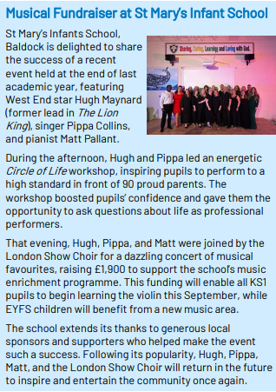
……………………………………………………………………………………………………………………………………………………
ERIC Reading – RECEPTION ONLY - 06.02.2026
ERIC (Everyone Reading In Class) Parents are invited to come in on Friday mornings at drop-off to read and share books with their child for 10–15 minutes.
……………………………………………………………………………………………………………………………………………………
Parent Courses
We have three online courses starting next week funded by HCC Targeted Parenting Fund. We have one course funded for Dads and male carers and two courses for mums, dads and carers who may need some additional support. We’ve had a good response however we do have a few places available particularly on our dad’s course. Would you kindly help us fill these places by sending on to your colleagues who may want to refer and to parents and carers. We have one online booking form now that can be used by professionals and parents and carers for all courses and bookings: https://forms.office.com/e/AhqfPJUW6T
- For Dads & male carers – Thursday evenings 7.00pm – 9.00pm 5 February – 26 March (excluding half term)
- For Mums, Dads & carers – Wednesday mornings 9.30am – 11.30am 4 February – 25 March
- For Mums, Dads & carers – Wednesday evenings 7.00pm – 9.00pm 4 February – 25 March
These fully funded 7-week term time courses can help with:
- Understanding how Feelings, Thoughts and Behaviour link together (including the stress response system)
- Understanding what may be influencing their child’s behaviour
- Responding to a range of feelings e.g. anger, frustration, anxiety, stress and worry
- Improving communication to build better relationships
- Building on strengths
- Learning strategies to help parents and their family feel safe
Confidential Parent/Carer Registration form 2025 - 2026
……………………………………………………………………………………………………………………………………………

Flag of the Week

Find the country and find a fact.
Reminder: Children may want to find the location of the country on a map, research traditions, food, culture or anything they find interesting. They don’t need to write anything down, just come ready with their fact. It should be quick and fun.
Kind regards,
Miss Markiewicz
……………………………………………………………………………………………………………………………………………










