Year | Subject | Autumn A | Autumn B | Spring A | Spring B | Summer A | Summer B
R | Phonics  Read Write Inc | Read Write Inc  Reading single letter sounds- Set 1 | Read Write Inc  Reading all set 1 sounds, blend sounds into words orally | Read Write Inc  Blend sounds to read words – read short ditty stories | Read Write Inc  Read Red story Books | Read Write Inc  Read green story books  Read some set 2 sounds | Read Write Inc  Read green or purple story books
R | Herts for Learning (HFL)  Essentials Writing | 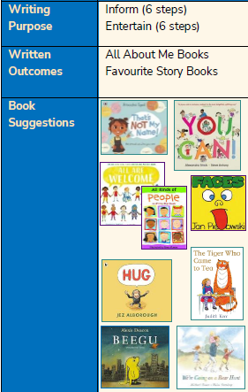 | 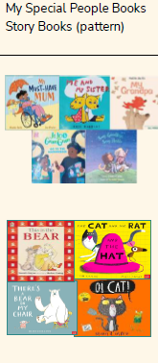 | 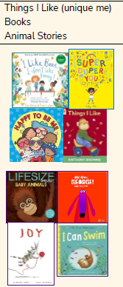 | 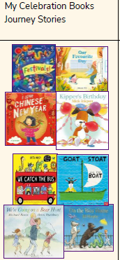 | 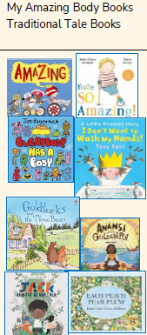 | 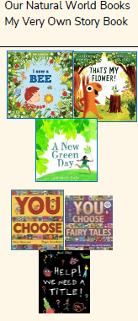
R | Additional Focus writing pieces |  | Winter clothing / Ernist Shackelton lists | Space and Luna New Year lists and labelling  Friendship topic - write a caption | Labelling plants, label toppings on a pancake, captions for growing a seed. | Write an invitation to a royal Teddy’s garden party  Label a coronation scene  Write a class Magna Carta (King John) | Make a story book  Dragon description  Write speech bubbles for the tortoise and the hare  Create a story map
R | White Rose White Rose Maths | Getting to Know You  Exploring provision/Understanding and using positional language  Just Like me  Matching/Sorting/Comparing amounts  Compare size/mass/capacity | It’s Me 1 2 3!  Representing/Comparing/Composition of 1 2 3  Circles and Triangles  Light and Dark  Representing numbers to 5  One more and less  Shapes with 4 sides  Time | Alive in 5!  Introduction to zero  Comparing numbers to 5  Composition of 4 and 5  Compare Mass/Capacity.  Growing 6 7 8!  6, 7 and 8.  Combining 2 amounts  Making pairs | Building 9 and 10  Counting to 9 and 10.  Composition of numbers to 10  Bonds to 10  3D Shapes  Patterns  Length and Height | To 20 and Beyond  Building numbers beyond 10  Counting patterns beyond 10  Spatial Reasoning  Match, rotate and manipulate  First Then Now  Adding more  Take away  Compose and decompose | Find my Pattern  Doubling  Sharing and grouping  Even and odd  Visualise and build  On the move  Deepening understanding  Patterns and relationships  Mapping
R | Understanding the World  Bold is PKC (Primary Knowledge Curriculum) | All About Me  My family, my school, my environment, the people around  me, people who help us.  Recycling week  Black History Month  Autumn | Transport: Past and Present  Modes of transport now, local transport, early transport including George Stevenson and the Steam Train, local transport in the past, exploring and travelling.  Diwali  Bonfire night – Guy Fawkes  Remembrance Sunday  Worries and being kind to others  Dental hygiene | Space  Our planet Earth, the moon, the sun, the planets in our solar system, space travel, astronauts, the International Space  Friendship  Winter  Birdwatch  Chinese New Year | Growing and Changing  Seasons, plants, what plants need to grow, how we grow and change, how animals grow and change, how things around us change.  Shrove Tuesday  World Book Day  Mother’s Day  Springtime | Kings and Queens  Our Queen, coronations, The Magna Carta, Buckingham Palace, London, locally significant areas in the past  World Earth Day  World Bee Day  Walk to school week | Stories from the Past/ Traditional Tales  Oral storytelling, how stories have changed over time. Fairytales, Myths, Legends and Fables.  Summer
R | Computing | See Knowledge organiser for Computing
R | DT | See progression of skills for: water play, mud and digging area, playdough area, creative area and small world area and construction area.
R | PE | PE within provision  Weekly Premier Education PE Sessions
R | PSHE Jigsaw | Being Me in My World | Celebrating Differences | Dreams and Goals | Healthy Me | Relationships | Changing Me
R | RE  Jigsaw and UC | What makes people special?  Creation | What is Christmas?  Christianity concept: Incarnation  Diwali | Celebrations  Holi  Chinese New Year | What is Easter?  Christianity concept: Salvation  Ramadan | What can we learn from stories?  Christianity, Islam, Sikh  Rosh Hashanah/ Yom Kippur | What makes places special?  Christianity, Islam, Judaism  churches, mosques and synagogues
R | Music | I’ve got a grumpy face  The sorcerer’s apprentice | Witch, witch  Row, row, row your boat | Bird spotting: Cuckoo Polka  Shake my sillies out | Up and Down  Five fine bumble bees | Down there under the sea  It’s oh so quiet | Slap clap clap  Bow, bow, bow Belinda
Y1 | Phonics  Read Write Inc | Read Write Inc  Groups appropriate to child’s reading level  Set 2i, 2ii, 3i and 3ii sounds
Y1 | Herts for Learning (HFL)  Essentials Writing | 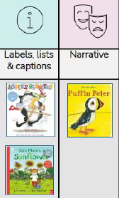 | 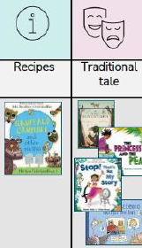 | 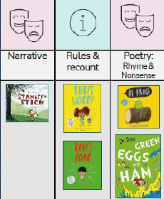 | 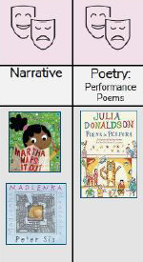 | 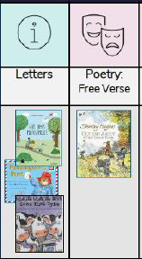 | 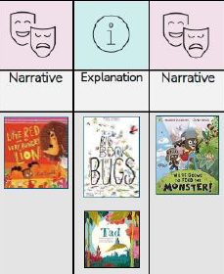
Y1 | Additional Focus writing piece linking to PKC | List, labels and captions- Label and write captions of the pyramids. (PKC History Discovering History) | Instructions- Directions for how to find places in the school- treasure hunt. (PKC Geography Spatial Sense) | Traditional Tales- Write a story based on Hansel and Gretel and the different landscapes.  (Geography- The UK)
Y1 | White Rose Maths | Place Value within 10 | Addition and Subtraction within 10  Shape | Place Value within 20  Addition and Subtraction within 20 | Place Value within 50  Length and Height  Mass and Volume | Multiplication and Division  Fractions  Position and Direction | Place Value within 100  Money  Time
Y1 | History  Primary Knowledge Curriculum (PKC) |  | Discovering History |  | Kings, Queens and Leaders |  | Parliament and Prime Ministers
Y1 | Geography Primary Knowledge Curriculum (PKC) | Spatial Sense  Around my School |  | The UK |  | The Seven Continents
Y1 | Art | Colour |  | Architecture |  | Sculpture
Y1 | Science Primary Knowledge Curriculum (PKC) | The Human Body | Animals and their Needs | Seasons and Weather | Taking Care of the Earth | Plants | Materials and Magnets
Y1 | Computing | Computing systems and networks: Improving mouse skills.  +Online Safety Lesson 1: The internet | Programming 1: Algorithms unplugged.  +Online Safety Lesson 2: Online emotions | Skills showcase: Rocket to the moon  +Online Safety Lesson 3: Always be Kind and Considerate | Programming 2: Bee-Bot  +Online Safety Lesson 4: Posting and Sharing | Creating media: Digital images | Data handling: Introduction to Data
Y1 | DT |  | Mechanisms (Moving Story Book) |  | Textiles: Joining Fabrics -puppets |  | Food: Fruits and Vegetable
Y1 | PE | Invasion Games | Gymnastics | Dance | Cricket | Tennis | Athletics
Y1 | Jigsaw PSHE | Being Me in My World | Celebrating Differences | Dreams and Goals | Healthy Me | Relationships | Changing Me
Y1 | RE  Jigsaw RE and Understanding Christianity | Creation  Who made the world? | Incarnation  Why does Christmas matter to Christmas? | Gospel  What is the good news Jesus brings? | Salvation  Why does Easter matter to Christians? | Judaism  Who is G-d to the Jews? | Judaism  Is Shabbat important to Jewish children?
Y1 | Music | Menu Song | Colonel Hathi’s march  Magical musical aquarium | Football | ‘Dawn’ from Sea Interludes  Musical conversations | Dancing and drawing to Nautilus  Cat and Mouse | Come dance with me
Y2 | Phonics  Read Write Inc | Read Write Inc  Groups appropriate to child’s reading level  Set 3i and 3ii sounds
Y2 | Herts for Learning (HFL)  Essentials Writing | 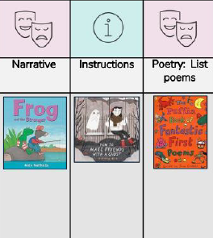 | 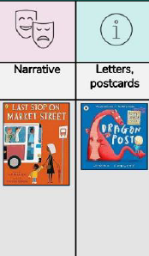 | 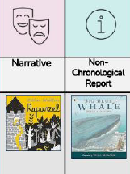 | 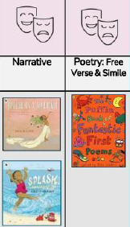 | 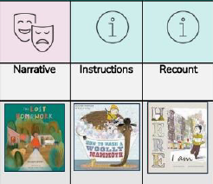 | 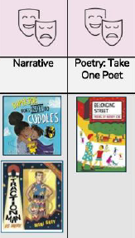
Y2 | Linked Writing piece linked to PKC |  | Write instructions for making a Roman pouch. (Romans in Britain - history topic and D&T sewing topic) | Write a postcard describing a part of the British Isles. (The British Isles, geography topic.) | Write a non-chronological report about a plant experiment. (Plants topic - science.) |  | Poetry writing about powerful voices from history.  (‘Powerful Voices’ - history topic.)
Y2 | White Rose Maths | Place Value | Addition and Subtraction  Shape | Money  Multiplication and Division | Length and Height  Mass, capacity and temperature | Fractions  Time | Statistics  Position and Direction  Consolidation
Y2 | History Primary Knowledge Curriculum (PKC) |  | The Romans in Britain |  | The Tudors |  | Powerful Voices
Y2 | Geography Primary Knowledge Curriculum (PKC) | Spatial Sense  Maps and globes |  | The British Isles  . |  | Northern Europe
Y2 | Art | Colour and Shape |  | Portraits and Self Portraits | History Painting
Y2 | Science Primary Knowledge Curriculum (PKC) | The Human Body | Living things and their Environments | Electricity | Plants | Materials and Matter | Astronomy
Y2 | Computing | Computing systems and networks: What is a computer?  +Online Safety: Posting online | Programming 1: Algorithms and debugging  +Online Safety Lesson 2 | Computing systems and networks: Word processing  +Online Safety Lesson 3: Who should I ask? | Programming 2: Scratch Jr  +Online Safety Lesson 4: It’s my choice | Creating media: Stop motion  +Online Safety Lesson 5: Is it true? | Data handling: International Space Station
Y2 | DT |  | Textiles-Pouches  (Unit 4 Kapow Planning) |  |  | Mechanisms: Moving Monsters  (Unit 5 Kapow Planning) | Food: A Balanced Diet  (Unit 2 Kapow Planning)
Y2 | PE | Invasion Games | Gymnastics | Dance | Cricket | Tennis | Athletics
Y2 | PSHE  Jigsaw | Being Me in My World | Celebrating Differences | Dreams and Goals | Healthy Me | Relationships | Changing Me
Y2 | RE  Understanding Christianity and Jigsaw | Creation  Digging Deeper  Who made the world? | Incarnation  Digging Deeper  Why does Christmas matter to Christians? | Gospel  Digging Deeper  What is the good news that Jesus brings? | Salvation  Digging Deeper  Why does Easter matter to Christians? | Judaism  Does visiting the synagogue help Jewish children feel closer to God? | Judaism  Are Rosh Hashanah and Yom Kippur important to Jewish children?
Y2 | Music | Tony Chestnut | Carnival of the animals  Composing music inspired by birdsong | Grandma rap | Orawa  Trains | Swing-a-long with Shostakovich  Charlie Chaplin | Tanczymy labada

