



Friday 24th October 2025
We are excited to be launching our new website, Watch this space.
……………………………………………………………………………………………………………………………………………………
Half Term
27.10.2025 – 31.10.2025
First day back Monday 03rd November.
……………………………………………………………………………………………………………………………………………………
Big Sing
Due to the success of the Big Sing, we will now be hosting this as a weekly event on a Friday, adults and children please join us in the gazebo to celebrate a successful week and sing our favourite worship songs.
……………………………………………………………………………………………………………………………………………………
Open Dates for Prospective Parents
04.11.2025 – Open Morning 09:30am
04.11.2025 – Stay and Play 03:30pm
18.11.2025 – Open Evening 04:00pm
https://forms.gle/hH6zzoR8hRA5NaAq8
……………………………………………………………………………………………………………………………………………………
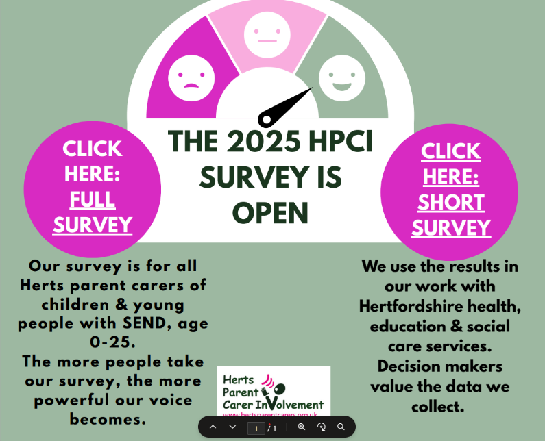
HPCI 4th Annual SEND Survey (2025)
The survey will close on Sunday 9th November 2025 at 11pm.
Please click the link below to take the survey
HPCI 4th Annual SEND Survey (2025)
HPCI Short Annual SEND Survey (2025)

……………………………………………………………………………………………………………………………………………………
……………………………………………………………………………………………………………………………………………………
Save the date
Thursday 11th December - Christmas disco 3.15-4.30pm
- Children can bring their disco clothes to change into at the end of the school day
- There will be new disco lights, bubble machines, mist machines and lots of dancing!
- Parents are not required to attend, we hope you may be able to enjoy some child free Christmas shopping time!
- Tickets will be on sale after half term.
……………………………………………………………………………………………………………………………………………………
Friday 5th December
We are excited to announce that we will be putting on the following event due to popular demand.
‘Assembly Blasters and Christmas Crackers’ 6.30pm led by our own talented musicians, I Rock, our Headteacher and Chair of Governors.
Come and join us for a casual, fun and festive evening of music and socialising.
Licensed bar will open at 6.00pm ready for a 6.30pm start.
Snacks available
We will be singing along to some best-known assembly tunes in the first half of the evening. After an interval we will have a festive sing along to lots of well-known Christmas songs. Take a look at this James B Partridge clip for what to expect
Bing Videos
Whether you want to just listen, join in or come and take a microphone, the evening is yours!
An evening of Christmas cheer for all our families, adults and children.
Ticket details will follow after half term.
We are looking for any parents among us who would like to volunteer some time to help us to create a band. We are looking for any parents (or contacts) who can play the guitar electric, acoustic and base. Please chat to Miss Edey if you can help. All money raised will go towards enhancing music within the school.
……………………………………………………………………………………………………………………………………………
Pupil Premium
Please visit www.hertfordshire.gov.uk/freeschoolmeals ,
call on 0300 123 4048 or speak to the school office to see if your child qualifies for the Pupil Premium Grant.
You can check your eligibility on the website linked above. The school receives additional funding if your child is eligible and can support with school uniform, cost of trips, paying for Premier Education Clubs and funding music lessons for your child.
........................................................................................................................................................
Calendar Dates
Please follow the link below which will take you to our school calendar. This is regularly updated for you all to refer to.
Term Dates & Calendar – St Mary's Church of England VC Infant School (stmarysinfants.herts.sch.uk)
……………………………………………………………………………………………………………………………………………………………………………………..
🧸💛 Give a bear a new beginning! 💛🧸
The team at Baldock Fireworks are collecting preloved teddies for the Teddy Tombola – and they’d love your help!
If you have a cuddly companion who’s ready for a new adventure, donate them to the tombola and let them bring joy to someone new. Whether they’ve been hugged, loved, or simply waiting on a shelf, every teddy deserves a second chance at snuggles. All funds generated at the stall will be donated to Lister Hospital’s Maternity Garden project.

📍 Drop-off: Anytime at 61 Hillcrest (SG7 6NF) or the School Office after Half Term.
☎️ Got loads?? Please message 07385601346 and they will arrange a collection.

Let’s rehome these furry friends and make the fundraiser un-bear-ably brilliant! 🐻

Have you got your tickets to the Baldock Fireworks yet? Link here: https://qrco.de/BaldockFireworks2025

#TeddyTombola #BearHugsForGood #TeddyRehoming #TombolaTime #tombola #CommunityCuddles #SupportLocalEvents #FundraisingFun #SecondChanceSnuggles


……………………………………………………………………………………………………………………………………………………………………………………..

