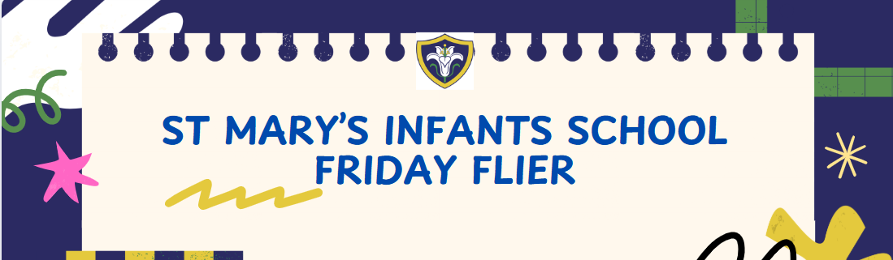



Friday 12th December 2025
Dates To Remember
Friday 19th December – Last Day Of Term – 1PM FINISH
……………………………………………………………………………………………………………………………………………………
Nativity
Wednesday 17th December - 1:30pm
Thursday 18th December - 09:30am
Doors will open on 17th December at 1pm for teas, coffees and snacks and from drop off on Thursday.
We have a few extra tickets available these will be first come first served. Please email admin with the day you would like and the name. We will email confirmation for these extra tickets.
Admin@stmarysinfants.herts.sch.uk

……………………………………………………………………………………………………………………………………………………………………………………..Pupil Premium
Please visit www.hertfordshire.gov.uk/freeschoolmeals ,
call on 0300 123 4048 or speak to the school office to see if your child qualifies for the Pupil Premium Grant.
You can check your eligibility on the website linked above. The school receives additional funding if your child is eligible and can support with school uniform, cost of trips, paying for Premier Education Clubs and funding music lessons for your child.
……………………………………………………………………………………………………………………………………………………
After School Clubs
School clubs have now finished. The new clubs will come out on Arbor next week.
Please only 1 club per child.
Premier Education Club
After School football club finishes on Thursday 18th December.
Next term premier education will be offering Gymnastics Club please see link below.
https://www.premier-education.com/parents/venue/courses/1775-932356/
……………………………………………………………………………………………………………………………………………………
Wonderful News
We’re delighted to share some wonderful news. Yesterday, Zebby and his Daddy had the honour of visiting The Queen with the Roald Dahl Nursing Team. He was invited to Clarence House to help decorate her Christmas tree. It was a truly special experience, and we’re very proud of him.
Keep an eye out for Zebby on the Royal Family’s Instagram account and in the news — you may spot him there soon!



