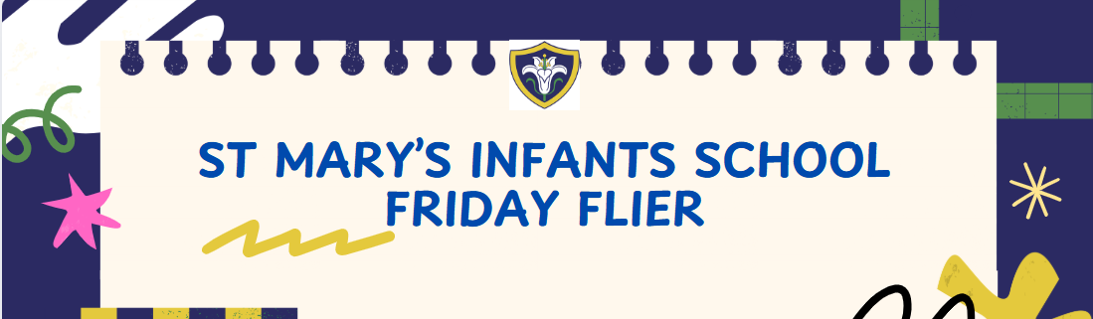



Friday 05th December 2025
Dates To Remember
Tuesday 09th December - iRock Concert (iRock Parents Only)
Wednesday 10th December – Christmas Lunch and Christmas Jumper Day
Friday 19th December – Last Day Of Term – 1PM FINISH
……………………………………………………………………………………………………………………………………………………
Assembly Blasters and Christmas Crackers’
TONIGHT
Tickets Still Available
https://www.ticketsource.co.uk/st-marys-infants-school
PASSWORD- CHRISTMAS2025
We are excited to announce that we will be putting on the following event due to popular demand.
‘Assembly Blasters and Christmas Crackers’ 6.30pm led by our own talented musicians, I Rock, our Headteacher and Chair of Governors.
Come and join us for a casual, fun and festive evening of music and socialising.
Licensed bar will open at 6.00pm ready for a 6.30pm start.
Snacks available
We will be singing along to some best-known assembly tunes in the first half of the evening. After an interval we will have a festive sing along to lots of well-known Christmas songs. Take a look at this James B Partridge clip for what to expect
Bing Videos
Whether you want to just listen, join in or come and take a microphone, the evening is yours!
An evening of Christmas cheer for all our families, adults and children.
We are looking for any parents among us who would like to volunteer some time to help us to create a band. We are looking for any parents (or contacts) who can play the guitar electric, acoustic and base. Please chat to Miss Edey if you can help. All money raised will go towards enhancing music within the school
……………………………………………………………………………………………………………………………………………………
Flu
The flu nurses will be in on Monday 8th December 10:30 - 12:00.
Please complete the below form if you haven't already. This will be the last opportunity.
Vaccination UK Bedfordshire Immunisation
……………………………………………………………………………………………………………………………………………………
Save the date
Thursday 11th December - Christmas disco 3.15-4.30pm
- Children can bring their disco clothes to change into at the end of the school day
- There will be new disco lights, bubble machines, mist machines and lots of dancing!
- Parents are not required to attend, we hope you may be able to enjoy some child free Christmas shopping time!
- Tickets are on sale now via Arbor £5 per ticket which includes a drink and snack.
……………………………………………………………………………………………………………………………………………………
Nativity
Please complete the following google form for Nativity Tickets.
Wednesday 17th December - 1:30pm
Thursday 18th December - 09:30am
https://forms.gle/2eQ1fDBmEh6iUHV89
……………………………………………………………………………………………………………………………………………………………………………………..Pupil Premium
Please visit www.hertfordshire.gov.uk/freeschoolmeals ,
call on 0300 123 4048 or speak to the school office to see if your child qualifies for the Pupil Premium Grant.
You can check your eligibility on the website linked above. The school receives additional funding if your child is eligible and can support with school uniform, cost of trips, paying for Premier Education Clubs and funding music lessons for your child.
……………………………………………………………………………………………………………………………………………………



