



Friday 14th November 2025
Please be reminded children should not be using the outside play equipment before or after school.
……………………………………………………………………………………………………………………………………………………
Open Dates for Prospective Parents
18.11.2025 – Open Evening 04:00pm
……………………………………………………………………………………………………………………………………………………
Christmas Craft Making – Parents Welcome - Friday 21st November
Christmas Tree Festival
We’re delighted to share that we’ll once again be entering a tree in this year’s Tree Festival – so exciting! Parents, we’d love you to help make decorations with your child in a festive craft session on Friday 21st November at 8.40am for about 30 minutes.
It’s a lovely way to start the season together and add your creations to our special ‘Communitree’ display.
We look forward to seeing you then. Please complete the below google form.
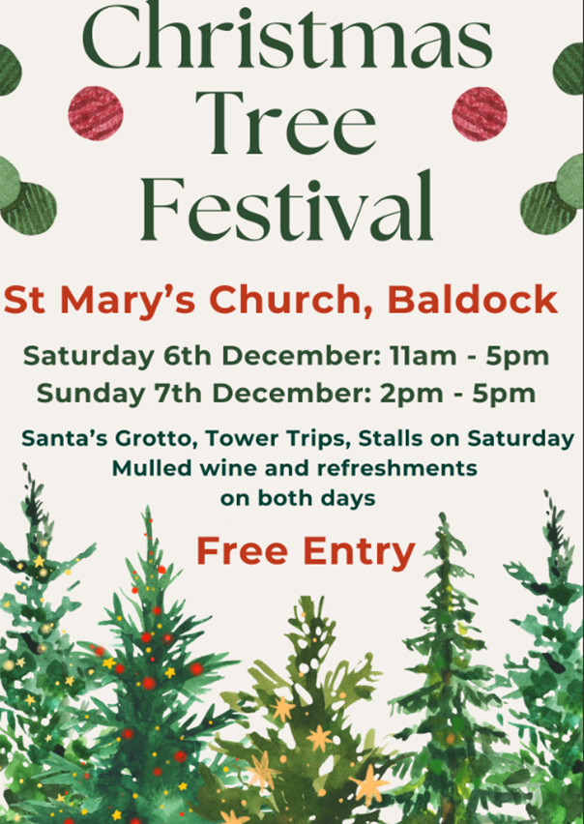
https://forms.gle/1vbuUJQjYRzBFL3u7
……………………………………………………………………………………………………………………………………………………
Big Sing
Due to the success of the Big Sing, we will now be hosting this as a weekly event on a Friday, adults and children please join us in the gazebo to celebrate a successful week and sing our favourite worship songs. This will also get us ready for our assembly blasters event on 5th December.
……………………………………………………………………………………………………………………………………………………
Friday 5th December
We are excited to announce that we will be putting on the following event due to popular demand.
‘Assembly Blasters and Christmas Crackers’ 6.30pm led by our own talented musicians, I Rock, our Headteacher and Chair of Governors.
Come and join us for a casual, fun and festive evening of music and socialising.
Licensed bar will open at 6.00pm ready for a 6.30pm start.
Snacks available
We will be singing along to some best-known assembly tunes in the first half of the evening. After an interval we will have a festive sing along to lots of well-known Christmas songs. Take a look at this James B Partridge clip for what to expect
Bing Videos
Whether you want to just listen, join in or come and take a microphone, the evening is yours!
An evening of Christmas cheer for all our families, adults and children.
We are looking for any parents among us who would like to volunteer some time to help us to create a band. We are looking for any parents (or contacts) who can play the guitar electric, acoustic and base. Please chat to Miss Edey if you can help. All money raised will go towards enhancing music within the school.
……………………………………………………………………………………………………………………………………………………
Save the date
Thursday 11th December - Christmas disco 3.15-4.30pm
- Children can bring their disco clothes to change into at the end of the school day
- There will be new disco lights, bubble machines, mist machines and lots of dancing!
- Parents are not required to attend, we hope you may be able to enjoy some child free Christmas shopping time!
- Tickets are on sale now via Arbor £5 per ticket which includes a drink and snack.
……………………………………………………………………………………………………………………………………………………

……………………………………………………………………………………………………………………………………………………
Pupil Premium
Please visit www.hertfordshire.gov.uk/freeschoolmeals ,
call on 0300 123 4048 or speak to the school office to see if your child qualifies for the Pupil Premium Grant.
You can check your eligibility on the website linked above. The school receives additional funding if your child is eligible and can support with school uniform, cost of trips, paying for Premier Education Clubs and funding music lessons for your child.
……………………………………………………………………………………………………………………………………………………………………………………..


