

St. Mary’s Church of England VC Infant School

‘Sharing, Caring, Learning and Loving with God’

St Mary’s Way
Baldock
SG7 6HY
www.stmarysinfants.herts.sch.uk
Tel: 01462 892347

Behaviour Policy

Policy Review:

This Policy will be reviewed by the staff annually

Reviewed | November 2025
Next Review | November 2026

Our Vision
We aspire to be a community living life in all its fullness. We share, care, learn and love with God, valuing the dignity and respect of all humanity and creation. Through the power of the Holy Spirit Jesus’ Kingdom comes and everyone can flourish together.
Our Mission
‘Sharing, caring, learning and loving with God.’
Our Values
Friendship, Perseverance, Respect, Trust, Thankfulness, Humility, Generosity, Forgiveness, Courage, Peace, Compassion, Responsibility
Our 6 Key ideals that underpin our vision
 | Uphold the Values of God
Nurture Creativity, Encourage Curiosity | Learning Together,  Flourishing Together | Connecting Communities
Stimulating
Surroundings

One
Message

Understanding our vision
Our 6 key ideals were created through the input of all stakeholders as being important factors in what we want from our school every day.
‘We aspire to be a community living life in all its fullness’ (John 10:10) Church of England vision for Education
‘Sharing, Caring, Learning and Loving with God’ (School’s mission statement)
‘Valuing the dignity and respect of all humanity and all creation’ (Reference to Jonah and the Whale and the Church of England vision)
‘Through the power of the Holy Spirit’ (The importance of the Holy trinity and that we can’t do it alone. We must work together.)
‘Jesus’ kingdom comes.’ (Themed verse, Lord ’s Prayer and the goal of the school for us to create a peaceful and successful kingdom)
Flourish: Achievement
Together: Community
1.1 Aims and expectations

St Mary’s is a happy and caring school. Our behaviour policy reflects the vision and aims by promoting the ethos of Hertfordshire Steps - all of our school community have the right to feel welcome, safe and supported. St Mary’s is committed to creating an environment where exemplary behaviour is at the heart of productive learning. Everyone is expected to maintain the highest standards of personal conduct, to accept responsibility for their behaviour and encourage others to do the same. We follow a therapeutic approach to developing positive behaviour in a variety of ways, aimed at developing internal discipline so that our children can go on to live successful lives as adults able to regulate their behaviour appropriately. We aim to teach positive behaviour rather than simply managing behaviour. We are committed to providing an inclusive environment in which individuals needs and feelings are understood and supported.

We recognise that all behaviour is a form of communication, and we endeavour to recognise and understand the behaviour that an individual may exhibit. We seek to understand and respond to children on an individual level, ensuring personalised and consistent responses which enable children to learn to effectively manage their own behaviour. We believe that positive, caring and trustworthy relationships are key to the success of our approach. At St Mary’s we recognise that experiences, feelings and behaviours are inextricably linked. We believe that positive experiences create positive feelings and positive feelings create positive behaviour. All staff need to know how to promote pro-social behaviour and how to manage difficult or dangerous behaviour. They also need to have an understanding of what behaviour might be communicating. All staff should focus upon preventative strategies and de-escalation rather than upon reactive strategies.
The school adopts a therapeutic approach to behaviour management.
School staff have received training in Therapeutic Approaches to Behaviour (TAB)

Policy Aim
• To create a culture of exceptionally good behaviour: for learning, for community life.
• To ensure that all learners are treated fairly, shown respect and to promote good relationships and self-confidence.
• To help learners be in control of their behaviour and responsible for the consequences of it.
• To build a community which values kindness, care and empathy for others
• To promote community cohesion through improved relationships.
• To ensure that excellent behaviour is a minimum expectation for all

St Mary’s School Rules
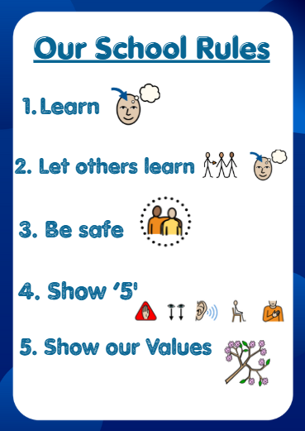
At St Mary’s we have consistent expectations of children across the school day, whether they are learning in the classroom, in the corridor, dining room or on the playground. These expectations are easily remembered with the 5 St Mary’s Rules.

Show 5
At St Mary’s we have consistent expectations of children across the school day, to get the attention of the children in any area of the school, staff members will say “5” while raising a hand to show 5 fingers. Children understand that when this is said they demonstrate that they can; Stop, Look, Listen, Posture, Respect to listen to the message or instruction from the adult.

Classroom Management
Classroom management is key to promoting positive behaviour. At St. Mary’s we expect all classrooms to have:
• A positive tone
• Clear set of class and school rules displayed which have been agreed by the class at the beginning of the year.
• Clear expectations about work and work that is set at an appropriate level for the child
• A clear and visual timetable so children know what is planned for the day
• An attractive, tidy, well-cared for environment
• A well-planned environment so that children can move easily, can find resources and know where property and resources belong
• Strategic seating arrangements for when children are working on the carpet or at a table
• Strategic lining up order for assemblies, playtimes and for other movement around the school
• Individually agreed approaches where necessary – agreed in consultation with the SENCO
• A network hand developed following on from an activity completed in class where all children choose who would be on their ‘network’ to talk to if they had a problem they needed to share
• Use of St Mary’s ‘show me 5’
• Use of 1-2-3 to manage movement around the classroom, for example from a carpet space to a table place – 1= stand, 2= move, 3= sit in new place

Strategies to acknowledge and encourage pro-social behaviour
Within the established positive leaning environment, children should expect to receive regular praise from all they come in to contact with. We aim to recognise children making positive choices. Strategies to acknowledge positive behaviour include:
• Verbal praise and encouragement, including recognition where the children have demonstrated learning behaviours, values or “shown 5”.
• Non-verbal praise – e.g. thumbs up
• Written remarks about successes in learning (based on knowledge about the standard that can be expected for each individual)
• Awarding dojo points
• Nominating pupils for a Headteachers learning or values achiever certificate or trophy shared within a weekly Celebration assembly.
• Sharing work or achievement with another member of staff
• Displaying child’s work or achievement
• Sharing work or achievement with a parent or carer at the end of the day

Strategies to respond to and de-escalate anti-social behaviour
When a pupil’s behaviour falls below an acceptable standard, a range of strategies may be used:
• Verbal and non-verbal reminders
• Praise positive behaviour of a child close by
• Remind of class rules
• Positive phrasing about the desired behaviour – clear instructions, with repetition. This provides children with processing and take up time.
• Move place of work/cooling off time/time away table
• Limited choices – this helps to encourage mutual respect and foster responsibility in the child: they choose from restricted choices and so still have some level of control
• Disempowering the behaviour – this may include tactical “ignoring” of unwanted behaviour and “catching them getting it right” at the earliest opportunity
• Time away from the classroom to support self-regulation
• Removal of stimuli, for example, moving other pupils to a different room.

Planned responses to escalating behaviour can include:
- Positive phrasing
- Distraction
- Limiting choice
- Disempowering the behaviour e.g. “you can listen from there”
- Consequences related to the incident.
Use of ‘Mittens’ (Guiding Hands) for Safety
- In incidents where a child’s behaviour presents a risk of harm to themselves, other pupils, staff, or school property, staff may use ‘mittens’ - a recognised low-level guiding technique - to support the safe movement of a dysregulated child.
- ‘Mittens’ refers to an adult’s open hands placed gently beneath the child’s upper arms, allowing the child to be safely guided to an alternative location to reduce the immediate risk of harm.
- The use of ‘mittens’ should only occur when de-escalation strategies have been exhausted, are judged unlikely to be effective, or when there is an imminent risk of harm to the child, others, or property.
- When a child has been guided away from an escalating situation using ‘mittens’, parents/carers will be informed at the earliest appropriate opportunity.
- In situations where the risk of harm is significant and immediate - such as a child moving towards a road with oncoming traffic - more direct physical intervention may be required to ensure the child’s safety. Physical intervention must only be used when the risk of not intervening outweighs the risk associated with intervening.

Consequences
Our approach to ensuring the best behaviour for all children is based on developing each child’s internal discipline therefore, it is important that they learn the logical consequences of their behaviour. Following an incident of unacceptable behaviour, a consequence may be given to a child. This may be a protective consequence, aimed at managing the risk of harm, or an educational consequence, focused on teaching so that the incident does not occur again.
Educational consequences may include:
• Completing work at a later time (this may involve missing part of a break time or work being sent home with the child to complete)
• Assisting with repairs or tidying
• Research
• Restorative meetings, writing a reflection or a letter of apology
• Communication with parents

Protective consequences may include:
• Time away from the classroom with a different member of staff
• Limiting access to outside space for a set period of time
• Suspension

Staff are discouraged from using group sanctions, as these are unlikely to follow the approach of a logical consequence. Through working closely and openly with pupils and their families, it is our aim at St. Mary’s to resolve behavioural issues at the earliest possible stage. Any incidents of unacceptable behaviour that have caused concern will be recorded on CPOMS and these are reviewed regularly by the SLT.

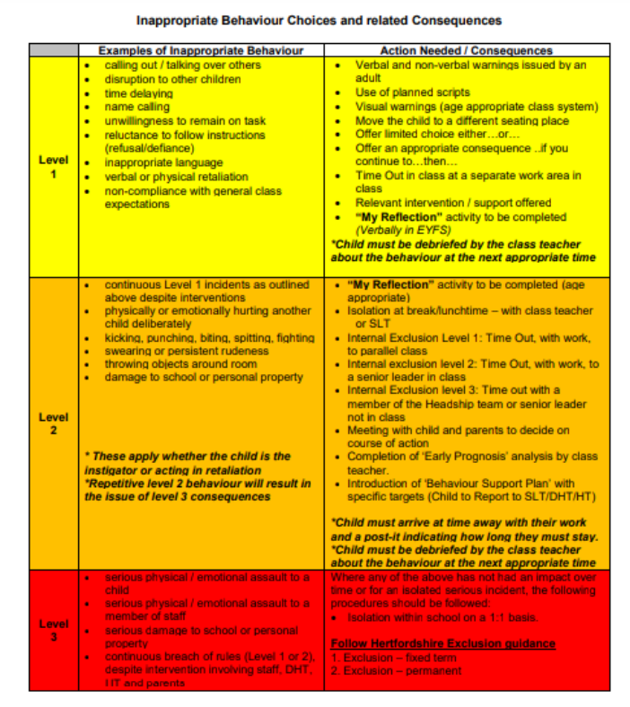

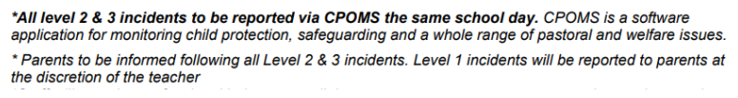

Post incident reflection, reparation and restoration
Following an incident of unacceptable behaviour, we will work with the pupil to reflect, repair and restore relationships as appropriate. The purpose of this is to revisit the experience, once calm, and learn from it. The process may be completed in a variety of ways, appropriate to the child’s age and learning style. For example, through comic strip conversations, role play with puppets. It involves,
• Telling the story of what happened
• Exploring what people were thinking and feeling at the time
• Exploring who has been affected and how
• Exploring how we can repair relationships
• Summarising what we have learned so we are able to respond differently next time

Zones of regulation One of the tools we use to support children in developing self-regulation skills, responding to and being aware of their emotions and feelings are the Zones of Regulation. Children are encouraged to monitor how they are feeling and apply relevant strategies, with support, to help them get back to the Green zone.

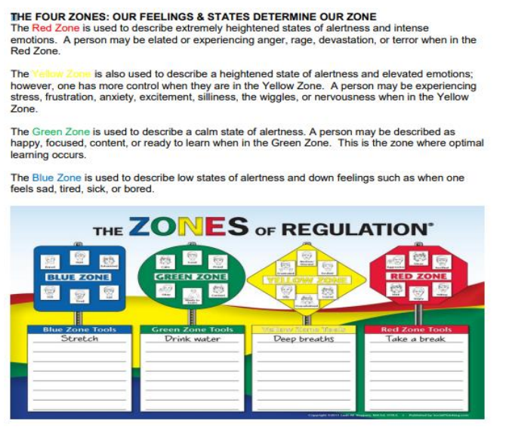

Anti-bullying
The school believes that nobody has the right to hurt other people by hitting or kicking them, calling them names, spreading rumours about them or by doing anything else that is intended to be upsetting.

All children have a right to learn in a supportive and caring environment without the fear of being bullied. Bullying is wrong and it will not be tolerated at St. Mary’s. We do everything in our power to ensure that all children attend school free from fear and discuss bullying on a regular basis, in various forums, throughout the school year. All children are encouraged to have a ‘network’ of adults to whom they can turn for support of any kind. This is reinforced during PSHE lessons, where children create a network hand to remind them of their support network. If we become aware of any bullying taking place between members of a class, we deal with the issue immediately by following the anti-bullying policy. Please refer to our Anti-bullying policy.

Personalised Plans Some pupils will require an individual approach that differs from the whole school policy. In this case an assessment of the child’s needs is undertaken, with an aim to develop an understanding of the child’s behaviour. A number of tools may be used including:
• Roots and Fruits – to explore the links between experiences, feelings and behaviour
• ABCC charts (antecedent, behaviour, communication and consequence) to look at triggers and patterns of behaviour
• Anxiety maps
A Risk Management Plan will be put in place, in conjunction with parents/carers and external professionals, for all staff to follow – this will ensure consistency and will be matched to pupil needs. This will be regularly reviewed and amended.

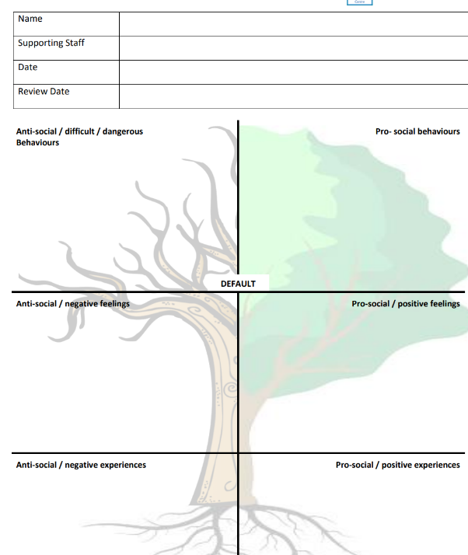

Notes on Sanctions and the Safety of Children
• Support from another adult in the case of an emergency can be gained by calling for help using the walkie talkie in the classroom.
• Physical punishment is forbidden at all times and in all circumstances. Only in exceptional circumstances will school staff have to physically intervene with a child – this would only ever be to prevent them from hurting themselves or others (please see above). This will always be with regard to DfE and LA guidelines and is to be avoided, wherever possible, by getting to know our children well so we can pre-empt and de-escalate such behaviour before it gets to such a level. Parents will always be informed if this becomes necessary and it must be logged on CPOMs.

The role of the class teacher
To ensure that a positive learning environment is implemented in their class, and that high expectations ensure children behave in a positive and responsible manner during lesson time. Positive and appropriate behaviour is acknowledged, praised and rewarded.

To treat each child fairly and follow the behaviour policy consistently. To treat all children with respect and understanding. Inappropriate behaviour is addressed discretely and privately, avoiding shouting and humiliation.

To report to parents about the progress of each child in their class, in line with the whole school policy. The class teacher will contact a parent at an early stage, if there are concerns about the behaviour or welfare of a child.
To use ‘circle-time’ and Pupil Voice sessions as an opportunity for children to gain life skills and confidence in giving their views and listening to the views of others. It may be used to address such behaviours as bullying and feelings within a safe and respectful environment.
The role of the SLT
To implement the school Positive Behaviour policy consistently throughout the school, and to report to governors, when requested, on the effectiveness of the policy. It is also the responsibility of the SLT to ensure the health, safety and welfare of all children in the school. To support the staff by implementing the policy as a role model, by setting the standards of behaviour and by supporting staff in the implementation of the policy with consistency and clarity.
To be alerted to records of all reported incidents of misbehaviour on CPOMs.
To plan for children who find the behavioural expectations particularly challenging to adhere to.
The Headteacher has the responsibility for giving fixed-term suspensions to individual children for serious acts of unacceptable behaviour. For repeated or very serious acts of anti-social behaviour, the Headteacher may permanently exclude a child. Both these actions are only taken after the school governors have been notified.
Children at risk of exclusion due to consistent disruptive behaviour will have an Individual Risk Management Plan (IRMP) written and agreed by the school and, sometimes, external agencies. Parents and pupils are always involved in this process that will clearly set out the school expectations together with agreed rewards and sanctions.

The role of parents
To work collaboratively with the school, so children receive consistent messages about how to behave at home and at school.
To abide by the home-school agreement in the school prospectus.
To support their child’s learning, and to co-operate with the school, as set out in the home–school agreement. We try to build a supportive dialogue between the home and the school, and we inform parents immediately if we have concerns about their child’s welfare or behaviour.
If the school has to use consequences with a child, parents should support the actions of the school. If parents have any concern about the way that their child has been treated, they should initially contact the class teacher or phase leader. If the concern remains, they should contact the head teacher and then the Governors. If these discussions cannot resolve the problem, a formal grievance or appeal process can be initiated.
The role of governors
The governing body has the responsibility of setting down these general guidelines on standards of discipline and behaviour, and of reviewing their effectiveness. The governors support the Headteacher in carrying out these guidelines.
Suspension and exclusion
Where a child’s behaviour causes significant concern and the range of strategies outlined above has failed, we will follow guidance set out in the current LA and DfE Exclusions Guidance.
Good discipline in schools is essential to ensure that all pupils can benefit from the opportunities provided by education. The Government supports headteachers in using exclusion as a sanction where it is warranted. However, permanent exclusion should only be used as a last resort, in response to serious or persistent breaches of the school's behaviour policy; and where allowing the pupil to remain in school would seriously harm the education or welfare of the pupil or others in the school.
Only the Headteacher (or Acting Headteacher) has the authority to suspend or exclude a pupil and this must be on disciplinary grounds. A pupil may be suspended for one or more fixed periods (up to a maximum of 45 school days in a single academic year), or permanently. A fixed period suspension does not have to be for a continuous period. In exceptional cases, usually where further evidence has come to light, a fixed period suspension may be extended or converted to a permanent exclusion.
The Headteacher could lawfully suspend/exclude a pupil if that pupil:
• repeatedly failed to follow academic instruction; or
• repeatedly and persistently breached the school’s behaviour policy.
Even if the offence that has immediately led to the exclusion would not have normally constituted a serious enough breach on its own, a child can still be excluded if it is part of a wider pattern of anti-social behaviour.
When considering whether to exclude, the Headteacher would take account of any contributing factors identified after an incident of anti-social behaviour has occurred – for example, where it comes to light that a pupil has suffered bereavement, has mental health issues or has been subjected to bullying.

If a child consistently behaves inappropriately at lunchtime, an afternoon suspension may be made, whereby the parent/carer will need to collect their child at 12:00. The procedure for such a suspension takes the same form as a fixed term suspension and parents will be informed in writing, as well as by phone or in person. As this will result in a child missing lessons, in addition to lunchtime, other means of positive behaviour management must be tried before a suspension is imposed. Eg other in-school arrangements at lunchtime for that child. Parents are able to take children home for lunch voluntarily, collecting at 12:00 and returning at 1:00pm.
An ‘informal’ suspension involves a child being sent off the school premises, without this being officially recorded as suspension (e.g. where a child is sent home for a ‘cooling off’ period). It is unlawful for a child to be informally excluded from school, even where the child’s parent/s or carer/s agree to this.
There are certain groups of pupils with additional needs who are particularly vulnerable to suspension. This includes pupils with an Education, Health & Care Plan (EHCP) and ‘looked after’ children.
The Headteacher would, as far as possible, avoid permanently excluding any pupil with an EHCP or a ‘looked after’ child. St Mary’s Infants School would engage proactively with parents in supporting the behaviour of pupils with additional needs. In relation to ‘looked after’ children we would co-operate proactively with foster carers or children’s home workers and the Local Authority that looks after the child.
7.10 Where St Mary’s Infants School has concerns about behaviour, or risk of suspension, of a child in one of these vulnerable groups, the Headteacher would, in partnership with others (including the Local Authority as necessary), consider what additional support or alternative placement may be required. This should involve assessing the suitability of support for a pupil’s SEN. Where a pupil has a statement of SEN or EHCP, we would consider requesting an early annual review or interim / emergency review.
In the unfortunate event of suspension/exclusion being necessary the school will let the parent/carer of the pupil know as soon as possible and will follow up with a letter stating why, and for how long, the child is suspended. The parent/carer should also be told how to challenge the suspension if they wanted to. Suspension would start at the discretion of the Headteacher and may start on the same day as the ‘offense’ but it is unlikely that the school would insist on the pupil being collected straight away.
The Governing Body itself cannot either suspend a pupil or extend the suspension period made by the Headteacher.
The suspension/exclusion may only be for a fixed term, or it may be permanent (expulsion). In all cases parent/carers have the right to appeal and if this is the case they should contact the local education authority.
The Governing Body can select a discipline committee made up of three members; this committee would consider any suspension/exclusion appeals by parent/carers on behalf of the Governors.
When an appeals panel meet to consider a suspension or exclusion they consider the circumstances under which the child was suspended/excluded, consider any representation by parents and the LA and consider whether the child should be reinstated.
The Governing Body has a duty to consider parents’ representations and will do so in strict accordance with DfE guidelines on the procedure to be followed. The Department for Education publishes up-to-date guidance on suspension and exclusion and the Governors at St Mary’s Infants School would always adhere to this.
If the Governors’ appeals panel decide that a child should be reinstated the Headteacher must comply with the ruling.
Monitoring
The SLT monitors the effectiveness of this policy on a regular basis, reporting to the governing body on the effectiveness of the policy. Equal opportunities are considered in all aspects of implementation and monitoring.
The school keeps a variety of records of incidents of misbehaviour on CPOMs.
The Headteacher keeps a record of any pupil who receives a fixed term suspension or permanent exclusion. It is the responsibility of the governing body to monitor the rate of exclusions, and to ensure that the school policy is administered fairly and consistently and in line with equal opportunities.
Review
The staff and governing body review this policy every year. The staff and/or governors may, however, review the policy earlier than this, if the government introduces new regulations, or if the governing body receives recommendations on how the policy might be improved. It is reviewed and discussed by staff at the beginning of each academic year and at intervals within, should the need arise.

