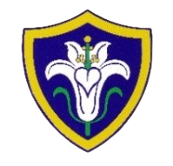
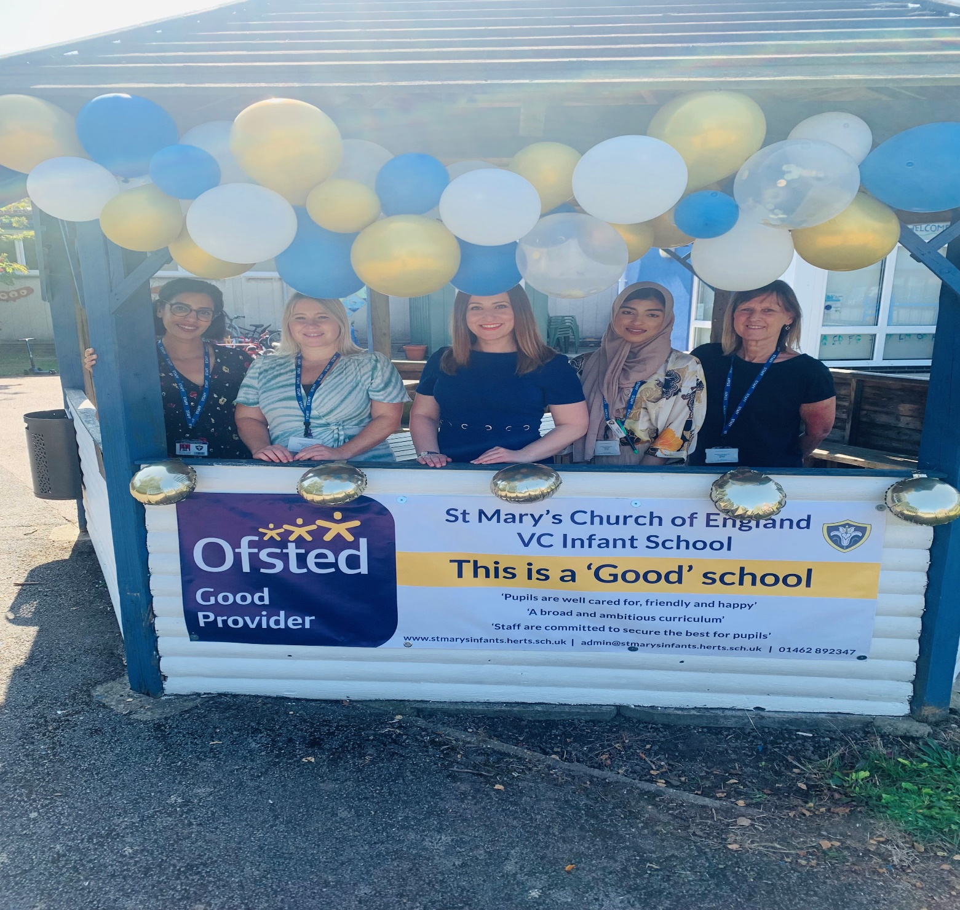
St Mary’s C of E (VC) Infants School
Sharing, Caring, Learning & Loving with God

Prospectus 2024-25

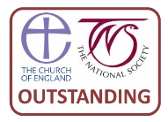
“The vision, inspiration and commitment of the headteacher, senior leaders and governors creates the best opportunities of all children within a Christian learning environment”
SIAMS Inspection 2016

“Pupils are well cared for, friendly and happy.”
“A broad and ambitious curriculum.”
“Staff are committed to secure the best for pupils.”
Ofsted Inspection 2023



A Welcome from our Headteacher

Dear Parents/Carers,
A very warm welcome to St Mary’s Church of England Infant School.
St Mary’s is a friendly, welcoming school where every child’s personal and academic development and wellbeing is important. We are a Church of England Voluntary Controlled School based in the west of Baldock and we accept children from Reception until Year 2.
Our dedicated staff are committed to ensuring that each child is valued. Our role is to ensure that every child is treated as an individual and that they are given the skills needed to achieve their full potential and flourish. We aim to provide a stimulating and caring ethos and environment in which children can gain life experience, understanding of the world and develop their own talents and abilities.
The school is set in picturesque grounds on the west side of Baldock, offering excellent resources, facilities, and smaller than average classes. Our caring team work closely together to create a secure, safe and caring environment in which pupils can develop, grow and flourish. Our playground provides areas for busy and quiet play, whilst the fields allow children to be active and healthy.
We very much look forward to sharing with you the next exciting stage in your child’s development and we aim to provide a successful and memorable educational experience. We hope that the time your child spends with us will be happy, stimulating and rewarding and that you and your child will feel a valued member of our St Mary’s family.
Your sincerely

Verity Edey
Headteacher

Our Mission, Values & Vision
Our Mission
‘Sharing, Caring, Learning and Loving with God.’
Our Values
Friendship Perseverance Dignity Respect Trust Thankfulness Humility
Generosity Forgiveness Courage Peace Compassion Responsibility
Our Vision
We aspire to be a community living life in all its fullness. We share, care, learn and love with God, valuing the dignity and respect of all humanity and creation. Through the power of the Holy Spirit Jesus’ Kingdom comes and everyone can flourish together.

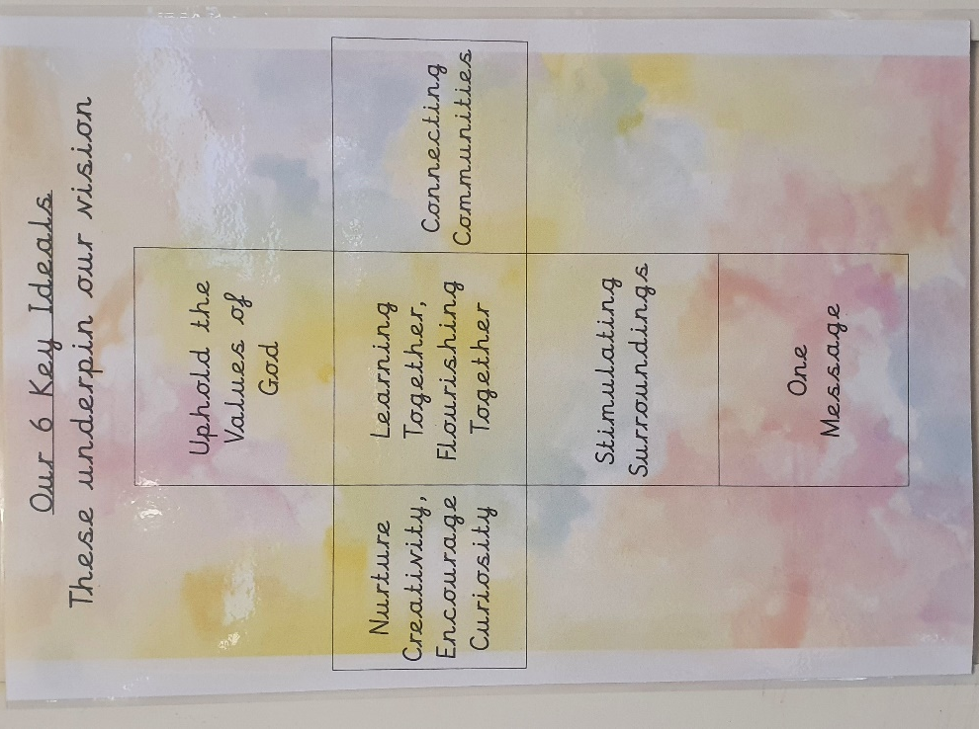
All About Our School
St Mary’s Infants School is a two-form entry school, with classes organised by year group. Class sizes range throughout the school, depending on the intake. On average, there are 22 pupils per class.

Our school has a long history of providing an education to local families and was established in 1873 on Park Lane in Baldock, by the Diocese of St Albans. After nearly 80 years, the school moved from its humble beginnings to the current building on St Mary’s Way in 1951. A further extension was built in 2016 adding the new school office and the Holly Blue Children’s Centre.

Shortly after we moved to these premises, the famous Czech artist, Franta Belsky, gifted the school a sculpture based on the poem “The Owl and the Pussy Cat”, by Edward Lear. His sculptures also appear under the clock tower in Stevenage and in Trafalgar Square, London. Our roots are important to us, and we continue to work in collaboration with the Embassy of the Czech Republic.

We are very lucky to enjoy a close relationship with St Mary’s Church. The children attend church services for key events in the school and church year, including the Harvest Festival, Christmas and Easter. There is also a weekly Collective Worship in the school hall taken by the Vicar of St Mary’s and invitational daily collective worship. We hold celebrations of successes weekly.
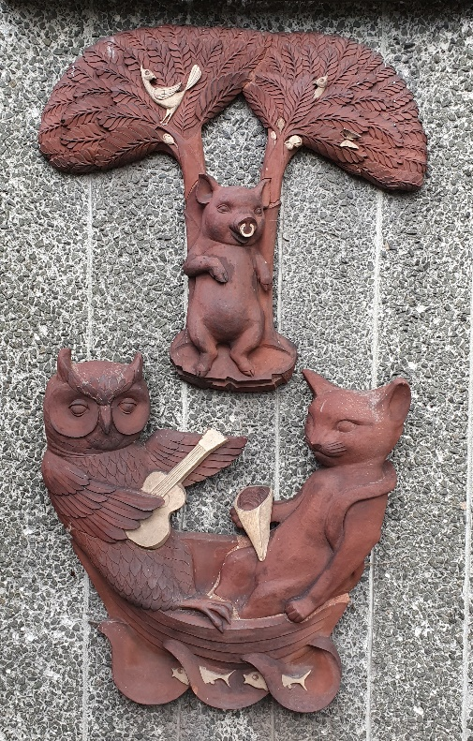
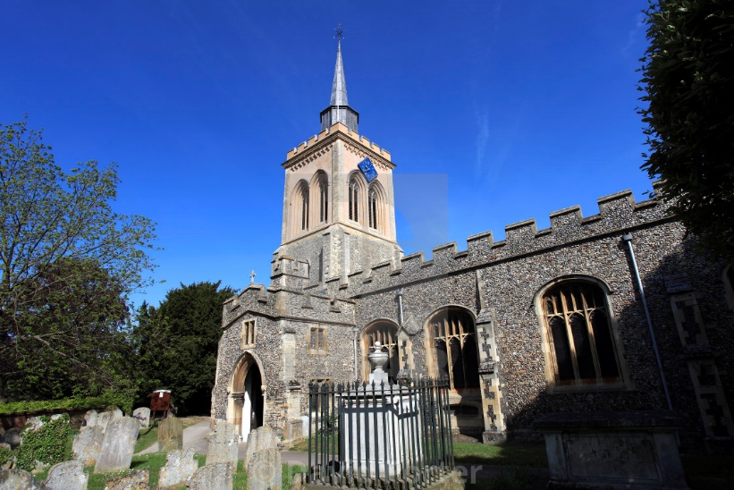
Our Children
At St Mary’s, every child is important. Being a small school, we can get to know each child extremely well. Our class sizes mean we can identify and meet the needs of our children in a more tailored way and can ensure all children are supported and challenged accordingly.

It is very important to us that every child is valued and that their individual qualities are recognised and celebrated. We work hard to build trusting relationships with all children and their families to ensure their engagement and enjoyment in every aspect of school life.

Children may experience a range of needs at different stages during their time at school. We have learning intervention strategies, pastoral support and a qualified Senior Leader and Special Educational Needs Co-ordinator that help all children feel supported and stretched, which enable them to reach their full potential.

We promote a values-based education and a caring ethos in our school, in which all children value and support each other. They work together as a learning community, recognising the strengths of one another and knowing that everyone is unique in their own way.

Reception
Children are admitted into Reception in the September of the academic year in which their fifth birthday falls. We realise the importance of the children having a smooth transition and them feeling confident and settled in their new surroundings. Our transition processes are based on the best interests and needs of the children and are guided by dialogue with our Early Years Adviser from Herts for Learning. We get to know the children in their current settings prior to starting school, meet the parents to explain the transition process and suggest ways that they can support their child to have a smooth transition. We also provide a transition pack to use through the summer holiday to prepare the children for starting school. We adopt a staggered approach when children start Reception in September.
Our setting has been planned to ensure that it is an enabling environment that allows the children to have a deep level of engagement in the activities that they choose to access. It includes: woodwork, bikes, climbing frames, reading areas, writing opportunities throughout, role play areas, rolling snack where the children have to use plates and are responsible for washing and drying them after use, maths resources are available throughout, sewing, playdough, gardening, small world play, construction, arts and crafts and more.
We plan in the moment, which is all about seizing the moment for children to progress. Based on what the children are already deeply involved in, this way of planning relies on skilled practitioners using quality interactions to draw out the children’s knowledge and build on it there and then (in the moment). This means that the practitioner uses skills to observe what the child is doing and needs to do next, assesses the teachable moment from the child’s perspective and be skilled enough to know when to intervene and when to stand back and observe. Planning in the moment is all about capturing the moment of engagement and running with it to make sure the children progress.
Child-initiated learning has an important role in children's learning and development, because children explore and learn from their own thoughts and ideas through the freedom and creativity that child-initiated play enables. We have named our child-initiated learning time ‘Grow Time’ as the children are developing, allowing them to flourish into growth mindset learners.

Children follow the Early Years Foundation Stage curriculum with a focus on play and practical experience. Learning focuses on the following areas:
- Personal, social and emotional development
- Communication and language
- Physical development
- Literacy
- Mathematics
- Understanding the world
- Expressive arts and design
Pupil Voice
Eco Warriors - Being a St Mary’s Eco-Warrior offers pupils the exciting opportunity to develop leadership skills, to positively impact our school’s eco-footprint and to improve the lives of all within our wider school community. Our Eco-Warriors become more aware of our local wildlife and build a conscientious and responsible attitude towards protecting it. Eco-Warriors are an integral part of our school and truly reflect our ethos.
Each class has 2 elected Eco-Warriors.

Pupil Parliament - Being part of the Pupil Parliament promotes pupil leadership opportunities, enabling children to develop valuable communication, organisation and debating skills through key roles of responsibility and new experiences. Pupil Parliament benefits the whole school, pupils and teachers because it provides opportunities for pupils to communicate their opinions as well as influence the decisions that are made on their behalf. Pupils relish the opportunity to become a greater part of school life and enjoy making their voices heard.
Each class has 2 elected members of the Pupil Parliament.

Worship Acolytes - The role of Worship Acolyte allows the children to take an active role in delivering worship and feeding back evaluations of worship on behalf of the rest of the class. They are responsible for helping to share and teach the vision, values and mission of the school to others.
Each class has 2 elected Worship Acolytes.

House Captains - Every child in the school is placed into a ‘House’ team – Rowan, Sycamore, Hazel, Horse Chestnut, or Oak – and they earn house points by displaying one of 12 learning behaviours. House teams encourage children to support each other and work as a team, not as individuals. The team with the most points earned each week is celebrated in the achievement assembly and they have their house leaf displayed on the House Team trophy.
Each team has a captain elected from Year 2.
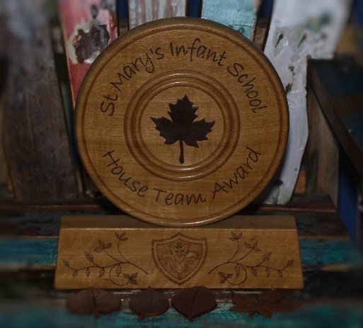
Our Curriculum
At St Mary’s, we believe in creating a broad and balanced curriculum which is knowledge rich and where they can develop lifelong learning skills. Children may work and learn as a whole class, in small groups or independently, depending on the activity. Our focus is on ensuring that essential skills are taught and embedded sequentially through your child’s time within our school, so that they can be confident, knowledgeable, and resilient learners.
Maths and Literacy lessons are taught daily. Religious Education is embedded throughout our school and is also taught within weekly sessions. Children can develop and apply a broad range of skills through our enquiry-based approach to learning, which encourages them to develop independence and self-motivation.
Music is an important part of the curriculum and features strongly at St Mary’s. Our Headteacher is passionate that children have enriched opportunities in this area to develop confidence and support well-being. The children are introduced to music, mainly through singing and movement, by our peripatetic music teacher. Children in Year 2 also learn to play the recorder. We have a pupil rock band led by professional musicians, choir, recorder club and many musical enrichment opportunities.
The promotion of healthy physical development is also an important part of a child's education, not only in terms of individual fitness but also through experience of teamwork and co-operation. Our specialist PE coaches ensure that pupils develop their skills in movement and coordination across a range of PE activities and sports.
Finding a Balance in Learning
We believe that learning is more than a classroom experience. We utilise our expansive outdoor space to provide outdoor learning opportunities. We further enrich the curriculum by planning exciting trips linked to year group topics and provide several after school clubs run by external professionals in their field. Our teaching staff are also committed to providing pupils with access to clubs, some of which are free for all to attend.
Our curriculum also includes Forest Schools education in early years which is an opportunity for pupils to take risks, develop problem solving skills and develop confidence while being at one with nature.

Working with Home
We are committed to a strong partnership with parents and carers. The principal mutual concern of this partnership is the social and academic progress of our children.
We ask that parent/carers support children on their educational and pastoral journey. First and foremost, we ask that parent/carers read with children each day. Home learning will be set that is appropriate for your child’s age and stage of learning and we appreciate parent/carers supporting their child to undertake this as these impact on a positive, reinforced learning experience.
Parent’s Consultations are held in the Autumn and Spring terms each year. You will be invited to book an appointment with your child’s teacher to discuss their progress. Additional meetings are held across the year for pupils with SEND.
If you have a particular concern regarding your child’s well-being or progress, we always actively encourage you to make an appointment with their class teacher at any point during the school year so these can be addressed.
Enrichment
Our curriculum extends beyond the National Curriculum and includes a wide range of enriching experiences and opportunities both within and beyond the school day. The school takes pride in providing a highly inclusive environment, where learners demonstrate high levels of enjoyment in their education and make very good progress across the curriculum. Children at all levels are helped to achieve their potential. Those who are most able are challenged and supported through being offered tasks which provide opportunities for greater depth and those who struggle are encouraged and given targeted, scaffolded support to embed skills, to develop at their own pace or simply to learn in a style that best suits their individual needs. Educational visits are carefully planned to enhance children’s learning experience and external visitors also enrich children’s learning providing exciting workshops, talks and interactive activities.
In addition to our exciting and stimulating cross-curricular themes, we also provide further opportunities to enhance children’s learning wherever possible. Throughout the year, themed days/weeks are woven into the curriculum to extend the breadth and balance of opportunities we offer our pupils. These include Anti-bullying Week and Safety Day, Creative Arts Week, World Book Day, Black History Month, Sport & Health Week, Science Day, Cultural Day, Community Day, European Day of Languages, National Museum Day, RE Days and others.
Visitors have a valuable role to play and can contribute to many aspects of the life and work of the school. They deliver talks, workshops, and full day activities across a wide range of subjects, giving pupils access to outside experiences and expertise. Visitors provide a link with the wider community – children can work alongside artists, musicians, authors, health professions and others.
Trips include class visits aimed at bringing learning alive and providing first-hand experience and bringing learning alive At St Mary’s. We strongly believe in the power of educational visits in bringing learning to life and enhancing interest, enthusiasm and achievement for all children. Our visits aim for children to acquire an awareness of the world around them, an understanding of how life works and a language with which to explain it all. This cultural capital provides a solid foundation on which pupils can build further knowledge, skills and understanding. Educational visits link closely to the corresponding Learning Journey sequence.
Extra-Curricular Activities
A wide variety of after-school and lunchtime clubs are run on a voluntary basis by teachers, as well as by outside providers. These change regularly and can include: Cooking, Sports, Lego, Art, Eco Club, Choir, dance to name but a few. We also have a school I’rock band.

Meeting Children’s Needs
Special Educational Needs
St Mary’s is an inclusive school and offers equal opportunities for all pupils with Special Educational Needs (SEN), however these may present themselves. We encourage all children to work to their full potential and a programme of early intervention and targeted support aims to ensure pupils make the best possible progress.
We have an onsite speech and language professional who works with individuals and groups to provide intervention and support.
Every child is an individual and they all develop and learn at different rates. You, the parent, or the class teacher may first raise concerns and it is important we discuss things together. Our Special Educational Needs Co-Ordinator (SENCO) assists class teachers in identifying needs and developing provision and strategies for individual pupils. When necessary, help and advice is also sought through working in partnership with outside agencies.

The class teacher may arrange individual or group support to meet a child’s needs. Where necessary, a personal plan will be written by the school, in consultation with parents.
Inclusion
The progress of all children in the school is monitored closely, including additional monitoring across a variety of groups:
- Children who are eligible for the Pupil Premium Grant
- Second language speakers
- All ethnic groups
- Children with disabilities
- Children with Special Educational Needs
- Children who are Young Carers
- Children who have ever had or currently have a social worker
- Children who have poor attendance
At St Mary’s, everyone works to make sure all learners feel welcome and valued, and that they get the right support to help them develop their talents and achieve their goals.
Pastoral Care
We are very fortunate to have dedicated time from staff in school to focus on the pastoral needs of our pupils and their wellbeing. They also ensure the most disadvantaged pupils have full access to the educational and extended school opportunities we have to offer and to help them overcome barriers to learning and participation. We have a trained mental health leader in school to support both adults and pupils, as well as a Family Support Worker.
Equality Statement
At St Mary’s, we are committed to ensuring equality and equity of opportunity for all pupils, staff, parents and carers irrespective of race, gender, disability, belief, sexual orientation, age, or socio-economic background. We aim to provide a school environment that promotes the educational progress and achievements of all pupils. We recognise that to do this we need to make each pupil feel confident that they have a positive and unique contribution to make to the school community, and that this contribution will be both recognised and respected by all the members of the school community.
At St Mary’s, we believe that diversity is a strength which should be respected and celebrated by all those who learn, teach and visit us.
We would very much like to welcome you and your child into our St Mary’s family.
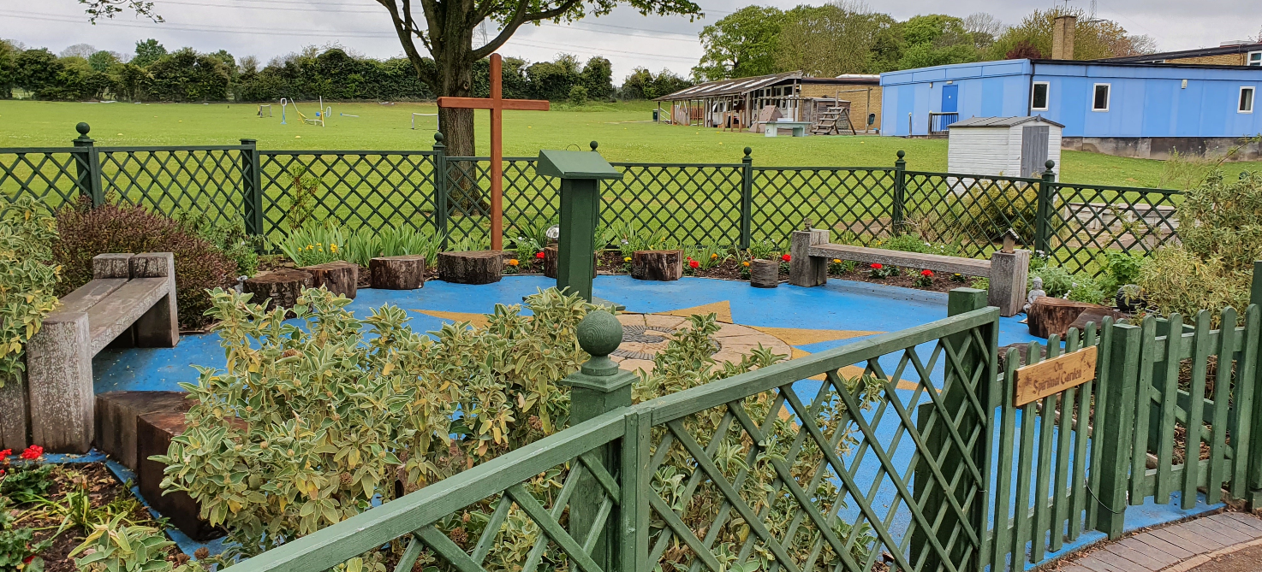
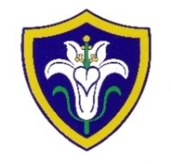
St Mary’s Church of England (VC) Infants School
St Mary’s Way
Baldock
SG7 6HY

Tel: 01462 892347
W: www.stmarysinfants.herts.sch.uk
E: admin@stmarysinfants.herts.sch.uk

