



Friday 18th September 2026
……………………………………………………………………………………………………………………………………………………………………………………
SCHOOL LUNCH
MONDAY 21ST SEPTEMBER
Lunch will be cold options on please log on to school grid and change this.

Dates for Prospective Parents
Stay and play 23/11 - 3.30
Open morning 11/11 - 9.30am (Head's talk, tour and then up to the Juniors)
Open evening 17/11 - 3.45pm (Head's talk, tour and then up to the Juniors)
……………………………………………………………………………………………………………………………………………………………………………………
FLU
The school nursing team will be visiting the School on Monday 21st September to administer the Nasal Flu for children that have completed the consent form. If you have not done this, please follow the link the nursing team sent out.
……………………………………………………………………………………………………………………………………………………………………………………
School Uniform
Please be reminded that our school uniform is WHITE polos only, no blue.
……………………………………………………………………………………………………………………………………………………………………………………
Gold the Attendance Teddy
Gold the Attendance Teddy will be spending the week with Gold the Attendance Teddy will be spending the week with
SATURN CLASS

……………………………………………………………………………………………………………………………………………………………………………………
iRock
Dear Parents and Carers,
Exciting news! Your child has the opportunity to join their very own band through fun weekly music lessons here at our school.
Through weekly band lessons, children can learn drums, electric guitar, keyboard or vocals, play songs they know and love, build confidence and enjoy making music with their bandmates. All instruments are provided and no previous experience is needed.
If your child would like to join, you can enrol them here:
Click Here to Enrol Your Child
(If you’re not sure whether iRock is right for your child, all new starters are covered by a first lesson money-back guarantee.)
To find out more, iRock has created a short year-group guide showing what children can learn and achieve through the iRock curriculum at each stage of primary school.
Learn more about iRock by year
If you have any questions, the iRock team will be happy to help. Please contact them on 0330 174 2655 or info@irockschool.com.
Kind regards

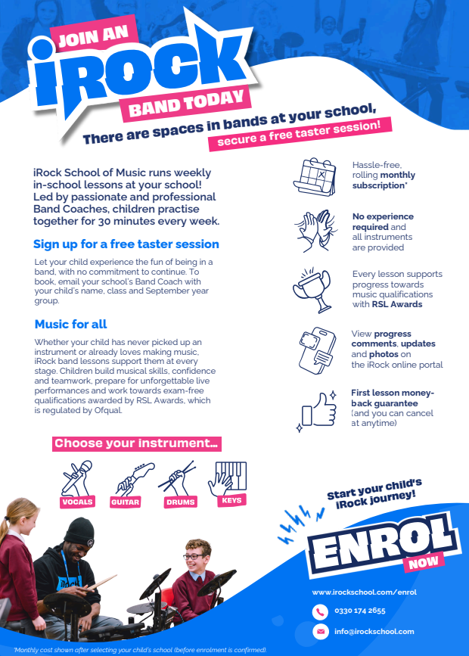
……………………………………………………………………………………………………………………………………………………………………………………

……………………………………………………………………………………………………………………………………………………………………………………

Pupil Premium Eligibility Check - Chance to Win a £20 Smyths Voucher
Dear Parents and Carers,
We would like to encourage all families to check or re-check their eligibility for Pupil Premium funding.
To thank you for taking the time to do this, all families who complete an eligibility check by 18th September will be entered into a prize draw to win a £20 Smyths Toys voucher.
MANY PEOPLE WHO HAVE CHECKED ELIGIBILITY SO FAR ARE NOW ELIGIBLE WHEN THEY WERE NOT PREVIOUSLY.
Please follow the link below to check your eligibility:
https://www.hertfordshire.gov.uk/ufs/CHSERV_FSMREG.eb?ebd=0&ebz=1_1788342237448
There is no need to inform school once you have completed the check. We will be able to see which families have submitted an eligibility check and will automatically enter them into the prize draw.
If you would prefer school to complete the check on your behalf, please send Miss Moss the parent/carer's in the home National Insurance number and date of birth, and we will be happy to do this for you.
Pupil Premium funding provides schools with additional financial support that directly benefits children. At St Mary's, this funding helps us to provide a range of valuable opportunities and support, including:
• Contributing towards our Speech and Language Therapy provision
• Support with the cost of school trips and educational visits
• Access to free Premier Sport club places for up to four half terms each year
• Support with access to music lessons
• Additional resources, interventions and enrichment opportunities for pupils
Even if you are unsure whether you qualify, we strongly encourage you to complete a check, as circumstances can change and eligibility may differ from previous years.
Thank you for your support. Every successful application helps us to continue providing enhanced opportunities and support for our children.
The voucher draw will take place on Monday 21st September.
……………………………………………………………………………………………………………………………………………………………………………………
Book Fair
Weds 16th Sept - Tuesday 22nd Sept
……………………………………………………………………………………………………………………………………………………………………………………





