



Friday 27th March 2026
Confirmed date: Friday 5th June 2026 Hugh Maynard, West End star will be returning for the afternoon and evening to help us to raise money so that we can continue our music offer into the next academic year.
TICKETS ARE NOW LIVE!
https://www.ticketsource.co.uk/st-marys-infants-school/t-glaklmz
Parents we need your help!
As you all know we have been working hard to plan a wonderful music event on June 5th at the school with west end lead Hugh Maynard.
We need this news to be spread far and wide to sell as many tickets as we can. In doing so, we will be able to fund further exciting enrichment opportunities as part of our enrichment programme. Last year’s show enabled us to fund a whole term of violin lessons for three classes and more!
We are asking that you please share the poster attached with everyone you know. Friends, families, work colleagues and please feel free to present the poster in any of your workplaces to attract attention!
We hope to see as many of you there as possible to experience the night with us and remember it is also open for children to attend to allow you to enjoy a family night of entertainment! There will be a cocktail bar putting on some impressive displays and some snacks!
If any parents would like to volunteer to collect some posters from our office to take to lots of local businesses, we would be grateful. If any parents can support the school through their places of employment with raffle prizes, please do help us if you can. Thank you!
Reminders

Summer Term 2026
Monday 13th April | Inset Day
Tuesday 14th April | First day of Summer Term
Monday 04th May | May Bank Holiday
Monday 25th May – Friday 29th May | Summer half term
Monday 01st June | Inset Day
Thursday 09th July | Transition Day
Wednesday 22nd July | Last day of summer term 1pm Finish
Thursday 23rd July | Inset Day

Monday 27th April – Class Photos
……………………………………………………………………………………………………………………………………………………………………………………..
Pupil Premium
Please visit www.hertfordshire.gov.uk/freeschoolmeals ,
call on 0300 123 4048 or speak to the school office to see if your child qualifies for the Pupil Premium Grant.
You can check your eligibility on the website linked above. The school receives additional funding if your child is eligible and can support with school uniform, cost of trips, paying for Premier Education Clubs and funding music lessons for your child.
……………………………………………………………………………………………………………………………………………………………………………………
Premier Education
Bookings for wrap around care are now live for the Summer term! Please see the below link:
St Mary’s Junior Mixed School – Premier Education

Afterschool Dodgeball Club
After School Dodgeball Club – Premier Education
Booking link is now open
……………………………………………………………………………………………………………………………………………………………………………………
Future Job Day
Dear Parents and Carers,
The ‘Agents of Change’ are delighted to announce that on Wednesday 15th April 2026 we will be holding a Future Career Day at school.
This special day is designed to help the children begin thinking about the exciting possibilities for their futures. We would love all children to come to school dressed as the job they would like to do when they grow up. This could be anything at all – from doctors, engineers and teachers to artists, athletes, builders, scientists, chefs and beyond!
To make the day even more inspiring, we are inviting parents and carers to volunteer to come into school to give a short 10–15-minute talk about their job. If possible, you may also wish to bring along equipment, photographs, uniforms or simple demonstrations to help the children understand what you do.
When speaking to the children, it would be wonderful if you could include:
- What your job involves on a typical day
- How you trained or worked towards your career
- How your job helps other people
- Whether your job entertains others, cares for the environment, or connects with other countries
- Any interesting or exciting aspects of your role
We know we have a wide range of careers within our school community, and we would love to share that variety with the children.
If you would like to volunteer, please express your interest by filing out the google form by April 7th. Depending on the number of volunteers, we will organise a timetable and confirm which class you will be speaking to. We will do our very best to accommodate everyone, although this will depend on the level of interest and time available on the day.
Thank you for your continued support in enriching the children’s learning experiences. We look forward to what promises to be an inspiring and exciting day!
Kind regards,
Miss Markiewicz
https://forms.gle/aNUbFRhFZDV4osZz9
…………………………………………………………………………………………………………………………………………………………
Flag Of The Week
Find the country and find a fact.
Reminder: Children may want to find the location of the country on a map, research traditions, food, culture or anything they find interesting. They don’t need to write anything down, just come ready with their fact. It should be quick and fun.
Kind regards,
Miss Markiewicz

…………………………………………………………………………………………………………………………………………………………
Enrichment Update: Year 1 and Year 2
St Mary’s Infants have been busy diving into learning how to be a ‘Sustainable Eco’ as part of their enrichment opportunities. They’ve been learning all about deforestation and its impact on the environment, particularly the loss of animal habitats. To help make a difference, the children got stuck in and planted new trees in our meadow, they also created wonderful posters to show why protecting our trees is so important.
In other exciting news, our young musicians have completed two terms of violin lessons. This culminated in a fantastic performance for families over the past couple of weeks. It was a wonderful turnout. Thank you so much for coming along to support your child’s hard work and musical journey.
Next half term, enrichment activities with include becoming ‘Courageous Advocates’, Boot Camp and Mad Science.
Kind regards,
Miss Markiewicz
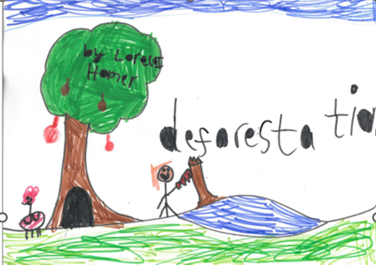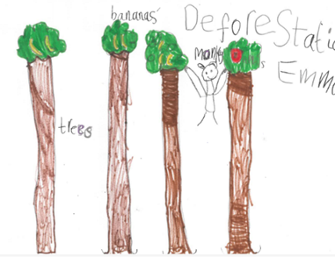
………………………………………………………………………………………………………………………………………………………… The Great Baldock Easter Hunt 2026
The Great Baldock Easter Hunt 2026 – The Blockbusters Are Back!
From 26th March to 14th April, the film‑set chicks will be appearing in windows throughout Baldock, scattering clues, surprises, and a few diva‑level selfies along the way.
Families can order their answer sheet online to print at home or visit Café Luna to purchase an answer sheet.

📍 Baldock Town Centre
📅 Trail runs 26th March – 14th April (the whole Easter Hols, even after the official Easter weekend)
👛 £3 per entrysheet (includes a Cadbury Crème Egg, extra available for purchase also)
🔗 https://qrco.de/BaldockEasterHunt OR visit Café Luna (cash/card)

Roll out the carrot‑coloured carpet! The superstar Easter chicks have wrapped filming and are returning to Baldock Town Centre with a brand‑new season of egg‑citing blockbuster releases throughout Baldock Town.

🎬 Lights 🎬 Camera 🎬 Hunt… Easter in Baldock is back and it’s going to be eggstraordinary!
…………………………………………………………………………………………………………………………………………………………





