



Friday 20th March 2026
Confirmed date: Friday 5th June 2026 Hugh Maynard, West End star will be returning for the afternoon and evening to help us to raise money so that we can continue our music offer into the next academic year.
TICKETS ARE NOW LIVE!
https://www.ticketsource.co.uk/st-marys-infants-school/t-glaklmz
Parents we need your help!
As you all know we have been working hard to plan a wonderful music event on June 5th at the school with west end lead Hugh Maynard.
We need this news to be spread far and wide to sell as many tickets as we can. In doing so, we will be able to fund further exciting enrichment opportunities as part of our enrichment programme. Last year’s show enabled us to fund a whole term of violin lessons for three classes and more!
We are asking that you please share the poster attached with everyone you know. Friends, families, work colleagues and please feel free to present the poster in any of your workplaces to attract attention!
We hope to see as many of you there as possible to experience the night with us and remember it is also open for children to attend to allow you to enjoy a family night of entertainment! There will be a cocktail bar putting on some impressive displays and some snacks!
If any parents would like to volunteer to collect some posters from our office to take to lots of local businesses, we would be grateful. If any parents can support the school through their places of employment with raffle prizes, please do help us if you can. Thank you!
Reminders
Violin Concert
26th March – 2:45pm – Saturn

School Easter Disco – Tuesday 24th March 3.15 - 4.30– Tickets are now for sale on Arbor
Whole School - Easter Service in Church, all Welcome – Thursday 26th March – Please contact your child’s class teacher if you would like to volunteer to walk with us.
Friday 27th March – Last Day Of Term – 1pm Finish
……………………………………………………………………………………………………………………………………………………………………………………..
Pupil Premium
Please visit www.hertfordshire.gov.uk/freeschoolmeals ,
call on 0300 123 4048 or speak to the school office to see if your child qualifies for the Pupil Premium Grant.
You can check your eligibility on the website linked above. The school receives additional funding if your child is eligible and can support with school uniform, cost of trips, paying for Premier Education Clubs and funding music lessons for your child.
……………………………………………………………………………………………………………………………………………………………………………………
Cat Eye Syndrome
Dear Parents/Carers,
On Monday 23rd March, children are invited to wear something orange to school to help raise awareness of Cat Eye Syndrome, a condition that affects one of our pupils.
This could be an item of orange clothing or a small orange accessory. Thank you for supporting us in raising awareness and showing kindness and inclusion within our school community.
……………………………………………………………………………………………………………………………………………………………………………………
Premier Education
Bookings for wrap around care are now live for the Summer term! Please see the below link:

St Mary’s Junior Mixed School – Premier Education

Afterschool Dodgeball Club
After School Dodgeball Club – Premier Education
Booking link is now open
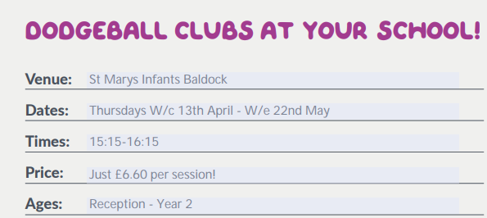

https://www.premier-education.com/parents/venue/courses/4526-939542/?back=1&location=ashwell

……………………………………………………………………………………………………………………………………………………………………………………
Future Job Day
Dear Parents and Carers,
The ‘Agents of Change’ are delighted to announce that on Wednesday 15th April 2026 we will be holding a Future Career Day at school.
This special day is designed to help the children begin thinking about the exciting possibilities for their futures. We would love all children to come to school dressed as the job they would like to do when they grow up. This could be anything at all – from doctors, engineers and teachers to artists, athletes, builders, scientists, chefs and beyond!
To make the day even more inspiring, we are inviting parents and carers to volunteer to come into school to give a short 10–15-minute talk about their job. If possible, you may also wish to bring along equipment, photographs, uniforms or simple demonstrations to help the children understand what you do.
When speaking to the children, it would be wonderful if you could include:
- What your job involves on a typical day
- How you trained or worked towards your career
- How your job helps other people
- Whether your job entertains others, cares for the environment, or connects with other countries
- Any interesting or exciting aspects of your role
We know we have a wide range of careers within our school community, and we would love to share that variety with the children.
If you would like to volunteer, please express your interest by filing out the google form by April 7th. Depending on the number of volunteers, we will organise a timetable and confirm which class you will be speaking to. We will do our very best to accommodate everyone, although this will depend on the level of interest and time available on the day.
Thank you for your continued support in enriching the children’s learning experiences. We look forward to what promises to be an inspiring and exciting day!
Kind regards,
Miss Markiewicz
https://forms.gle/aNUbFRhFZDV4osZz9
…………………………………………………………………………………………………………………………………………………………
Flag Of The Week
Find the country and find a fact.
Reminder: Children may want to find the location of the country on a map, research traditions, food, culture or anything they find interesting. They don’t need to write anything down, just come ready with their fact. It should be quick and fun.
Kind regards,
Miss Markiewicz









