



Friday 13th March 2026
Confirmed date: Friday 5th June 2026 Hugh Maynard, West End star will be returning for the afternoon and evening to help us to raise money so that we can continue our music offer into the next academic year.
TICKETS ARE NOW LIVE!
https://www.ticketsource.co.uk/st-marys-infants-school/t-glaklmz
Reminders
Violin Concerts
19th March – 2:45pm - Venus
26th March – 2:45pm – Saturn

School Easter Disco – Tuesday 24th March 3.15 - 4.30– Tickets are now for sale on Arbor
Whole School Church Visit – Thursday 26th March – Please contact your child’s class teacher if you would like to volunteer to walk with us.
……………………………………………………………………………………………………………………………………………………………………………………..
Pupil Premium
Please visit www.hertfordshire.gov.uk/freeschoolmeals ,
call on 0300 123 4048 or speak to the school office to see if your child qualifies for the Pupil Premium Grant.
You can check your eligibility on the website linked above. The school receives additional funding if your child is eligible and can support with school uniform, cost of trips, paying for Premier Education Clubs and funding music lessons for your child.
……………………………………………………………………………………………………………………………………………………………………………………

……………………………………………………………………………………………………………………………………………………………………………………
Comic Relief
Dear Parents and Carers,
Next week our school will be supporting Comic Relief on Friday 20th March 2026. Comic Relief is a wonderful charity that helps families and communities both in the UK and around the world, supporting people facing poverty, hardship and inequality.
To celebrate and raise awareness, children are invited to come to school wearing their own clothes on the day. We will also be having a little bit of fun by asking the children to bring in their favourite joke to share with the class.
Each class will choose their best joke, and the winner will receive 5 Dojo points.
If you would like to make a small donation to Comic Relief, the website link below will take you to a donation page. We do not want money brought into school.
Thank you for your continued support.
Kind regards,
Miss Markiewicz
http://donation.comicrelief.com
……………………………………………………………………………………………………………………………………………………………………………………
Cat Eye Syndrome
Dear Parents/Carers,
On Monday 23rd March, children are invited to wear something orange to school to help raise awareness of Cat Eye Syndrome, a condition that affects one of our pupils.
This could be an item of orange clothing or a small orange accessory. Thank you for supporting us in raising awareness and showing kindness and inclusion within our school community.

……………………………………………………………………………………………………………………………………………………………………………………
……………………………………………………………………………………………………………………………………………………………………………………
Premier Education
Bookings for wrap around care are now live for the Summer term! Please see the below link:

St Mary’s Junior Mixed School – Premier Education

Afterschool Dodgeball Club
After School Dodgeball Club – Premier Education
Booking link will open on Wednesday 18th March 12 Noon
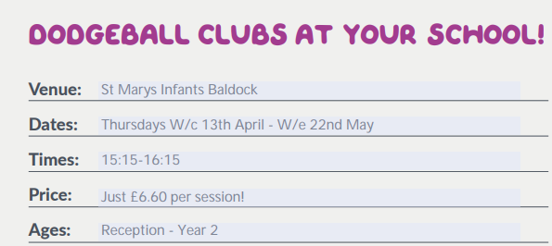

https://www.premier-education.com/parents/venue/courses/4526-939542/?back=1&location=ashwell

……………………………………………………………………………………………………………………………………………………………………………………
……………………………………………………………………………………………………………………………………………………………………………………
Future Job Day
Dear Parents and Carers,
The ‘Agents of Change’ are delighted to announce that on Wednesday 15th April 2026 we will be holding a Future Career Day at school.
This special day is designed to help the children begin thinking about the exciting possibilities for their futures. We would love all children to come to school dressed as the job they would like to do when they grow up. This could be anything at all – from doctors, engineers and teachers to artists, athletes, builders, scientists, chefs and beyond!
To make the day even more inspiring, we are inviting parents and carers to volunteer to come into school to give a short 10–15-minute talk about their job. If possible, you may also wish to bring along equipment, photographs, uniforms or simple demonstrations to help the children understand what you do.
When speaking to the children, it would be wonderful if you could include:
- What your job involves on a typical day
- How you trained or worked towards your career
- How your job helps other people
- Whether your job entertains others, cares for the environment, or connects with other countries
- Any interesting or exciting aspects of your role
We know we have a wide range of careers within our school community, and we would love to share that variety with the children.
If you would like to volunteer, please express your interest by filing out the google form by April 7th. Depending on the number of volunteers, we will organise a timetable and confirm which class you will be speaking to. We will do our very best to accommodate everyone, although this will depend on the level of interest and time available on the day.
Thank you for your continued support in enriching the children’s learning experiences. We look forward to what promises to be an inspiring and exciting day!
Kind regards,
Miss Markiewicz
https://forms.gle/aNUbFRhFZDV4osZz9
…………………………………………………………………………………………………………………………………………………………
Flag Of The Week
Find the country and find a fact.
Reminder: Children may want to find the location of the country on a map, research traditions, food, culture or anything they find interesting. They don’t need to write anything down, just come ready with their fact. It should be quick and fun.
Kind regards,
Miss Markiewicz










