

St. Mary’s Church of England VC Infant School

‘Sharing, Caring, Learning and Loving with God’

St Mary’s Way
Baldock
SG7 6HY

www.stmarysinfants.herts.sch.uk

Tel: 01462 892347

Teaching & Learning (EYFS) Policy

Policy Review:

This Policy will be reviewed annually.

Reviewed | February 2026
Next Review | February 2027
Our Vision
We aspire to be a community living life in all its fullness. We share, care, learn and love with God, valuing the dignity and respect of all humanity and creation. Through the power of the Holy Spirit Jesus’ Kingdom comes and everyone can flourish together.
Our Mission
‘Sharing, caring, learning and loving with God.’

Our Values
Friendship, Perseverance, Respect, Trust, Thankfulness, Humility, Generosity, Forgiveness, Courage, Peace, Compassion, Responsibility
Our 6 Key ideals that underpin our vision

 | Uphold the Values of God
Nurture Creativity, Encourage Curiosity | Learning Together, Flourishing Together | Connecting Communities
 | Stimulating Surroundings
 | One Message
Understanding our vision
Our 6 key ideals were created through the input of all stakeholders as being important factors in what we want from our school every day.
‘We aspire to be a community living life in all its fullness’ (John 10:10) Church of England vision for Education
‘Sharing, Caring, Learning and Loving with God’ (School’s mission statement)
‘Valuing the dignity and respect of all humanity and all creation’ (Reference to Jonah and the Whale and the Church of England vision)
‘Through the power of the Holy Spirit’ (The importance of the Holy trinity and that we can’t do it alone. We must work together.)
‘Jesus’ kingdom comes.’ (Themed verse, Lord ’s Prayer and the goal of the school for us to create a peaceful and successful kingdom)
Flourish: Achievement
Together: Community

This policy outlines the principles for good practice across our Foundation Stage. It uses the four guiding principles from the EYFS framework of every child is a unique child, children learn through positive relationships, children develop well in enabling environments and children develop and learn in different ways and at different rates. These principles enable all children to become competent and confident independent learners. The curriculum is carefully constructed with the needs and interests of the specific cohort in mind. The learning is sequenced to ensure the correct knowledge and skills are obtained to progress successfully into Key Stage One.
Our main aims for all children are:
• To provide a broad and balanced curriculum for every child to develop the building blocks for future learning
• To provide first hand experiences to put their learning into context
• To provide a safe and secure learning environment
• To develop confidence, independence and self esteem
• To encourage and motivate children to become independent learners
• To support children on the first steps of their learning journey
• To provide a range of learning opportunities such as solitary play, independent group play, adult supported play, adult directed learning and discrete teaching
• To develop social skills and relationships
• To reflect the diversity of social and cultural backgrounds in the class
• To provide a free flow curriculum where learning happens inside and outside
• Take children interests and use them to plan relevant activities
• To provide children with a secure grounding in the core skills necessary for children to continue to be successful in Year 1
The Early Years Foundation Stage Curriculum
The curriculum is divided into seven areas of learning.
These are the three prime areas:
• Communication and language
• Physical development
• Personal, social and emotional development
The specific areas
• Literacy
• Mathematics
• Understanding of the world
• Expressive arts and design

Daily Routine
Through the day there is a mixture of whole class adult led sessions, adult led group activities and child-initiated time. We call the latter Grow Time, the period when children are actively developing important skills e.g. independence, creativity, problem-solving, social skills and confidence.

Children have focused learning in the morning for Maths and Phonics and in the afternoon, for targeted learning sessions for Understanding the World, PSHE, R.E. and Music. As appropriate, adults adhere to the St Mary’s implementation strategies when delivering adult led class sessions.

For each adult led group activity an information sheet is prepared that includes the task, vocabulary and questions to help with learning and assessment.

During Grow Time, all children have access to the clearly defined areas within the provision both indoors or outside.
Before Grow Time begins, children gather on the carpet to discuss what they are going to do. Practitioners guide the children to think about their learning and the skills they will be using. They might refer to something the child did the day before and encourage them to continue with it.
At the end of Grow Time a plenary takes place. Children share what they have done and reflect on what they have learned and the skills they have used.
It is important for all children to tidy up and ‘reset’ the room at the end of a session. This helps them to value and respect their environment. Approximately five minutes is allowed for this.

Rainbow challenges
Rainbow challenges are used in the EYFS to provide purposeful activities that support learning in the seven areas of the EYFS. Each challenge is carefully planned to be engaging, practical and accessible, allowing children to practise key skills through play while working independently or with peers. Adults support learning through sensitive questioning, modelling language and observing children's progress. Rainbow challenges promote choice, independence, and resilience, while ensuring learning is progressive and clearly linked to Development Matters. Children record when they have finished a challenge, promoting ownership of their learning and independence.

Planning
The cycle of observation, assessment, planning, observation is carried out on a moment-by-moment basis. This a continual process and all staff within the EYFS setting have input into this process. Each child has their own bespoke targets with all staff being aware of these and in turn, these are used to inform planning.

We work in this way because ...

“Children are born with a natural desire to explore and learn and practitioners can support them in this. We do this by creating an enabling environment (both physical and emotional) and through the relationships and interactions that the children experience. We remain “in the moment” with the children as they explore and learn. We observe carefully and enhance the learning whenever we spot a “teachable moment”. Our observations, interactions and the outcomes are recorded afterwards”.

ANNA EPHGRAVE- GUEST BLOG “IN THE MOMENT”
APRIL 16, 2015 BY EYFSMATTERS

Progress and Development

When children show high levels of involvement, that is when there is progress and development occurring – when the brain is at its most active. High level involvement occurs, most often, when children can pursue their own interests in an enabling environment.
Planning in the moment helps to make this possible.

An Enabling Environment
Children learn in our enriching, engaging and safe environment. They have time to explore and select what they want to do in the different areas. They are in control of their learning and display deep levels of engagement.
Invitations and provocations to learning are also laid out on tables and tuff trays.
The principle is that resources are accessible to all and they are varied, open-ended and high quality. This gives children the opportunity to select resources to support their chosen activity.
The Role of The Adult
The adults are there to facilitate learning. They do this through observations and interactions.
Our adults know the children very well and have a sound understanding of child development. This ensures that the adults enhance and extend the learning at the appropriate level.
At St.Mary’s we adopt the SHREC principle for high quality interactions:

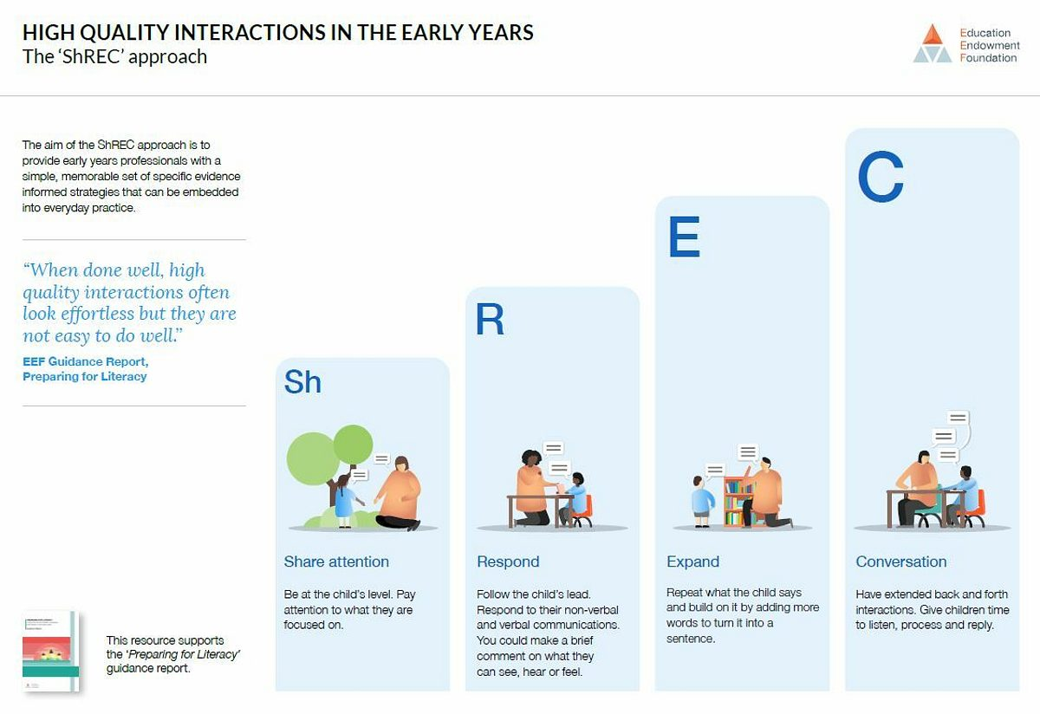

As the children become involved in activities of their choice, the adults observe them carefully, join them, when appropriate, and engage in quality interactions (teaching) to move the learning on.

“Teaching should not be taken to imply a ‘top down’ or formal way of working. It is a broad term that covers the many different ways in which adults help young children learn. It includes: their interactions with children during planned and child-initiated play and activities, communicating and modelling language, showing, explaining, demonstrating, exploring ideas, encouraging, questioning, recalling, providing a narrative for what they are doing, facilitating and setting challenges. It takes account of the equipment that adults provide and the attention given to the physical environment, as well as the structure and routines of the day that establish expectations. Integral to teaching is how practitioners what children know, understand and can do, as well as taking account of their interests and dispositions to learn (characteristics of effective learning), and how practitioners use this information to plan children’s next steps in learning and to monitor their progress.”
School inspection handbook
November 2019, Np. 190017

Assessment

The children initiate their own learning and the adults support and guide them to extend the learning opportunities.
Children are given an opportunity to create their own learning journal, adding work they are proud of to their ‘special book’ or display frame. This allows them to take pride in their learning, and it also promotes independence. Pupil voice is added and allows children to reflect on their learning.

Adults continually assess and review the progress of all the children and plan for next steps.
Adults consider the Characteristics of Effective Learning when making judgments for each child and how these influence how the child learns.
These are: • Playing and exploring • Active learning • Creating and thinking critically.

Children are formally assessed on entry (RBA) and exit (EYFSP) to Reception. They are tracked termly on the school tracking system.

We introduce teaching of specific skills as and when appropriate to individual children and groups of children.

Progression of Skills
For each area of the room and outside too, we have carefully mapped out the skills that pupils should acquire during the year which will allow them to progress successfully to Year 1 and beyond.
Included with these progressions are relevant vocabulary and questions practitioners could ask to assess the learning and help with moving the learning forward.

Adult Directed Implementation processes at St Mary’s
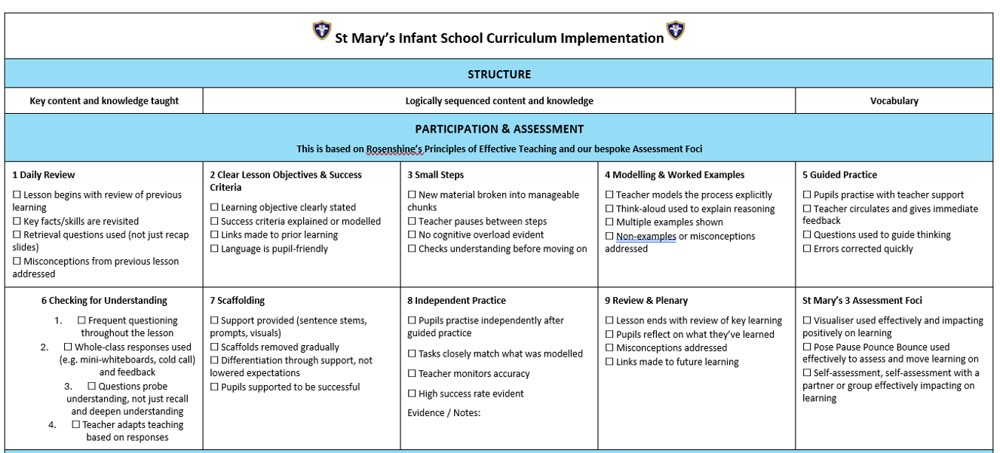

Responsive Teaching at St Mary’s

Responsive Teaching
At St Mary’s we use responsive teaching approaches when implementing our curriculum.
We adopt the mindset that pupils haven’t learnt anything until teachers have evidence to suggest otherwise.
The three parts of responsiveness are:
Cognizant of – What they understand, where they are stuck and what next
Sensitive to: Accepting mistakes and misconceptions and take children beyond their misconceptions
Behaviourally supporting of: Adapting teaching to meet the needs of pupils.
Defining Learning
At St Mary’s we define learning as a lasting change in pupils’ capabilities of understanding
Performance is an immediate change in behaviour or knowledge that can be observed and measured in the moment but it is not evidence that learning has occurred. We therefore provide tasks that enable us to assess all pupils at that point.

Simple Model of Memory by Daniel Willingham
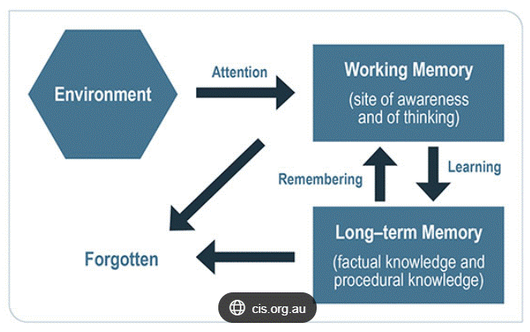

We use this model to remind us to:
- Minimise distractions for attention and focus to learn
- We are unlikely to learn something if we have only heard it once
- We can only attend to one thing at a time and the working memory cannot take lots of information at once
- Working memory is limited in capacity
Cognitive Load Theory
Our working memory can only handle a limited amount of information at once. Content must be broken down. Working memory is limited in its capacity. We are therefore selective with regards to the key information that children need within a lesson.
Therefore, we need:
- Clarity in the key focus of the lesson
- To reduce distractions and consider our environment
- Clear consistency in routines
- To break content down into manageable chunks
- To revisit prior learning
- To provide models and scaffolds
- To provide carefully considered explanations
Novices and Experts
Novices lack background knowledge and rely on working memory. They see superficial details and experience cognitive over lad. They need explicit guidance and clear steps. They struggle to transfer principles and new concepts. Problem solving requires scaffolding and clear steps.
Experts have a lot of background knowledge and use their long-time memory. They can se underlying structures and are less likely to be overloaded. Problem solving is intuitive. They can transfer principles between domains.
At St Mary’s novices that lack fundamental knowledge need more teacher guidance. Experts can work more independently as they have increased ability. Experts don’t require so many steps. The teachers at St Mary’s therefore reduce the steps and scaffolds required from novice to expert.
Assessment
At St Mary’s we see assessment as a systemic collection, review and use of information carried out to see what children know and how it informs next steps. It is a measure and a support of learning.
E.g. Pose, Pause, Pounce and Bounce
We consider the thinking/participation ratio
Thinking = how hard to pupils have to think when participating?
Participation = How many pupils are participating and how often
We therefore plan tasks that ensure maximum thinking and participation so that we can achieve higher rates of success.
Retrieval Practice and Spaced Practice
With retrieval and spaced practice, children can recall and have a better chance of remembering their learning.
How do we build retrieval into our teaching?
- We begin our lessons with a short review
- We review weekly, monthly and termly
- We use knowledge organisers
- We return to the focus of learning as many times as possible within a lesson
How do we build explicit teaching into our practice?
- Clear, direct instruction
- Mastery approach, my turn, your turn to ensure everyone is keeping up
- Present new information into small steps
- Use models
- Scaffold
- Plan for the use of key vocabulary
How do we frame responsive teaching?
- Where do they need to get to?
- Where are they now?
- How am I going to move them from their starting point to their target?

