

St. Mary’s Church of England VC Infant School

‘Sharing, Caring, Learning and Loving with God’

St Mary’s Way
Baldock
SG7 6HY

www.stmarysinfants.herts.sch.uk

Tel: 01462 892347

Curriculum Policy

Policy Review:

This Policy will be reviewed by staff and the Governing Body annually.

Reviewed | February 2026
Next Review | February 2027

Our Vision
We aspire to be a community living life in all its fullness. We share, care, learn and love with God, valuing the dignity and respect of all humanity and creation. Through the power of the Holy Spirit Jesus’ Kingdom comes and everyone can flourish together.
Our Mission
‘Sharing, caring, learning and loving with God.’
Our Values
Friendship, Perseverance, Respect, Trust, Thankfulness, Humility, Generosity, Forgiveness, Courage, Peace, Compassion, Responsibility
Our 6 Key ideals that underpin our vision

 | Uphold the Values of God
Nurture Creativity, Encourage Curiosity | Learning Together, Flourishing Together | Connecting Communities
 | Stimulating Surroundings
 | One Message
Understanding our vision
Our 6 key ideals were created through the input of all stakeholders as being important factors in what we want from our school every day.
‘We aspire to be a community living life in all its fullness’ (John 10:10) Church of England vision for Education
‘Sharing, Caring, Learning and Loving with God’ (School’s mission statement)
‘Valuing the dignity and respect of all humanity and all creation’ (Reference to Jonah and the Whale and the Church of England vision)
‘Through the power of the Holy Spirit’ (The importance of the Holy trinity and that we can’t do it alone. We must work together.)
‘Jesus’ kingdom comes.’ (Themed verse, Lord ’s Prayer and the goal of the school for us to create a peaceful and successful kingdom)
Flourish: Achievement
Together: Community

Our curriculum aims to create:
- High academic standards for all – strong progress and attainment and a desire to achieve.
- Consistently good behaviour, an applied repertoire of learning behaviours and modelling of values.

- High academic standards for all – strong progress and attainment and a desire to achieve.
- High attendance

- Safe pupils with healthy lifestyles and good mental and physical wellbeing

- Pupils who embrace difference and are prepared for life in modern Britain.
- Active participation by all stakeholders with learning, extracurricular and community events

We do this through our 6 key ideals:

Learning Together, Flourishing Together and One Message (Consistency)
- Clear systems to track and monitor the progress and attainment of each pupil and shared with parents
- Questioning and feedback at the point of learning enables accurate assessment for learning and positive progress within each lesson
- Staff use updated pedagogy and maintain high expectations of all pupils.
- All stakeholders actively taking part in learning and following agreed procedures consistently to enable flourishing.
- Independent children are supported to challenge themselves and take risks.
- Collaborative learning through paired, group and whole class discussions.
- Clear progression of vocabulary, knowledge and skills from R to Y2 across all subjects with cross curricular links encouraged to apply learning.
- Pupils ask questions and lead learning
- Instilling initiative which encourages children to seek support when needed and to pursue understanding
- Growth mindsets discussed and valued. Metacognition is encouraged.

Uphold the Values of God
- Explicit teaching and recognition of the school values in action.
- Explicit teaching of learning behaviours and recognition of these in action.
- Pupil voice is encouraged and valued. All stakeholders respond with respect
- Take on leadership roles and make a valued contribution to the schools’ vision.
- Discover, discuss and reason about other religions, cultures and beliefs.
- Church school distinctiveness woven across the curriculum
- Strong focus on pastoral care to meet personal and social needs of all stakeholders.
- Pupils share in the creation of and follow their rights and responsibilities demonstrating understanding of right and wrong and fundamental British values.

Stimulating Surroundings
- Use of outdoor and in school resources including technology/ high quality texts engage and motivate.
- Pupils voice is listened and responded to and a safe environment is provided
- Pupils are provided with a calm, natural environment to replicate the context of the school grounds.
Nurture Creativity and Encourage Curiosity
- Opportunities for ongoing self-evaluation and reflection
- An enriched curriculum with wider opportunities to apply skills to real life situations.
- Opportunities to apply learning in different contexts and extend their skills through challenge.
- Individualised curriculum and timely intervention where necessary to enable success.

Connecting Communities
- Maintaining local, regional, national and international networks.
- Supporting and volunteering for local, national and international charities
- High profile given to sustainability and being eco-friendly led by the pupils across the school
- Enrichment through visits, visitors, peripatetic teachers and experts in their field. Opportunities for children to ‘live life in all its fullness’ through regular access to activities that extend beyond the National Curriculum.
- Pupils experience democracy in action within their school community.

1. Curriculum Intent

At St Mary’s Infant school our intent is to deliver a broad and balanced curriculum that will inspire, enthuse and educate our children so they learn knowledge and skills that will help them prepare for life in modern Britain. During their time with us, from Reception to Year 2, we aim to foster a love of learning, a natural curiosity and a thirst for knowledge. Good social skills and very high standards of behaviour are vital in creating happy children who are keen and active learners

Our curriculum is composed of the composite objectives of the National Curriculum. These composite objectives are broken down into small, manageable key components. These components are well considered and sequenced to enable children to meet the composite objectives fully.
Our curriculum is ambitious, knowledge and vocabulary rich and reflects the context of our community. Our curriculum offers enrichment so that children can 'live life in all their fullness' above and beyond the curriculum. (See our curriculum overview on our website)

2. Curriculum Implementation

To achieve our curriculum intent, careful thought and consideration goes into its implementation. Our curriculum is implemented with regards to the three areas of structure, assessment and participation, and reflect research on Rosenshine’s effective teaching approaches. This is monitored by the subject leader of each area and moderated by senior leaders. Our implementation approaches take into account the context of need for the school.

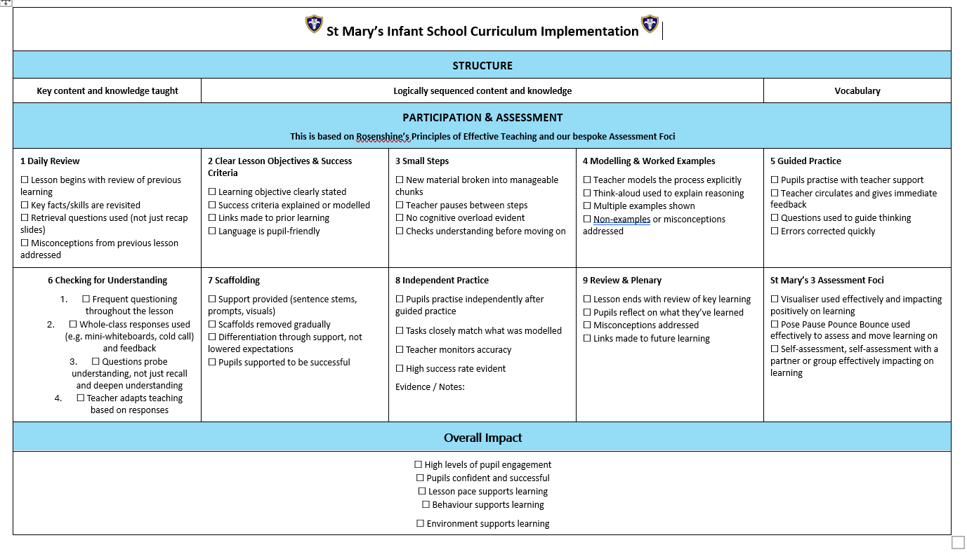
3. Curriculum Impact

☐ High levels of pupil engagement
☐ Pupils confident and successful from their starting points
☐ Lesson pace supports learning
☐ Behaviour and attitudes supports learning

☐ Environment supports learning

☐ Attendance support learning

☐ Safe pupils with healthy lifestyles and positive mental and physical well-being.

4. Legislation and guidance
This policy reflects the requirements of the National Curriculum programmes of study, which all maintained schools in England must teach.
It also reflects requirements for inclusion and equality as set out in the Special Educational Needs and Disability Code of Practice 2014 and Equality Act 2010, and refers to curriculum-related expectations of governing boards set out in the Department for Education’s Governance Handbook.
In addition, this policy acknowledges the requirements for promoting the learning and development of children set out in the Early Years Foundation Stage (EYFS) statutory framework.

5. Roles and responsibilities
5.1 The Governing Board
The governing board will monitor the effectiveness of this policy and hold the Headteacher to account for its implementation.
The governing board will also ensure that:
- A robust framework is in place for setting curriculum priorities and aspirational targets
- Enough teaching time is provided for pupils to cover the National Curriculum and other statutory requirements
- Proper provision is made for pupils with different abilities and needs, including children with special educational needs (SEN)
- The school implements the relevant statutory assessment arrangements
- It participates actively in decision-making about the breadth and balance of the curriculum
- It fulfils its role in processes to disapply pupils from all or part of the National Curriculum, where appropriate, and in any subsequent appeals
5.2 Headteacher
The headteacher is responsible for ensuring that this policy is adhered to, and that:
- All required elements of the curriculum, and those subjects which the school chooses to offer, have aims and objectives which reflect the aims of the school and indicate how the needs of individual pupils will be met
- The amount of time provided for teaching the required elements of the curriculum is adequate and is reviewed by the governing board
- Where appropriate, the individual needs of some pupils are met by permanent or temporary disapplication from all or part of the National Curriculum
- They manage requests to withdraw children from curriculum subjects, where appropriate
- The school’s procedures for assessment meet all legal requirements
- The governing board is fully involved in decision-making processes that relate to the breadth and balance of the curriculum
- The governing board is advised on whole-school targets in order to make informed decisions
- Proper provision is in place for pupils with different abilities and needs, including children with SEN
5.3 Other staff
Curriculum subject leaders, under the direction of the senior leadership team, will ensure that the school curriculum is implemented in accordance with this policy.
Subject leaders are responsible for:
- Strategic Direction and Development of the Subject (with the support of, and under the direction of, the head teacher and senior management team)
• developing and implement policies and practices which reflect the school’s commitment to high achievement through effective teaching and learning;
• having an enthusiasm for the subject which motivates and supports other staff and encourages a shared understanding of the contribution the subject can make to all aspects of pupils’ lives;
• using relevant school, local and national data to inform targets for development and further improvement for individuals and groups of pupils;
• developing plans for the subject which identify clear targets, times-scales and success criteria for its development and/or maintenance in line with the school development/improvement plan;
• monitoring progress and evaluate the effects on teaching and learning by working alongside colleagues, analysing work and outcomes.
- Teaching and Learning within their subject.
• setting an example of high quality teaching and learning in the subject;
• ensuring continuity and progression in the subject by supporting colleagues in choosing the appropriate sequence of teaching and teaching methods and set clear learning
objectives through an agreed scheme of work, developed in line with the school development/improvement plan;
• establishing clear targets for achievement in the subject and evaluate progress through the use of appropriate assessments and records and regular yearly analysis of this data;
• evaluating the teaching of the subject by the monitoring of teachers' plans and through
work analysis, identify effective practice and areas for improvement, and take
appropriate action to improve further the quality of teaching;
• developing effective links with the local community including parents, business and industry;
• ensuring that teachers are aware of the implications of equality of opportunity which the subject raises.
c) Effective Deployment of Resources
• supporting the head teacher by maintaining efficient and effective management and organisation of learning resources, by developing or identifying new resources including ICT applications to the subject;
• being aware of and respond appropriately to any health and safety issues raised by materials, practice or accommodation related to the subject;
• supporting the head teacher by maintaining efficient and effective management of the expenditure for the subject;
• helping colleagues to create a stimulating learning environment for the teaching and learning of the subject;
• taking on any additional responsibilities which might from time to time be reasonably determined.

6. Organisation and planning
The curriculum is taught through dedicated teaching time for each subject. We use cross curricular approaches where possible.
The curriculum provided for our pupils will cover the following National Curriculum subjects:
- English
- Maths
- Science
- Art and Design
- Computing
- Design Technology
- Geography
- Music
- Physical Education
- Personal, Social and Health Education and Citizenship (PSHE) incorporating SRE (Relationships and Health Education)

Each subject follows a progression of skills which is outlined on our website.
See our relationships and health education and SMSC policy with regards to how these areas are covered within our curriculum.
See our teaching and learning policies (EYFS and KS1) for information on how our curriculum is delivered.

7. Inclusion
Teachers set high expectations for all pupils. They will use appropriate assessment to set ambitious targets and plan challenging work for all groups, including:
- More able pupils
- Pupils with low prior attainment
- Pupils from disadvantaged backgrounds
- Pupils with SEN
- Pupils with English as an additional language (EAL)
Teachers will plan lessons so that pupils with SEN and/or disabilities can study every National Curriculum subject, wherever possible, and ensure that there are no barriers to every pupil achieving.
Teachers will also take account of the needs of pupils whose first language is not English. Lessons will be planned so that teaching opportunities help pupils to develop their English, and to support pupils to take part in all subjects.
Further information can be found in our statement of equality information and objectives, and in our SEN policy and information report.

8. Quality Assurrance and the Impact
Governors monitor coverage of National Curriculum subjects and compliance with other statutory requirements through: school visits, governing body curriculum meetings, meetings with the subject leader and involvement in deep dives.
Subject leaders quality assure the curriculum and the extent to which pupils are learning the curriculum. They do this by, checking the sequence of learning is as expected by using progressions of knowledge and skills, joint governor visits, planning scrutinies, learning walks, book scrutinies, discussions with parents, pupils and staff and assessment analysis.
Subject leader’s also have responsibility for monitoring the way in which resources are stored and managed.
This policy will be reviewed every review, the policy will be shared with the full governing board.

9. Links with other policies
This policy links to the following policies and procedures:
- Teaching and Learning (EYFS) policy
- Teaching and Learning (KS1) policy
- Assessment policy
- SEN policy and information report
- Equality information and objectives
- SRE Policy
- SMSC Policy

