Pupil premium strategy statement – St Mary’s Infant School

This statement details our school’s use of pupil premium funding to help improve the attainment of our disadvantaged pupils.
It outlines our pupil premium strategy, how we intend to spend the funding in this academic year and the outcomes for disadvantaged pupils last academic year.

School overview
Detail | Data
Number of pupils in school | 81
Proportion (%) of pupil premium eligible pupils | 27%
Academic year/years that our current pupil premium strategy plan covers (3-year plans are recommended – you must still publish an updated statement each academic year) | 2026 - 2027
Date this statement was published | July 2026
Date on which it will be reviewed | Jan 2027 and June 2027
Statement authorised by | Miss V Edey, Headteacher
Pupil premium lead | Miss M Moss
Governor / Trustee lead | Mr M Day

Funding overview
Detail | Amount
Pupil premium funding allocation this academic year | £29450
Pupil premium funding carried forward from previous years (enter £0 if not applicable) | £1,600 [trips]
Total budget for this academic year  If your school is an academy in a trust that pools this funding, state the amount available to your school this academic year | £31,050

Part A: Pupil premium strategy plan

Statement of intent
The school uses Pupil Premium funds for additional provision which aims to support raising of attainment for the most vulnerable pupils as well as providing opportunities for these children that they might not otherwise benefit from.
Our Pupil Premium Strategy Plan is intended to help us to clarify our intentions in how that provision is planned and how funding is allocated to those plans. It also serves to communicate our intentions, and how they are implemented to stakeholders of the school
The Statement is based on the key principles of our vision statement:
We aspire to be a community living life in all its fullness. We share, care, learn and love with God, valuing the dignity and respect of all humanity and creation. Through the power of the Holy Spirit Jesus’ Kingdom comes and everyone can flourish together.’
and incorporates our values and key ideals which seek to provide the best possible outcomes for all our children, regardless of vulnerability, disadvantage or any other barriers to learning.

Challenges
This details the key challenges to achievement that we have identified among our disadvantaged pupils.
Challenge number | Detail of challenge
1 | Baseline and ongoing assessments indicate that a significant proportion of pupil premium eligible pupils enter school with speech, language and communication skills below those typically expected for their age.
2 | Attendance and punctuality analysis shows that pupils eligible for Pupil Premium account for 46% of all recorded late marks during the 2025–2026 academic year. This indicates that disadvantaged pupils are disproportionately affected by punctuality issues, resulting in lost learning time and reduced access to key morning learning opportunities.
3 | In 2025–2026, 42.9% (3 children) of Year 1 pupils eligible for Pupil Premium did not meet the expected standard in the Phonics Screening Check. While a number of pupils who did not achieve the expected standard also present with additional barriers to learning, analysis indicates that many Pupil Premium pupils have limited opportunities to read regularly with an adult at home.
4 | Analysis indicates that some pupils eligible for Pupil Premium experience reduced access to extra-curricular opportunities, particularly sporting clubs during the winter months, where participation often requires a financial contribution. This can limit opportunities for physical activity, skill development, social interaction and enrichment experiences available to their peers. Pupil progress meeting analysis identifies that pupils eligible for Pupil Premium are more likely to require targeted interventions to support key areas of learning, including fine motor development and handwriting.
5 | Analysis of behaviour incidents and suspensions indicates that pupils eligible for Pupil Premium are disproportionately represented within these groups. Further investigation has identified social, emotional and mental health (SEMH) needs, alongside difficulties with social communication and learning behaviours, as key barriers for many disadvantaged pupils. These challenges can impact pupils’ ability to regulate emotions, form positive relationships, engage successfully in learning and meet school behaviour expectations.

Intended outcomes
This explains the outcomes we are aiming for by the end of our current strategy plan, and how we will measure whether they have been achieved.
Intended outcome | Success criteria
To improve speech, language and communication skills for pupils eligible for Pupil Premium, enabling them to access learning more effectively, develop confidence in expressing their ideas and make accelerated progress across the curriculum. | - Pupils eligible for Pupil Premium with identified speech, language and communication needs will demonstrate measurable progress against individual targets and intervention outcomes.  - The proportion of Pupil Premium pupils working at age-related expectations in communication and language will increase.  - Pupils will demonstrate increased confidence when speaking, participating in class discussions and presenting their ideas to adults and peers.  - Speech and language interventions will be implemented consistently, with progress monitored through regular assessment and review.  - Early identification of speech, language and communication needs will ensure pupils access appropriate support in a timely manner.  - Improved communication skills will contribute to stronger outcomes in phonics, reading and writing for disadvantaged pupils.
To improve attendance and punctuality for pupils eligible for Pupil Premium, ensuring they are able to access the full curriculum, maximise learning time and engage positively with school life. | - The attendance of Pupil Premium pupils will improve and move closer to, or exceed, national averages and the attendance of non-disadvantaged pupils.  - The proportion of Pupil Premium pupils who are persistently absent will decrease.  - The proportion of late marks attributed to Pupil Premium pupils will reduce from the 2025–2026 baseline of 46%.  - Pupil Premium pupils will access a greater proportion of teaching time, particularly during the start of the school day when key literacy, phonics and maths learning takes place.  - Parents/carers of Pupil Premium pupils will engage positively with school attendance support and communication systems.  - Improved attendance and punctuality will contribute to better academic progress, engagement and wellbeing outcomes for disadvantaged pupils.
To improve phonics and early reading outcomes for pupils eligible for Pupil Premium, ensuring they develop secure decoding skills, read fluently and confidently, and achieve outcomes in line with their peers. | - The proportion of Pupil Premium pupils achieving the expected standard in the Year 1 Phonics Screening Check will continue to increase.  - Targeted pupils will make accelerated progress in phonics through high-quality teaching and timely intervention.  - Pupils will demonstrate increased confidence, fluency and accuracy when reading.  - Reading records and parental engagement monitoring will show an increase in the frequency of reading at home for Pupil Premium pupils.  - Staff will identify and address gaps in phonics knowledge quickly through regular assessment and targeted support.  - Pupils with speech and language difficulties will receive appropriate intervention to support the development of phonological awareness and early reading skills.  - Improved phonics attainment will lead to stronger outcomes in reading comprehension and writing.
To increase participation in extra-curricular activities for pupils eligible for Pupil Premium, ensuring they have equitable access to enrichment opportunities that support their physical, social, emotional and personal development. | - Pupils eligible for Pupil Premium access a wider range of extra-curricular opportunities, including sporting, creative and enrichment activities.  - Financial barriers to participation are reduced through targeted funding and support.  - Participation rates in clubs and enrichment activities for Pupil Premium pupils increase and move closer to those of their peers.  - Pupils demonstrate increased confidence, resilience, teamwork and social skills through engagement in extra-curricular activities.  - Disadvantaged pupils report feeling included and able to participate fully in the wider life of the school.  - Increased participation contributes positively to pupils' wellbeing, attendance, behaviour and engagement with learning.
To reduce behaviour incidents and suspensions involving pupils eligible for Pupil Premium by strengthening social, emotional and mental health (SEMH) support, improving social communication skills and developing positive learning behaviours. | - Behaviour incidents involving Pupil Premium pupils decrease over the course of the academic year.  - The number of suspensions issued to Pupil Premium pupils reduces compared to the previous year.  - Pupils demonstrate improved self-regulation, resilience and engagement in learning.  - Targeted pupils show improvements in social communication skills, enabling them to build positive relationships with peers and adults.  - Teachers report improved learning behaviours, including attention, independence, cooperation and readiness to learn.  - SEMH needs are continued to be identified early and addressed through appropriate interventions and pastoral support.  - Pupil Premium pupils feel safe, supported and included within the school environment.  - Families of identified pupils engage positively with school-led support, including the Family Support Worker and/or Early Help services, where appropriate.  - Strong home-school partnerships continue to contribute to improved attendance, behaviour, wellbeing and educational outcomes for targeted pupils.

Activity in this academic year
This details how we intend to spend our pupil premium funding this academic year to address the challenges listed above.

Teaching (for example, CPD, recruitment and retention)
Budgeted cost: £15,550
Activity | Evidence that supports this approach | Challenge number(s) addressed
The school will implement a structured programme of ongoing professional development for teachers and support staff, focused on evidence-informed strategies that improve outcomes for disadvantaged pupils. Training will include areas such as high-quality teaching, adaptive teaching, speech and language development, behaviour and self-regulation, SEND, and effective intervention delivery. This will ensure that all staff have the knowledge, skills and confidence to meet the needs of disadvantaged learners and provide consistently high-quality provision across the school. | The EEF identifies high-quality teaching as the most important lever schools have for improving outcomes for disadvantaged pupils. Effective professional development is a key mechanism for improving teaching practice and pupil outcomes. Evidence also suggests that improving staff expertise in areas such as oral language, behaviour, self-regulation and adaptive teaching can have a significant impact on both attainment and wider outcomes for disadvantaged pupils. The EEF further highlights that sustained, carefully planned professional development is more likely to lead to improvements in classroom practice than one-off training events. | 1,3,5
The Headteacher and Deputy Headteacher will provide a structured coaching programme based on Rosenshine’s priciples for all teaching and support staff to strengthen classroom practice and improve outcomes for disadvantaged pupils. Through regular coaching conversations, observations, modelling, feedback and professional reflection, staff will develop their expertise in high-quality teaching, adaptive practice, behaviour support and effective provision for pupils with SEND and those eligible for Pupil Premium. | The EEF identifies high-quality teaching as the most important in-school factor for improving outcomes for disadvantaged pupils. Effective professional development, including coaching and sustained support, can improve teacher practice and lead to better pupil outcomes. The EEF's guidance on effective professional development highlights the importance of building knowledge, motivating staff, developing teaching techniques and embedding new approaches through ongoing coaching and feedback rather than one-off training sessions. Oral language, behaviour and adaptive teaching approaches are particularly effective when supported through high-quality professional development | 1, 3, 5
The Headteacher and Deputy Headteacher will continue to participate in the DfE RISE programme in partnership with Tennyson Road Primary School, using evidence-informed approaches to drive school improvement. Learning from the programme will be disseminated through a structured programme of professional development, coaching and training for all teaching and support staff, ensuring that evidence-based strategies are embedded consistently across the school to improve outcomes for disadvantaged pupils. | The EEF identifies high-quality teaching as the most important in-school factor for improving outcomes for disadvantaged pupils. Effective professional development is a key mechanism for improving teaching quality, with the greatest impact achieved through sustained, collaborative learning, coaching and ongoing implementation support rather than one-off training events. By engaging in the RISE programme and sharing learning across the staff team, the school aims to strengthen teaching practice, improve staff expertise and secure better outcomes for all pupils, particularly those facing disadvantage | 1, 2, 3, 5

Targeted academic support (for example, tutoring, one-to-one support, structured interventions)
Budgeted cost: £13,310
Activity | Evidence that supports this approach | Challenge number(s) addressed
The school will continue to commission a Private Speech and Language Therapist partly through Pupil Premium Funding and Partly through inclusion fund Therapist for 8 days per year to provide specialist assessment, intervention and staff guidance.  PPG funding - £1,410  Inclusion funding - £1,310  Total - £2,720 | EEF research highlights oral language and communication interventions as among the most effective approaches for improving outcomes for disadvantaged pupils.  Oral Language Interventions show an average of +6 months' progress, while Communication and Language Approaches in the Early Years show an average of +7 months' progress. Given the high proportion of Pupil Premium pupils with identified speech, language and communication needs, targeted support from a Speech and Language Therapist will help improve vocabulary, expressive and receptive language, social communication and readiness for learning. | 1,3
The school will work in partnership with NHS Speech and Language Therapists to deliver targeted interventions through Early Language Explorers, Language Explorers and Language Adventurers groups, according to identified pupil need. Programmes will be delivered by trained school staff and supported by high-quality resources to ensure consistent and effective implementation. | This provision aims to develop pupils' speech, language and communication skills, improve vocabulary and understanding, and enhance access to learning across the curriculum.  Evidence: EEF research shows that oral language interventions can provide an average of +6 months' additional progress. Targeted speech and language programmes delivered by trained staff are particularly effective in supporting disadvantaged pupils with communication and language needs and improving access to learning. | 1,3,5
A Speech and Language Teaching Assistant will deliver targeted language interventions for EYFS pupils, including Early Language Explorers and Language Explorers groups. Interventions will be closely aligned to advice and targets set by the school's Private Speech and Language Therapist, ensuring pupils receive regular opportunities to develop vocabulary, understanding, speaking and listening skills. This provision aims to strengthen communication and language development at an early stage, improving children's readiness for learning and supporting future success in phonics, reading and writing. | EEF research shows that communication and language approaches in the early years can lead to an average of +7 months' additional progress, particularly benefiting disadvantaged pupils. Approaches are most effective when delivered by trained adults and embedded within everyday practice | 1,3,5

Wider strategies (for example, related to attendance, behaviour, wellbeing)
Budgeted cost: £ 2090
Activity | Evidence that supports this approach | Challenge number(s) addressed
The school subscribes to a local Family Support Worker programme to provide targeted support for pupils and families facing barriers to learning. The service offers early intervention, supports attendance, behaviour and wellbeing, strengthens home-school relationships, and helps families access appropriate external services. This provision aims to improve pupil engagement, wellbeing and outcomes by ensuring timely and effective support for vulnerable children and their families. | Parental Engagement (+4 months) and Social and Emotional Learning (+4 months) are identified by the EEF as effective approaches for improving pupil outcomes, particularly for disadvantaged children. | 1,3,5
The school will continue to develop a targeted attendance and punctuality programme for disadvantaged pupils, informed by regular analysis of attendance data and collaboration between key stakeholders, including school leaders, teachers, the Family Support Worker, pupils and parents. Pupil voice will be used to identify barriers to attendance and punctuality and to shape approaches that promote engagement. This will include the introduction of agreed incentives and rewards that pupils can work towards, alongside targeted family support and early intervention, with the aim of improving attendance, punctuality and access to learning. | Supporting School Attendance; Parental Engagement (+4 months); Social and Emotional Learning (+4 months). These approaches emphasise strong relationships with families, targeted support and pupil engagement as key factors in improving attendance and educational outcomes.  The Headteacher and Deputy Headteacher are currently participating in the DfE RISE programme for Attendance and Behaviour in partnership with Tennyson Road Primary School, Luton. Through this collaboration, leaders are engaging with current educational research and evidence-informed approaches to school improvement, with a particular focus on strategies that improve outcomes for disadvantaged pupils. This partnership supports the school's commitment to implementing effective, research-based practices and evaluating their impact on pupil achievement, attendance, behaviour and wellbeing. | 2, 5
As part of the school's involvement in the DfE RISE programme, the SENCo will lead the development of the Ready to Learn Room, funded through Pupil Premium, to provide a targeted regulation and support space for pupils experiencing barriers to learning linked to social, emotional and mental health needs.  The provision will focus on helping pupils develop self-regulation, emotional literacy and positive learning behaviours, enabling them to successfully return to their mainstream classroom as quickly as possible and engage effectively in learning. The room will provide structured interventions, restorative conversations and personalised support, with a clear emphasis on reintegration rather than removal from learning. | This work forms part of the school's wider commitment to implementing evidence-informed approaches through the RISE programme, ensuring that disadvantaged pupils are supported to overcome barriers to engagement, improve behaviour outcomes and maximise their access to the curriculum.  This approach is supported by EEF evidence, which highlights that improving pupils' self-regulation, behaviour and readiness to learn can strengthen the impact of high-quality teaching, identified as the most important in-school factor in improving outcomes for disadvantaged pupils. The provision will complement classroom teaching by reducing barriers to learning and ensuring pupils are able to fully participate in high-quality instruction and classroom experiences.  EEF Evidence Base: High-Quality Teaching, Behaviour Interventions (+4 months) and Social and Emotional Learning (+4 months), which emphasise the importance of supporting pupils' emotional regulation, learning behaviours and engagement in order to improve attainment and wider outcomes | 2, 5
Pupil Premium funding will be used to remove financial barriers to enrichment by supporting access to sporting activities, music lessons and educational visits, ensuring disadvantaged pupils can fully participate in the wider life of the school. | EEF evidence highlights that disadvantaged pupils can benefit significantly from opportunities that broaden their experiences and increase engagement with school. Participation in enrichment activities can support pupils' social and emotional development, confidence, wellbeing and sense of belonging, all of which contribute to improved engagement in learning.  The EEF also recognises the importance of developing cultural capital and removing barriers that may prevent disadvantaged pupils from accessing the wider opportunities available to their peers. Approaches that support social and emotional learning have been shown to have a positive impact on attainment, with an average of +4 months' additional progress. | 2,4,5

Total budgeted cost: £ 31,050

Part B: Review of the previous academic year

Outcomes for disadvantaged pupils
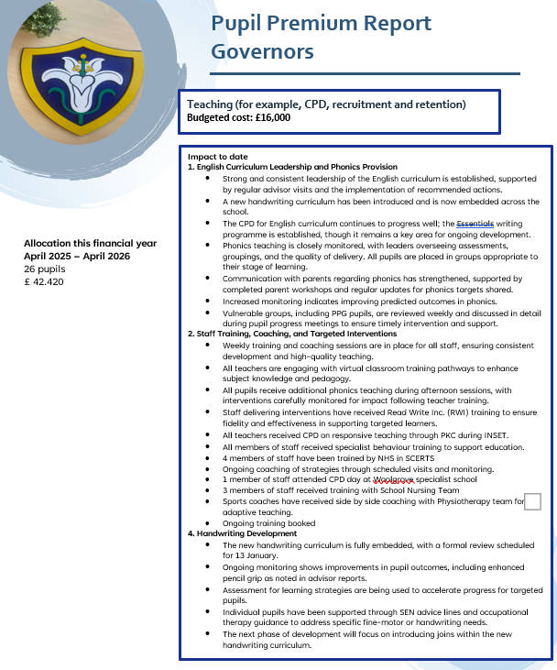
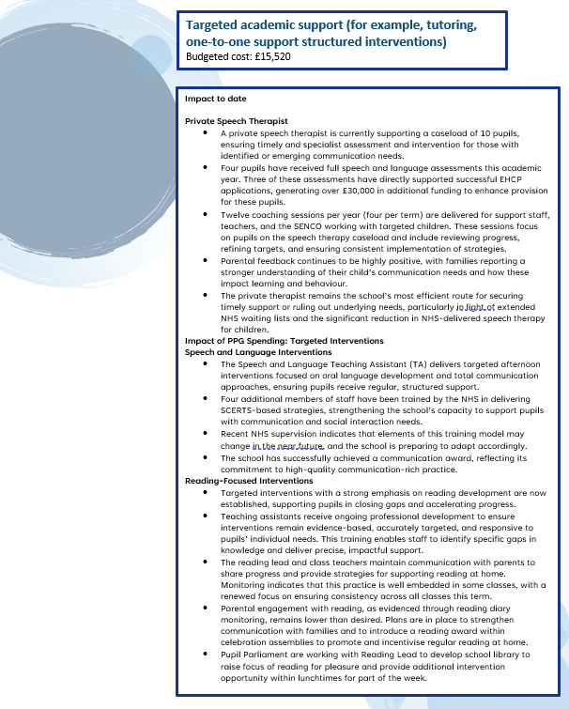
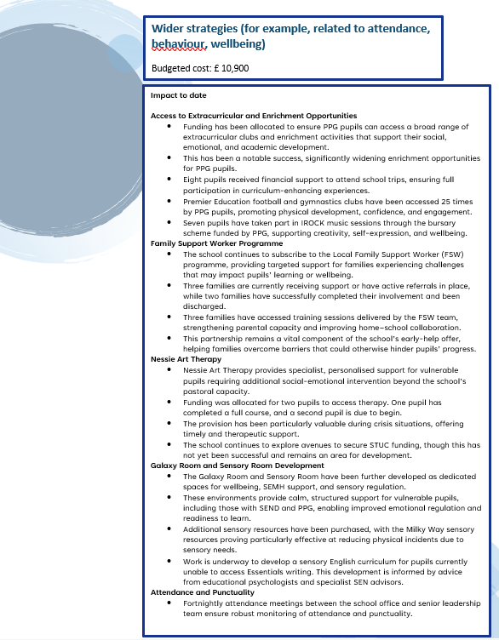

Externally provided programmes
Please include the names of any non-DfE programmes that you used your pupil premium to fund in the previous academic year.
Programme | Provider

Service pupil premium funding (optional)
For schools that receive this funding, you may wish to provide the following information: How our service pupil premium allocation was spent last academic year
n/a
The impact of that spending on service pupil premium eligible pupils
n/a

Further information (optional)
Use this space to provide any further information about your pupil premium strategy. For example, about your strategy planning, implementation and evaluation, or other activity that you are delivering to support disadvantaged pupils that is not dependent on pupil premium funding.

