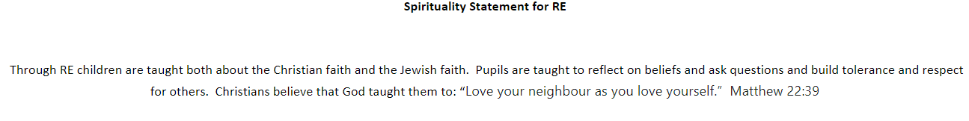

reflection
Spiritual Areas
Holy Trinity
Spiritual garden
silence
Spirituality at St Mary’s Infants School
What does spirituality mean to us?
At St Mary’s spirituality is not something that you can see, It is not something that you can hear,
It is something that you can feel and wonder about, that is greater than ourselves.

