
St Mary’s Infants School
SEND Information Report

St Mary’s Infant School SEN Information Report
February 2025
Welcome to St. Mary’s Infants School’s Information Report.
The intent of this document is to give you an overview of SEND (Special Education Needs and Difficulties) and support at our school and this document should be read alongside our Special Educational Needs and Disability Policy, SEND quality offer and Equality Policies which are available on our website.
This information and related policies comply with the legislation;
- SEND Code of Practice 0-25 (2015)
- Equality Act (2010)
- Part 3 of the Children and Families Act (2015)
- The Special Educational Needs and Disability Regulations (2014)
Contents
- Who can I contact for further information or if I have a concern?
- How does the school know if children need extra help and what should I do if I think my child may have special educational needs?
- How will school staff support my child?
- How will I know how my child is doing?
- How will the School’s approach to teaching & learning be matched to my child’s needs?
- What support will there be for my child’s overall wellbeing?
- What training have the staff supporting children with SEND had or are having?
- What specialist services and expertise are available at, or accessed by, the school?
- How will you help me to support my child’s learning?
- How does the school enable constructive partnership working with families?
- How will my child be included in activities outside the classroom including school trips?
- How accessible is the school environment?
- How will the school prepare and support my child to join the school, transfer to a new school or the next stage of education and life?
- How are the school’s resources allocated and matched to children’s special educational needs?
- How are decisions made about how much support my child will receive?
- Where can I find information about the local authority’s Local Offer of services and provision for children with special educational needs and disability?
- Complaints

- Who can I contact for further information or if I have a concern?
Each child has a class teacher who you can speak to them anytime that you have concerns.
In addition, a named member of staff is the Special Educational Needs Co-ordinator (SENCo). This is currently Miss Moss. Miss Moss has worked at St Mary’s Infants School since 2023 and works 5 days a week. If you would like to get in contact with Miss Moss directly you can send an email to senco@stmarysinfants.herts.sch.uk. Miss Moss is also often on the front gate at the beginning of the school day.
Appointments to see the Class Teacher or SENCo can also be made via the school office or you can use Class DoJo to contact them. Please refer to the school’s communication policy in regards to expected time frames for responses to queries.
If you have any concerns or are unhappy about provision and have followed the relevant channels of communication please refer to our complaints policy.
Back to top
2. How does the school know if children need extra help and what should I do if I think my child may have a Special Educational Need?
Children who have special educational needs may initially be identified in a number of ways. Initial concern is most likely to be the result of parent/carer or teacher observation and teacher assessment. This is likely to be by informal classroom and playground observation of children’s approaches to learning and to socialising.
Children are assessed regularly by their class teacher and by the reading leader for phonics. If children are not making expected progress in their learning, in accordance with age related expectations, our experienced teachers and teaching assistants, together with the SENCo, use their professional expertise to identify learning needs and will meet with the child and the child’s parents/carers to suggest appropriate action.
We believe in a child centred approach and seek the views, wishes and feelings of the child and the child’s parents/carers. We encourage parents/carers to participate as fully as possible in decisions and make sure we share the information and support necessary to enable us to work together.
This flow chart shows you how we identify children with SEND:
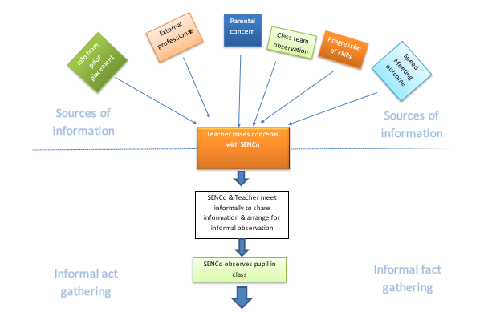
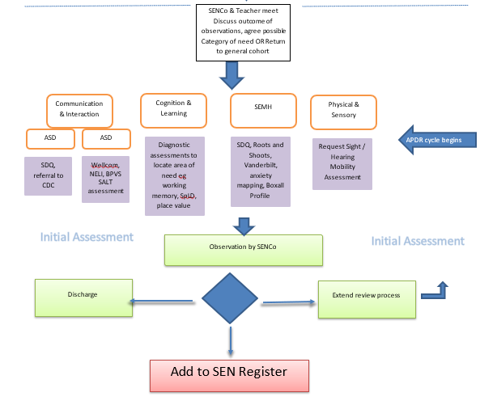

If parents/carers have a concern about their child’s learning, development or behaviour, the first person to speak to is the class teacher. This may be followed by a further conversation the Special Educational Needs Coordinator (SENCo), to determine next steps.
Back to top
3. How will school staff support my child?
Within the school, class teachers are responsible and accountable for the progress and development of all the children in their class, including children who have identified special educational needs and/or disabilities.
High quality first teaching is our first step in responding to children who have, or may have, special educational needs and/or disabilities (SEND). This may include support from the teacher or teaching assistant in class, individually or in a small group. This will normally occur within the class setting.
Some children may need provision that is additional or different to this. The class teacher and SENCo, in consultation with the parents/carers and the child, will agree the adjustments, interventions and support to be put in place, as well as the expected impact on progress, development or behaviour, along with a clear timeframe for review. This is shared with parents on an assess, plan, do review sheet (see example below).
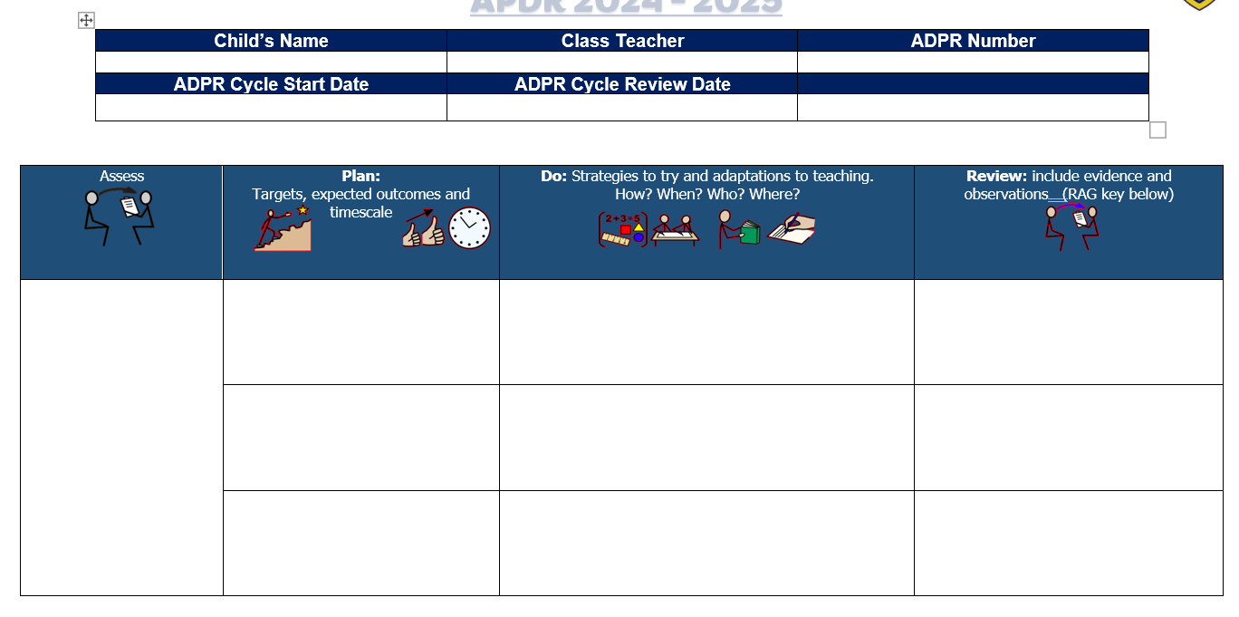
If a child has an identified speech and language difficulty, they will be supported by either a teaching assistant in the classroom or by Mrs Evans, an Elklan (a programme to develop children’s communication skills) and Neli (Nuffield Early Language Intervention) trained TA or a child’s designated key worker, who will deliver a specific 1:1 programme, under the direction of a Speech & Language Therapist and also speech and language support at the point of learning in class lessons.
Back to top
4. How will I know how my child is doing?
We support and involve parents/carers in their child’s learning both formally and informally. We have an open-door policy and parents/carers have every opportunity to speak to the class teacher or the SENCo to discuss their child’s progress and/or any concerns. Parent Consultations are held in the Autumn Term and the Spring Term and all children receive an Annual Report.
All children on the SEN register are given the opportunity to have a discussion with the class teacher or SENCo on at least three occasions per year. A child’s current APDR will be reviewed and shared with parents alongside the child’s new suggested targets ahead of parent meetings. Parents are invited to add child and parent voice and suggest any changes or additions they feel are needed. These will then be adapted and agreed targets finalised at a more formal meeting with the class teacher or SENCo. At St Mary’s Infants School APDRs are reviewed in October, February and May.
If a child has been provided with an Education, Health and Care (EHC) Plan, Parents/carers will also be invited to an Annual Review meeting to be held every 12 months (or 6 months if the child is under 5 years of age) and the child will be contributing in their own way.
Back to top
5. How will the school’s approach to teaching and learning be matched to my child’s needs?
High quality first teaching is our first step in responding to children who have, or may have, special educational needs and/or disabilities (SEND). Where a pupil is identified as having SEND, we will take action to remove barriers to learning.
Reasonable adjustments are put in place within the classroom to support individual pupils to access the curriculum.
In addition, children may take part in interventions outside the classroom. Interventions that your child may take part in include: Speech and Language individual programme, NHS speech therapy groups; Early Language Explorers, Language Explorers, Language Adventurers, Read Write Inc 1 to 1 phonics support, Place Value intervention, sensory circuits, 1:1 pastoral support (My World and Me), Zones of Regulation, Nurture group or Lego therapy.
The school uses the graduated approach to carry out a continuous four-part cycle of ‘Assess, Plan, Do, Review’ to ensure that all children are making progress and learning with the correct provision for their individual needs.
Back to top
6. What support will there be for my child’s overall wellbeing?
Every member of staff is committed to ensuring the wellbeing of all children. A rolling programme of Christian Values is embedded throughout the school through collective worship and classroom teaching and is promoted by all staff throughout the school day e.g. Trust; Friendship; Thankfulness; Perseverance; Humility and Respect.
The whole school follows a structured PSHE (Personal, Social and Health Education) curriculum, based on the Jigsaw PSHE resource to support children’s social and emotional development, and is tailored to meet the specific needs of our children. Protective Behaviours, a practical and down to earth approach to personal safety and developing self-esteem, is also adopted throughout the school. In addition, we teach the NSPCC Pantosaurus’ five easy rules for staying safe.
We follow a therapeutic approach to behaviour at St Mary’s Infants. This is Hertfordshire County Council’s preferred approach to supporting positive behaviour management in schools. All staff have received training in TAB (Therapeutic Approaches to Behaviour). This is a therapeutic approach which prioritises the pro-social experiences and feelings of everyone. Further information on this can be found in our Behaviour policy. We regularly use Zones of Regulation to develop emotional literacy, this is integrated into each classroom’s daily routine. This program is designed to enable children to gain skills in consciously regulating their actions.
The school has a dedicated adult for pastoral support as well as a Mental Health Lead. Children who have additional social, emotional and mental health needs may receive 1:1 mentoring/support or small group support in order to support their emotional and social development, increase attendance and avoid exclusion.
If it is felt that a child is experiencing significant social, emotional and mental health difficulties support from specialist services will be considered, in consultation with parents/carers e.g. NHPSS (North Herts Primary Support Service); NESSie (North Herts Emotional Health in Schools Service).
If a child has a medical condition that might include the administration of medicines or provision of personal care an Individual Healthcare Plan will be compiled in consultation with parents/carers in line with our Medical needs policy.
School policies that may be of interest in this area can be found on the policies section of our website:
Behaviour
Supporting Children with Medical Needs policy.
Bullying
Attendance
Exclusions

Back to top

7. What training have the staff supporting children with SEND had or are having?
The SENCo attends termly SENd briefings in order to keep up to date with any SEND related matters in Hertfordshire. She also attends termly SENCo breakfasts to liaise and share good practice with other local SENDco’s. The SENCo is attending training on ‘Using Diagnostic Literacy Assessments to Identify a Pupil’s Strengths and Needs for Target Setting’ with the cognition and learning to further our ability to support children with Literacy difficulties.
Our Specialist Speech and Language Teaching Assistant has ELKLAN training, WELLCOMM training and NELI training.
Some of our SEND TAs have completed a number of training courses through the NHS Speech Therapy Team.
Our SENCo and Specialist Speech and Language TA have completed training with NHS Speech Therapist Team to work towards achieving the Hertfordshire Shining Communication Award.
St Mary’s Infants work alongside a private, accredited speech therapist who supports our teaching team to ensure strategies to support communication difficulties are fully embedded within the classroom as well as in individual speech therapy sessions. All staff will also be trained in ‘Word Aware’ this academic year.
Our Mental Health Lead will be undertaking D of E approved Senior Mental Health lead training.
Teaching and support staff access regular training and support to enable them to improve the teaching and learning of our children, including those with SEND.
This year all staff have received training or top up training on Zones of Regulation, Trauma and Attachment Training and TAB (Therapeutic Approaches to Behaviour)
Staff also receive specific healthcare training, e.g. management of anaphylaxis, asthma and epilepsy, as appropriate and key staff have undertaken paediatric first aid qualifications.
The SENCo has completed Protective Behaviours Training.
Back to top
8. What specialist services and expertise are available at, or accessed by, the school?
There will be times when we need further advice from other professionals. We will always talk to parents/carers about this and get your permission to do so. We work with agencies including:
North Herts Primary Support Service (NHPSS)
Specialist Teachers for Communication and Autism
Specialist Teachers for Early Years
Specialist Teachers for Visual Impairment
Special School Outreach Teachers
Educational Psychologist;
Speech & Language Therapist;
School Health Team;
Occupational Therapist;
Physiotherapist;
North Herts Emotional Health in Schools Service (NESSie),
Art/Play Therapists
BeeZee Bodies
Cognition and Learning Team advisory teachers
Back to top

9. How will you help me to support my child’s learning?
It is important that we work closely together and our home learning agreement is shared with you when you join our school.
Every year we run workshops for parents around how we teach key learning skills in school, which all parents are invited to attend.
All children are expected to read at home with an adult regularly. As children get older there may be home learning activities which we will share with you.
Remote education is provided for children who are not unwell but unable to attend school in line our remote education policy.
Back to top
10. How does the school enable constructive partnership working with families?
We work in partnership with our parents and communicate regularly as detailed above. Even very young children with SEND can make their wishes and feelings known when they are observed in the classroom and take the children’s views into account in this way.
We value your views and encourage parents to share their suggestions with the school.
School staff will support families to gather pupil voice which feeds into APDRs. For children with EHCPs or applying for ECHNAs school staff may use the Hertfordshire’s ‘This is Me’ document to gather their views (pictured below).
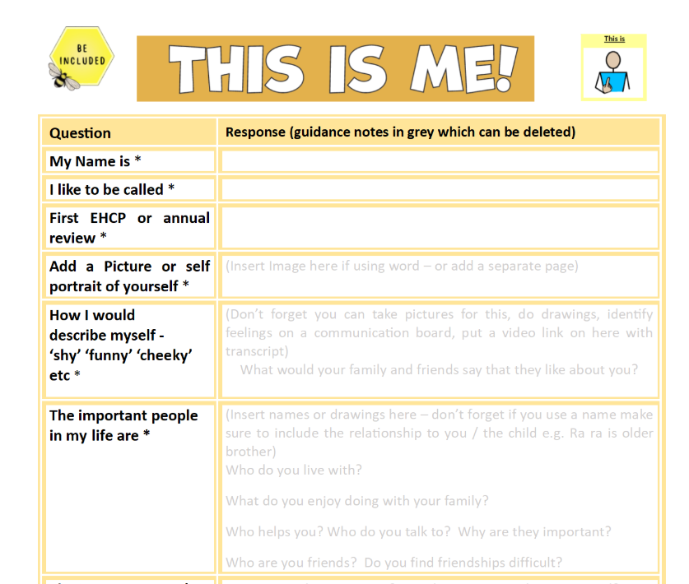
Back to top
11. How will my child be included in activities outside the classroom including school trips?
The individual needs of our children are taken into consideration when planning outside activities and trips. In consultation with parents/carers, appropriate provision and reasonable adjustments will be made, where necessary, to enable children with SEND to participate in all aspects of school life and activities. Medical support will be put in place when needed.
Children with Health Care Plans relating to medical conditions have a section of their plans that outline school trip considerations specific to their conditions. These plans are developed with parents and relevant medical teams which allow for the smooth planning of trips.
Back to top
12. How accessible is the school environment?
Our Accessibility Plan and Equality Scheme are regularly updated and reviewed. We aim to ensure that the school is fully accessible in terms of access to the curriculum, to the physical environment and to information for members of our school community. For further details please see the accessibility plan.
Back to top
13. How will the school prepare and support my child to join the school, transfer to a new school or the next stage of education and life?
We recognise that transitions can be difficult and we take steps to ensure that any transition is as smooth as possible.
Joining the school
Children are invited to visit the school prior to admission. For children with SEND it is sometimes appropriate to arrange a phased start to the school, building up to full-time attendance. Early Years Foundation Stage (EYFS) teachers and/or the SENCo visit the nursery settings of our new starters and liaise with the nursery settings on appropriate provision for SEND children. Where a child may have more complex needs a meeting is arranged between the SENCo and parents/carers prior to transition. Visual transition books are provided to children to familiarise them with the environment and key people they need to know.
Additional ‘settle sessions’ are offered to parents of children with SEND in which the parent can attend a quieter play based session at the school to familiarise the children with the setting. The class teaching team and SENCo are available during these settle sessions to support with any questions parents or children may have.
The SENCo and class teachers will work closely with parents ahead of a child starting school to ensure any risk reduction, intimate care or health care plans are in place to ensure the smoothest transition possible. The SENCo leads a team briefing with school staff before the new academic year to ensure timely information sharing.
Transition within school
Transition within school is supported by planning meetings between class teachers and opportunities for children to visit their new classes in the Summer Term. Children with significant needs, have an individual enhanced transition programme, including photos of their new teacher, support staff and classroom to take home during the summer holiday.
Transferring to a new school
We contact the receiving school to ensure that they are aware of any special arrangements or support needed by the child. All SEND documentation is then passed on to the new school in a timely manner following transfer. A rigorous transition programme is in place to support children transferring to St Mary’s Junior School at the end of Year 2, including visits to and from both schools. The class teachers and SENCos from both schools meet formally to discuss children’s individual needs and share information on children’s learning and social and emotional profiles. Children with SEND, and children presenting with worries or concerns, make additional visits to the school in a small group, organised by the SENCos from both schools. Where a child may have more complex needs, a meeting is arranged between the SENCos, parents/carers and the child, prior to transition.

Back to top
14. How are the school’s resources allocated and matched to children’s special educational needs?
The school budget, received from the local authority, Hertfordshire County Council, includes a notional SEN budget. This is used to provide additional support or resources, as appropriate, in order to meet the individual needs of the children.
The current SEND funding system to meet complex needs in mainstream schools, introduced in April 2020, is known as Local High Needs Funding (LHNF) via a transparent banded system. This provides funding for children without an EHCP. Children with an EHCP may be provided with resources by the local authority as agreed in their EHCP and reviewed annually. The SENCo works with colleagues in the SEN Cluster of local schools to share good practice in ways to support children with SEND.
Back to top
15. How are decisions made about how much support my child will receive?
The amount and type of support children receive is decided on the basis of the needs within the school and in consultation with the teaching staff and any relevant specialist services. the level of support needed will be assessed and reviewed regularly, as part of the graduated approach, in order to identify when and where additional support may be needed.
Back to top
16. Where can I find information about the local authority’s Local Offer of services and provision for children and young people with special educational needs and disability?
The local authority, Hertfordshire County Council, has published its’ local offer of services and provision for children and young people with SEND on its’ website: www.hertsdirect.org/localoffer
Get support from SENDIASS Hertfordshire SENDIASS provides information advice and support which is accurate and confidential in ways that is accessible for young people and parents. They aim to promote independence and self-advocacy to enable you to participate in making informed decisions
You can email us at: info@hertssendiass.org.uk or you can call us on:
Telephone: 01992 555847
Monday to Thursday 9.30am – 3pm
Friday 9.30am – 2.00pm
Outside of these hours please leave an answerphone message for the team and we will respond within 3 working days.
Back to top

- Complaints
Please click the link below for the schools complaints policy
Complaints policy Sept 2023

