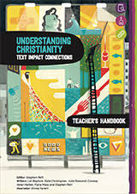
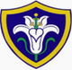St Mary’s Infants School RE Curriculum Map
At St Mary’s we believe that it is vital for all our pupils to learn from and about religion, so that they can understand the world around them. Our curriculum is designed to make learning stick by revisiting the same key themes with a deepening level of understanding each year. It is underpinned by Christian values and encouraging our pupils to ask questions about the world and to reflect on their own beliefs, values and experiences.

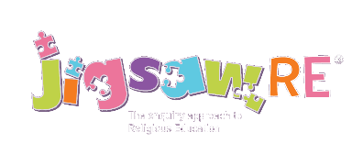

Age Group | Autumn 1 | Autumn 2 | Spring 1 | Spring 2 | Summer 1 | Summer 2
Reception | What makes people special?  Christianity and Judaism | What is Christmas?  Christianity concept: Incarnation | Celebrations  Sanatana Dharma | What is Easter?  Christianity concept: Salvation | What can we learn from stories?  Christianity, Islam, Sanatana Dharma, Sikhi | What makes places special?  Christianity, Islam, Judaism
Year 1 | CREATION  Who made the world? | INCARNATION  Why does Christmas matter to Christians? | GOSPEL  What is the good news Jesus brings? | SALVATION  Why does Easter matter to Christians? | JUDAISM  Who is G-d to the Jews? | JUDAISM  Is Shabbat important to Jewish children?
Year 2 | CREATION  Digging Deeper  Who made the world? | INCARNATION  Digging Deeper  Why does Christmas matter to Christians? | GOSPEL  Digging Deeper  What is the good news Jesus brings? | SALVATION  Digging Deeper  Why does Easter matter to Christians? | JUDAISM  Does visiting the synagogue help Jewish children feel closer to  G-d? | JUDAISM  Are Rosh Hashanah and Yom Kippur important to Jewish children?

